|  |
| --- |
| Sarvajanik Education Society  **Shree Ramkrishna Institute of Computer Education and Applied Sciences**  Behind P.T Science College, M.T.B.College Campus, Athwalines, Surat-395 001.    **A Software Project On**    **E-Learning System**    as the partial fulfillment of    **Semester -V study**    for the degree of    **Bachelor of Science (Computer Science)**  (Affiliated to Veer Narmad South Gujarat University)  during the academic year 2019-2020.    **Developed By: Guided By:**  1) Yesha Kaniyawala Mrs.Shweta Shinde |

|  |
| --- |
| **Sarvajanik Education Society**  **Shree Ramkrishna Institute of Computer Education and Applied Sciences**  **Behind P.T. Science College, M.T.B College Campus, Athwalines, Surat-395 001.**  **CERTIFICATE**  **DEPARTMENT OF COMPUTER SCIENCE**    This is to certify that  Student name Exam no  Yesha Kaniyawala 20116      has / have successfully completed his / her / their software engineering project work entitled  **E-Learning System**    as the partial fulfillment of    **Semester-V study**  for the degree of    **Bachelor of Science (Computer Science)**  (Affiliated to Veer Narmad South Gujarat University) during the academic year 2019-2020.  ___________________ ___________________  **Internal Project Guide HOD**  **Dept. of Computer Science**    **Date: ____________ Place: Surat**  **University Examination:**    **Examination No. : ____________**    **Signature of External Examiners: _______________________________**  **_______________________________**    _______________________________ |

**INDEX for Project Documentation**

|  |  |  |  |
| --- | --- | --- | --- |
| **SR.NO** | **CONTENTS** | | **Page. No** |
| **1.** | **Introduction** | | 1 |
|  | • | Project Profile |  |
| **2.** | **System Introduction** | | 2 |
|  | • | System Definition, Objective and scope |  |
|  | • | Hardware & Software Requirements |  |
| **3.** | **Requirement Analysis & Modeling** | | 4 |
|  | • | Expected working of system |  |
| • | Data Flow Diagrams (DFD) |  |
| • | Process Specification |  |
| • | Data Dictionary |  |
| **4.** | **Design** | | 12 |
|  | • | ER Diagram & Database Design |  |
| • | System Flowchart |  |
| • | Form & Report Designs (Screenshots) Layouts |  |
| **5.** | **Coding** | | 26 |
|  | • | Coding Approach/style |  |
| • | Code Snippets |  |
| **6.** | **Testing** | | 29 |
|  | • | Testing Data Inputs ( Data Validations) |  |
| • | Testing Operations (Actions on each screen) |  |
| **7.** | **New Tools/ Technologies learned/used** | | 32 |
| **8.** | **System Limitations/Restrictions and Dependencies/Constraints** | | 33 |
| **9.** | **Future Enhancement & Opportunities** | | 34 |
| **10.** | **Bibliography & References** | | 35 |

**Introduction**



# **1. Introduction**

**System Profile**

* Project Title E-Learning System

* Organization Shree Ramakrishna Institute . Of Education and Applied Sciences.

* Front -End tool PHP(Laravel),CSS,HTML
* Back -End tool MySQL

* Project Category Web Application
* Operating System Windows 8 or above

* Project Duration 2 Month

* Project Guided By Mrs.Shweta Shinde

* Developed By Yesha Kaniyawala



SRICEAS 1 E-Resource System

# **2. System Introduction**

**2.1 System Definition, Objective and scope**

**2.1.1 System Information: -**

A learning system based on formalised teaching but with the help of electronic resources is known as E-learning. While teaching can be based in or out of the classrooms, the use of computers and the Internet forms the major component of E-learning. E-learning can also be termed as a network enabled transfer of skills and knowledge, and the delivery of education is made to a large number of recipients at the same or different times. Earlier, it was not accepted wholeheartedly as it was assumed that this system lacked the human element required in learning.

**2.1.2 PROJECT OBJECTIVE: -**

E-Learning Enhance the quality of learning and teaching. Meet the learning style or needs of students. Improve the efficiency and effectiveness. Improve user-accessibility and time flexibility to engage learners in the learning process.

**2.1.3 System Scope: -**

The following project has much scope both in present as well as future.E-Learning system is based on formal teaching but with the help of electronic resources outside of a traditional classroom.

**2.2 Hardware & Software Requirements**

**Hardware:-**

* Processor : 4-bit operating system, x64-based processor

* Ram : 8 GB or above

* Hard-Disk : 8 GB or above

**Software:-**

* Backend : MySQL.

* Frontend : PHP(Laravel),HTML,CSS.

* Operating System : Windows 8 or above.

# **3. REQUIREMENT ANALYSIS**

**3.1 Expected working of System**

* **Role of User**
* Register
* Login/Logout
* Edit data
* Add Instructor
* Add Feedback
* View Course
* Forget Password
* **Role of Course**
* Add Instructor
* Add Course
* View Course
* Add Feedback
* Forget Password
* **Role of Instructor**
* Add Course
* View Course
* Add Feedback
* Forget Password

## 3.2 Data Flow Diagrams (DFD)

* **CONTEXT LEVEL DFD:-**

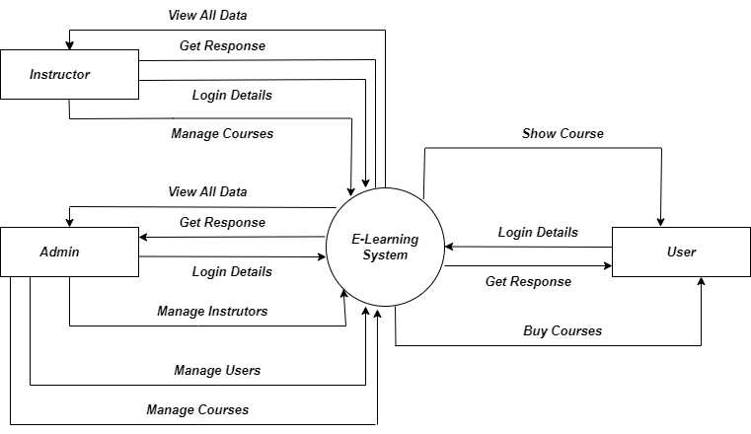

* **1ST LEVEL DFD FOR ADMIN:-**

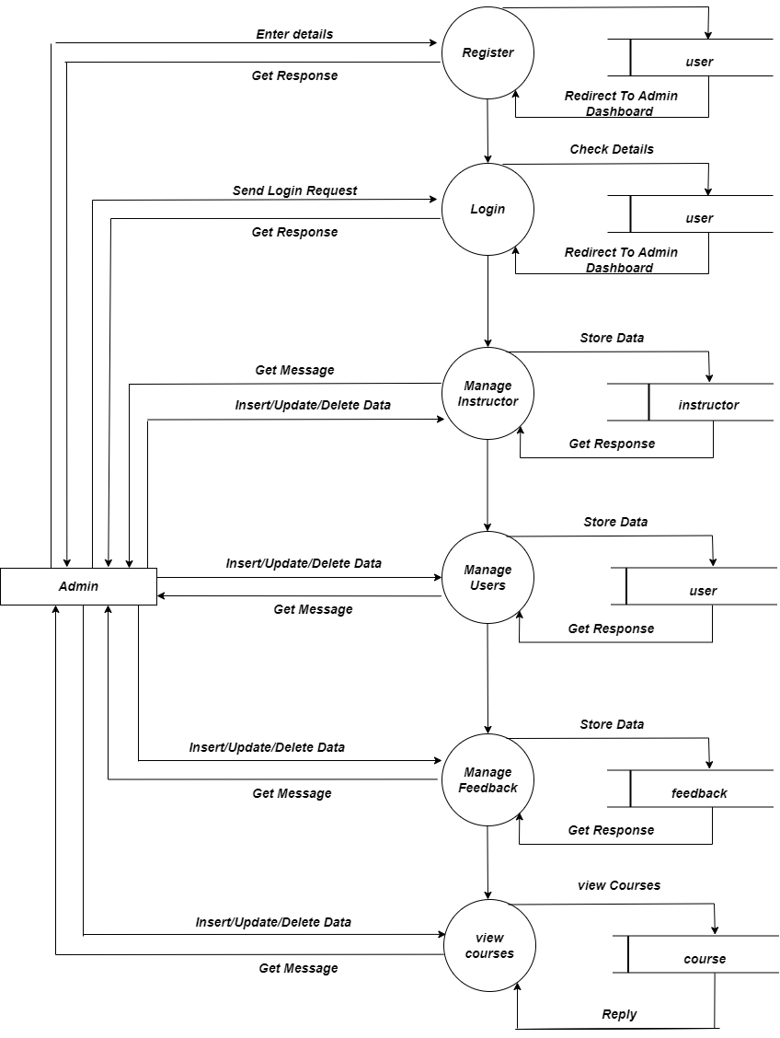

* **1ST LEVEL DFD for user:-**

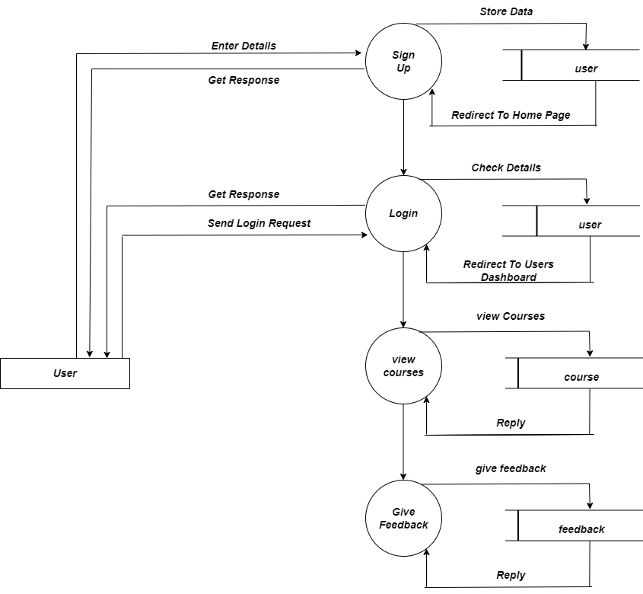

* **1ST LEVEL DFD FOR Instructor:-**

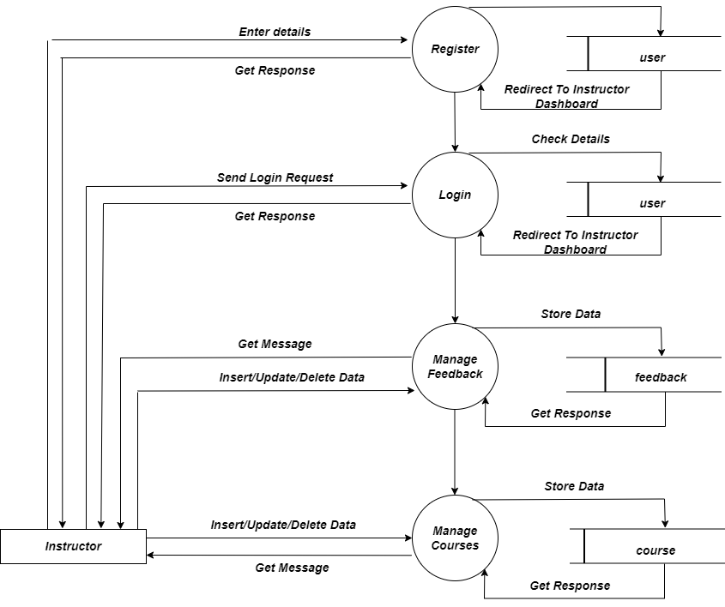

**3.3 Process Specification**

**1. User module:**

Process 1.1: Log in

The user and instructor can login into the System by using unique email and password from general login form general Login Form.

Process 1.2: Registration

If there is new user they can register their data.

## Process 1.3: Operations

Members can change their data it means update option is also available Teacher can view their student list If any One forgot their password they can update their password with unique providing by system.

**2. Admin module:**

## Process 2.1: Log in

The Admin can login into the System by using unique email and password from general login form general Login Form.

Process2.2: Registration

If there is new user they can register their data.

## Process 2.3: Operations

Members can change their data it means update option is also available.

If anyone forgot their password they can update their password with email providing by system.

**3. Admin module:**

## Process 2.1: Log in

The Instructor can login into the System by using unique email and password from general login form general Login Form.

## Process 2.3: Operations

Instructor can add course which is also available.

**3.4 Data Dictionary**

* **Users Table**

|  |  |
| --- | --- |
| **Name:** | Users details |
| **Alias:** | Users |
| **Where used/How used:** | Data use for particular login For users |
| **Content Description:** | id+ email+ password |

* **Instructor Table**

|  |  |
| --- | --- |
| **Name:** | Instructor details |
| **Alias:** | Instructor |
| **Where used/How used:** | Instructor details use for selection of instructor of resources |
| **Content Description:** | id+ **name+ email + date+ qualification+ experience+ is_approved** |

* **Course Table**

|  |  |
| --- | --- |
| **Name:** | Resources data details |
| **Alias:** | Course |
| **Where used/How used:** | Course details are used for insert or/and retrive data of resources. |
| **Content Description:** | id+**course_title**+**course_brief**  +**num_of_chapters** +**course_fee**+**video**+**language_id +instructor_id** |

# **4. Design**

**4.1 E-R Diagram :**

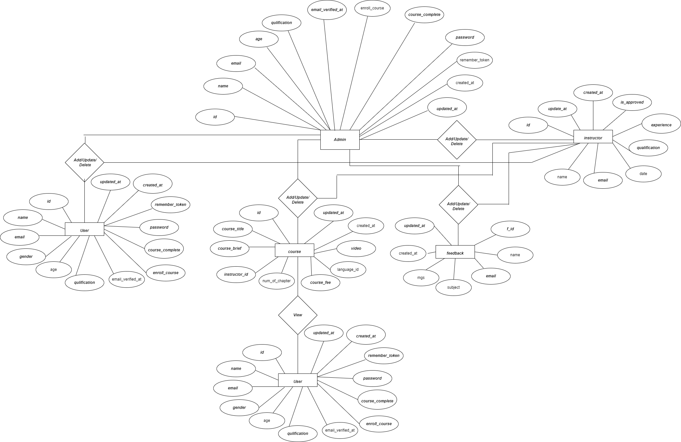

**4.2 Database design:**

# ➢ Table Name : **users**

|  |  |  |  |  |
| --- | --- | --- | --- | --- |
| **Field Name** | **Data Type** | **Constraints** | **Field Size** | **Description** |
| **id** | Auto Number | Primary Key |  | Contains ID of staff |
| **name** | varchar |  |  | Contains username |
| **email** | varchar |  |  | Contains email id of  user |
| **gender** | varchar |  |  | Contains gender of  user |
| **Age** | Int |  |  | Contains age of  User |
| **Qualification** | Varchar |  |  | Contains qualification of  User |
| **email_verified_at** | Int |  |  | Contains email verified of  User |
| **enroll_course** | Int |  |  | Contains enroll course of  User |
| **course_complete** | Int |  |  | Contains completed course of  User |
| **password** | Varchar |  |  | Contains password of  User |
| **remember_token** | varchar |  |  | Contains token of  User |
| **created_at** | timestamp |  |  | Inserted data of  user |
| **updated_at** | timestamp |  |  | Updated data of  user |

* Table Name :  **roles**

|  |  |  |  |  |
| --- | --- | --- | --- | --- |
| **Field Name** | **Data Type** | **Constraints** | **Field Size** | **Description** |
| **id** | Auto Number | Primary Key |  | Contains ID of role |
| **name** | varchar |  |  | Contains name of role |
| **guard_name** | varchar |  |  | Contain guard name of role |
| **created_at** | timestamp |  |  | Created data of  Role |
| **updated_at** | timestamp |  |  | Updated data of  Role |

* Table Name :  **permissions**

|  |  |  |  |  |
| --- | --- | --- | --- | --- |
| **Field Name** | **Data Type** | **Constraints** | **Field Size** | **Description** |
| **id** | Auto  Number | Primary Key |  | Contains ID of permissions |
| **name** | Varchar |  |  | Contains name of permissions |
| **guard_name** | Varchar |  |  | Contains guard name of permissions |
| **created_at** | timestamp |  |  | Created data of  Permissions |
| **updated_at** | timestamp |  |  | Updated data of  Permissions |

# ➢ Table Name : **model_has_roles**

|  |  |  |  |  |
| --- | --- | --- | --- | --- |
| **Field Name** | **Data Type** | **Constraints** | **Field Size** | **Description** |
| **role_id** | Auto  Number | Primary Key |  | Contains ID |
| **model_type** | Varchar |  |  | Contains the model type |
| **model_id** | Bigint |  |  | Contains model id |

# ➢ Table Name : **Instructor**

|  |  |  |  |  |
| --- | --- | --- | --- | --- |
| **Field Name** | **Data Type** | **Constraints** | **Field Size** | **Description** |
| **id** | Auto  Number | Primary Key |  | Contains ID of instructor |
| **name** | Short Text |  |  | Contains name of instructor |
| **email** | Short Text |  |  | Contains email of instructor |
| **Date** | Short Text |  |  | Contains Date of instructor |
| **qualification** | Hyperlink |  |  | Contains qualification of instructor |
| **experience** | Short Text |  |  | Contains experience of instructor |
| **is_approved** | Short Text |  |  | Contains approved of instructor |
| **created_at** | Short Text |  |  | Created data of  instructor |
| **updated_at** | Number | Foreign Key |  | Updated data of  Instructor |

# ➢ Table Name : **feedback**

|  |  |  |  |  |
| --- | --- | --- | --- | --- |
| **Field Name** | **Data Type** | **Constraints** | **Field Size** | **Description** |
| **id** | Auto Number | Primary Key |  | Contains ID of feedback |
| **name** | varchar |  |  | Contains name |
| **email** | varchar |  |  | Contains mail id |
| **subject** | varchar |  |  | Contains subject of feedback |
| **message** | varchar |  |  | Contains feedback |

# ➢ Table Name : **Course**

|  |  |  |  |  |
| --- | --- | --- | --- | --- |
| **Field Name** | **Data Type** | **Constraints** | **Field Size** | **Description** |
| **id** | Auto Number | Primary Key |  | Contains ID of course |
| **course_title** | varchar |  |  | Contains title of course |
| **course_brief** | varchar |  |  | Contains brief of course |
| **instructor_id** | varchar |  |  | Contains instructor ID of course |
| **num_of_chapters** | varchar |  |  | Contains number of chapters of course |
| **course_fee** | Int |  |  | Contains course fee of course |
| **language_id Index** | bigint | **Foreign key** |  | Contains language ID of course |
| **video** | longblob |  |  | Contains video of course |
| **created_at** | timestamp |  |  | Created data of  Course |
| **updated_at** | timestamp |  |  | Updated data of  Course |

# 

**4.3 System Flowchart :**

**4.3.1 Admin Side :**

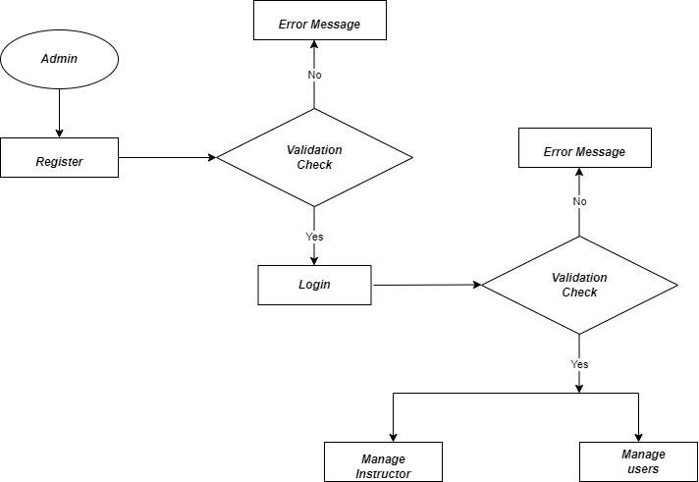

**4.3.2 User Side :**

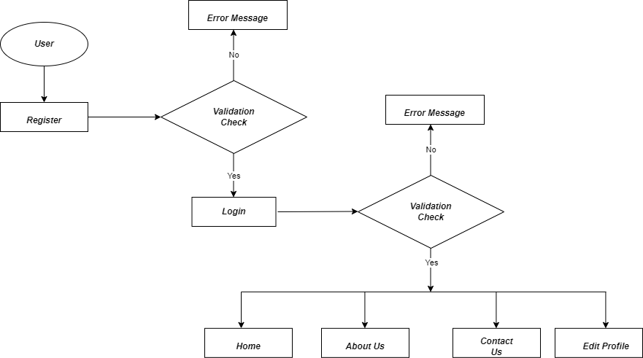

**4.3.3 Instructor Side :**

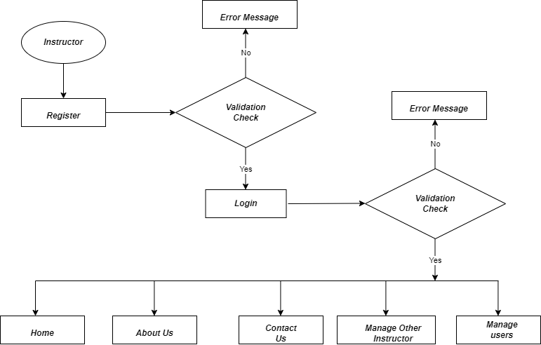

**4.4 FORM AND REPORT DESIGN(SCREENSHOT)LAYOUT:**

* **Registration Page**

* + - Registration page to login in e-learning system.

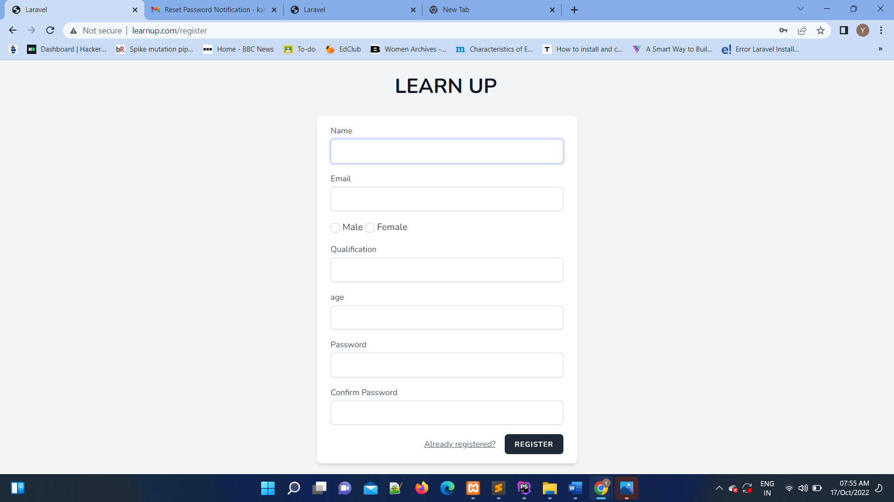

* **Login Page For User And Admin**

* + - Login page used by admin and instructor member to login in e-learning system.
    - Login done with email and password of admin And instructor member.

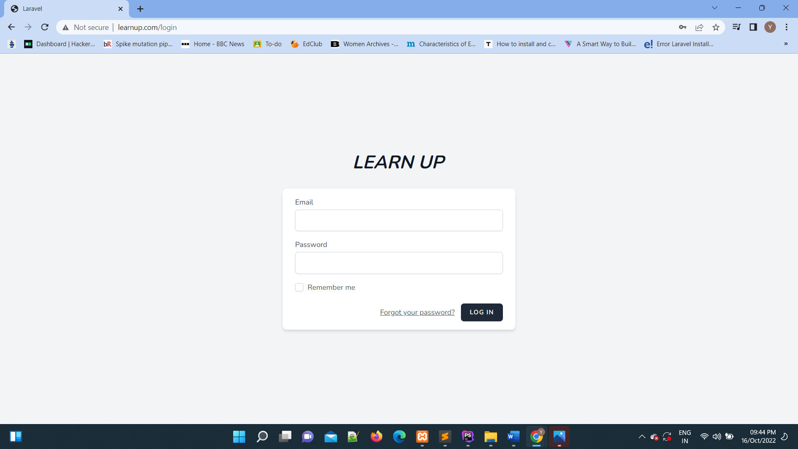

**Admin Home Page**

* + - If admin is login in this system then admin redirectedon home page of admin.

* + - In this home page the name of user who logins is show with welcome message.



* **Forget Password Page** 
  + - If any user forget their password then they use the email id and getPassword on the mail.

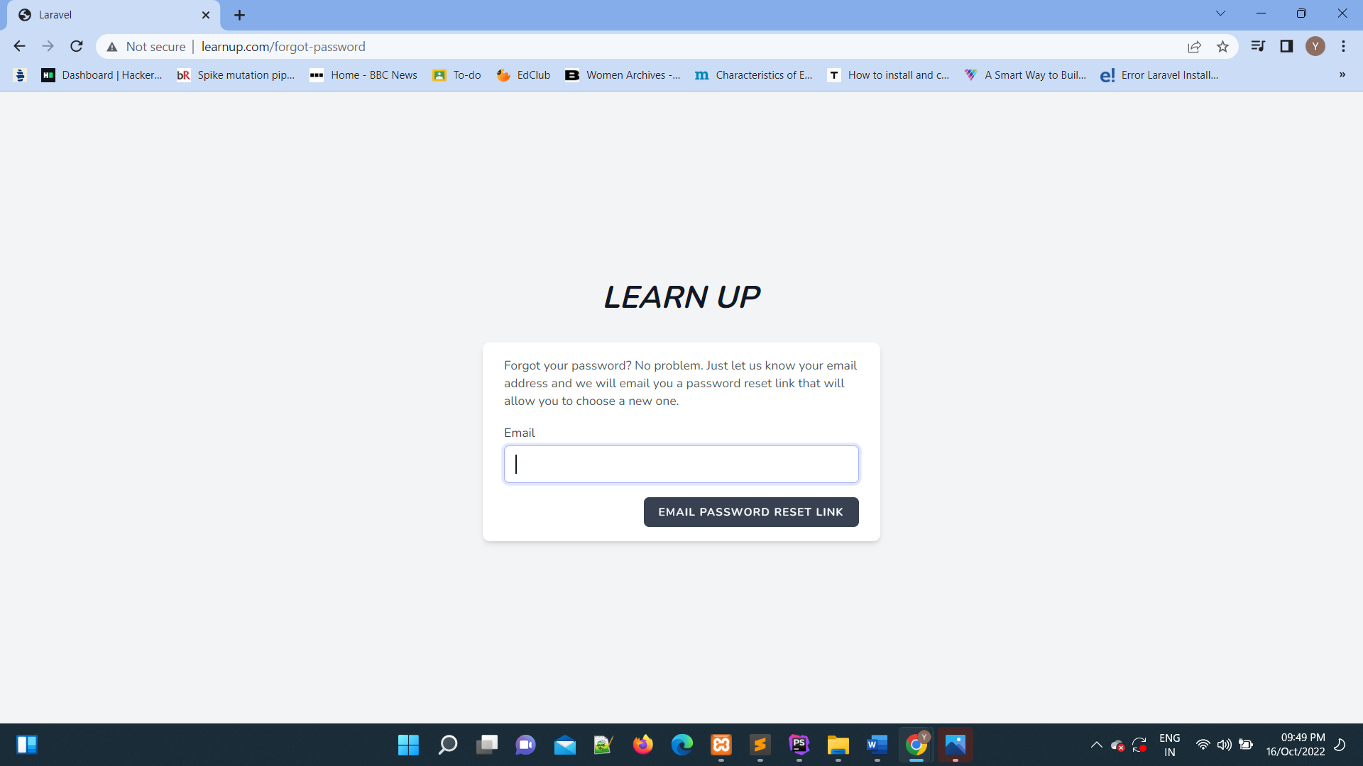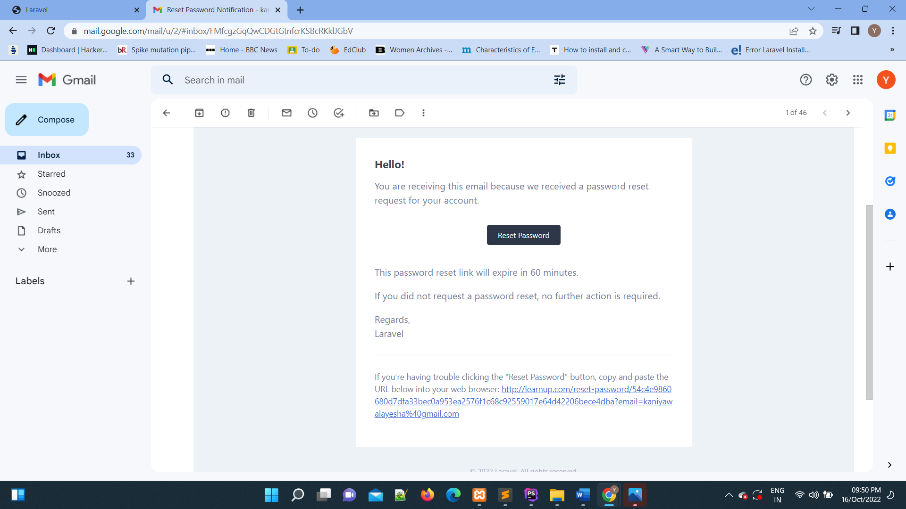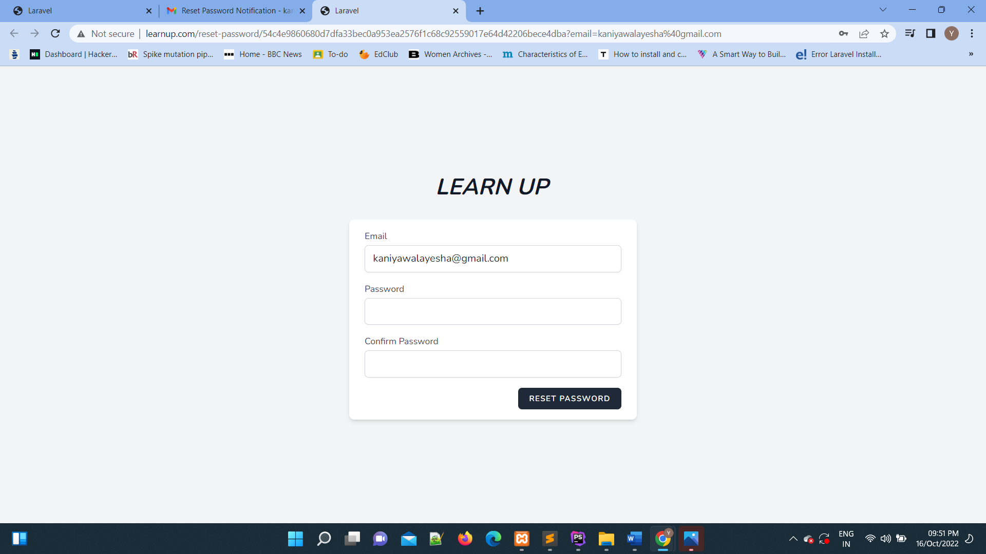

* **Home Page after login**

1111111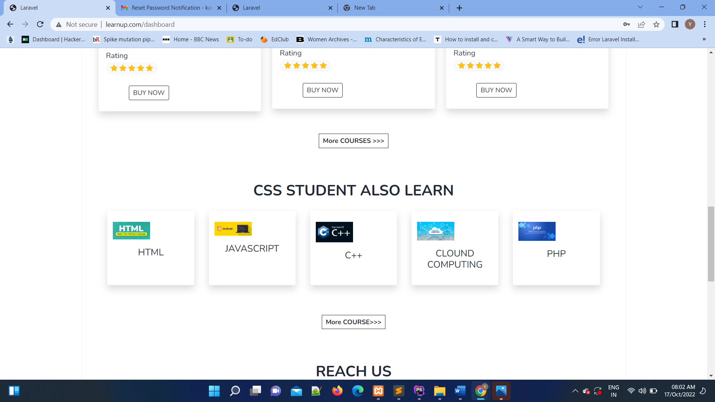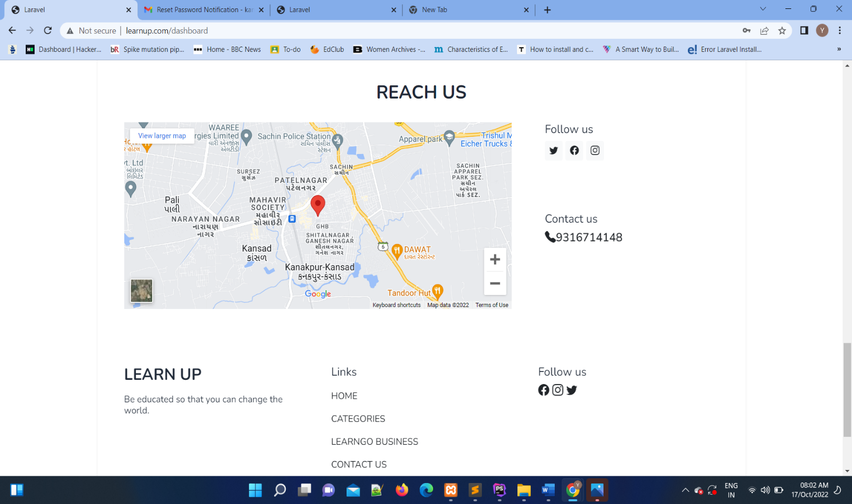

* **Edit/Update user profile**

* + - In this home page, User can edit their profile

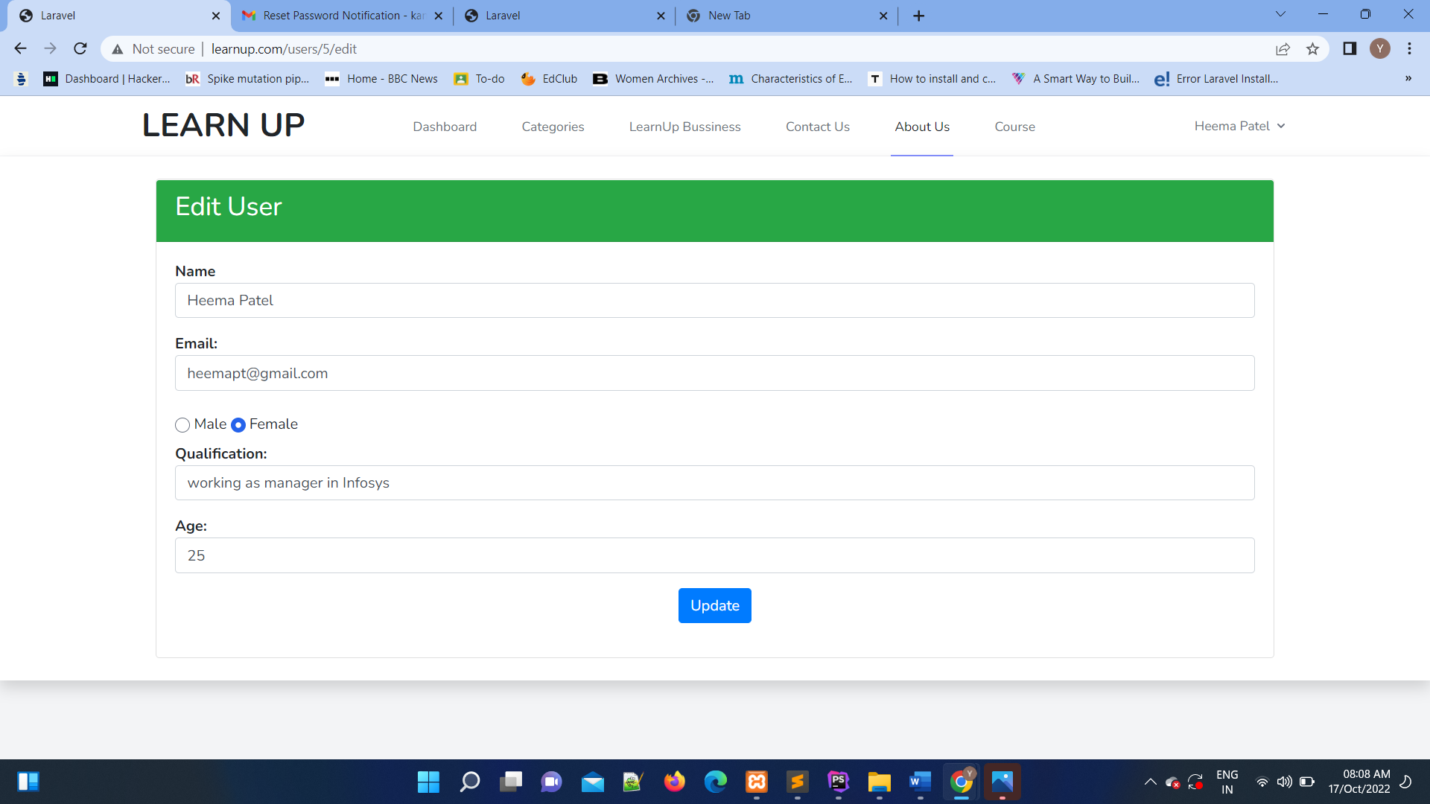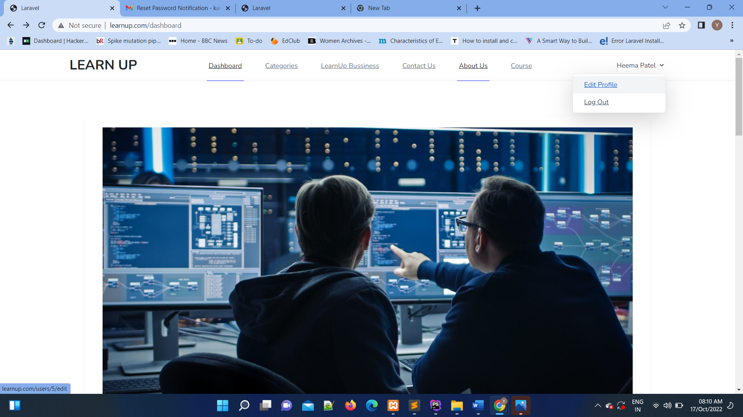

* **Apply for learnup bussiness**

* + - If user wants to do business they have to first register.

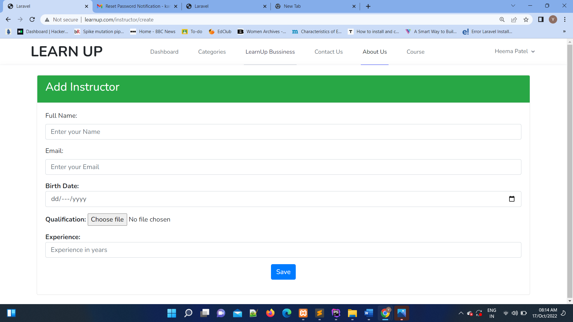

**Contact Us Page**

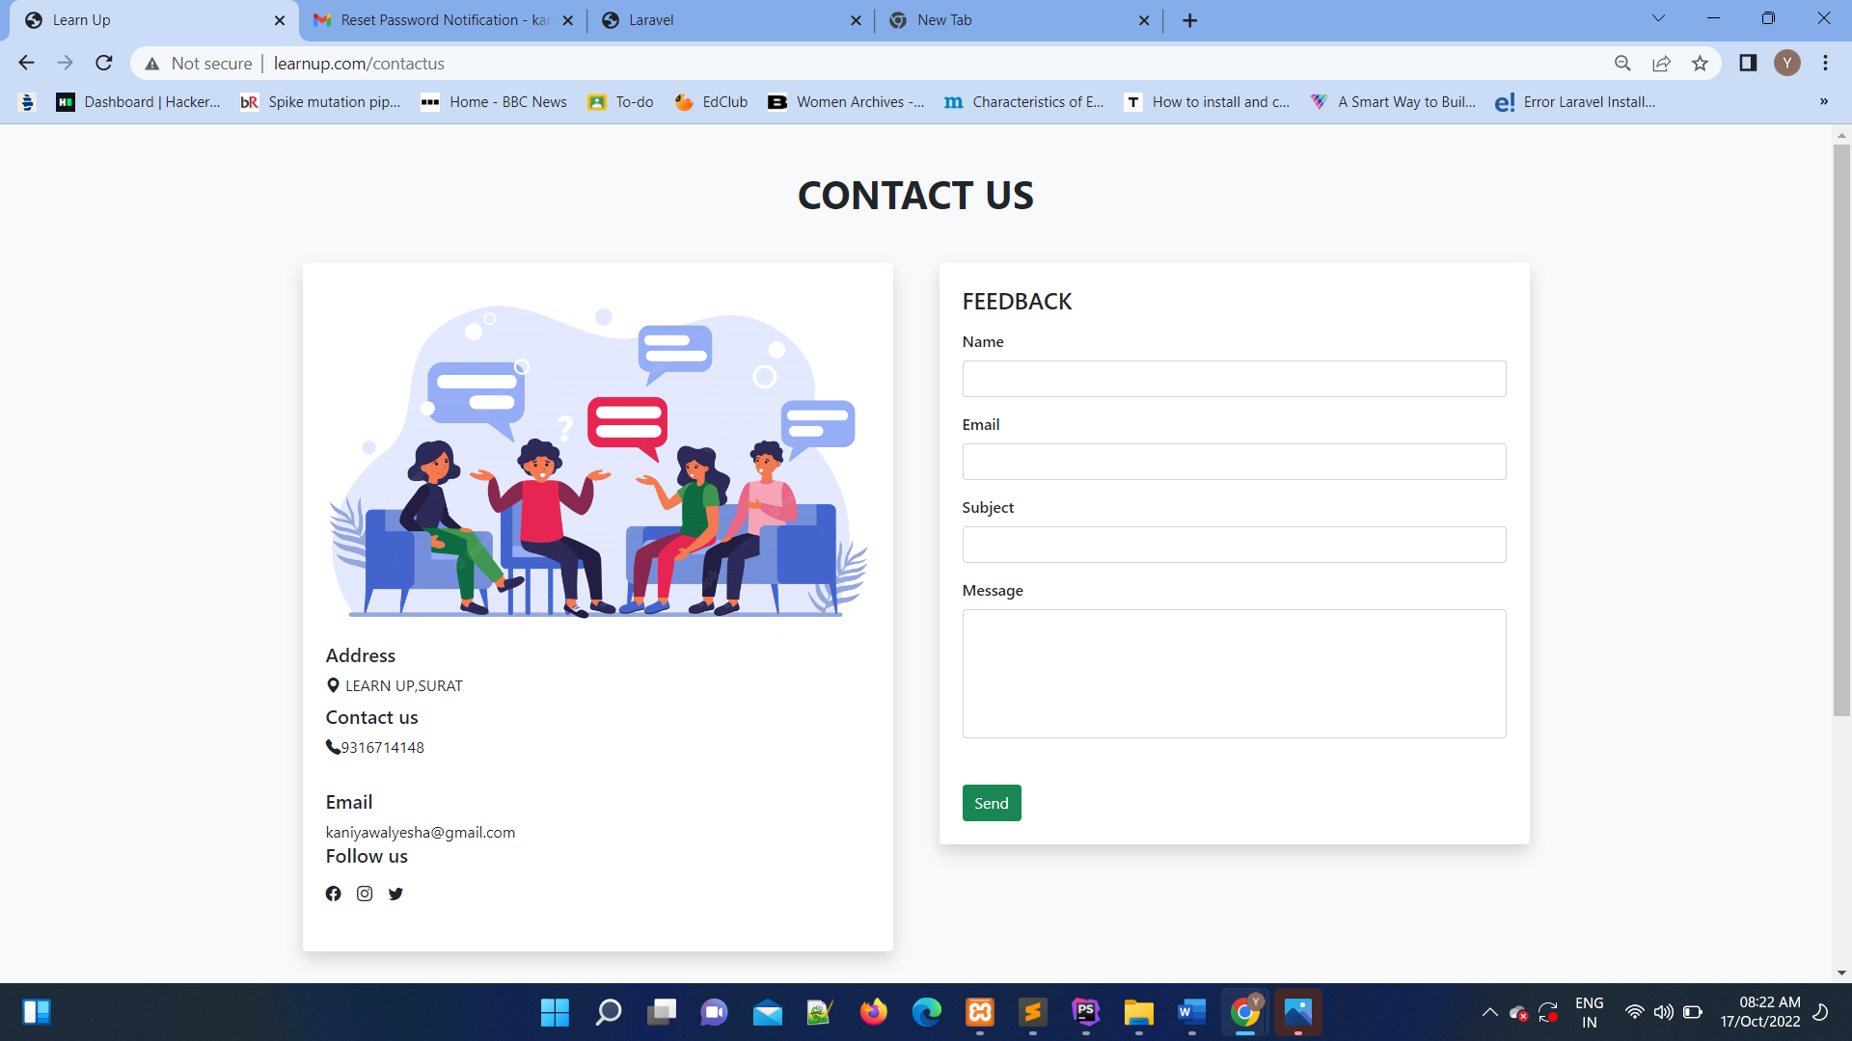

**Add Course**

* + - In this home page,Instructor can add course.

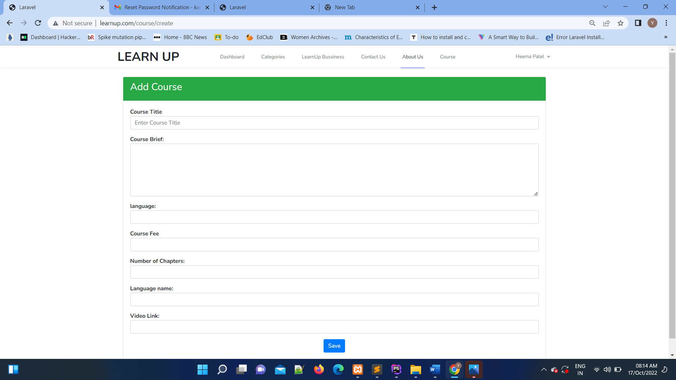

**View Instructor**

* + - Admin give permission to a role of instructor to add course.

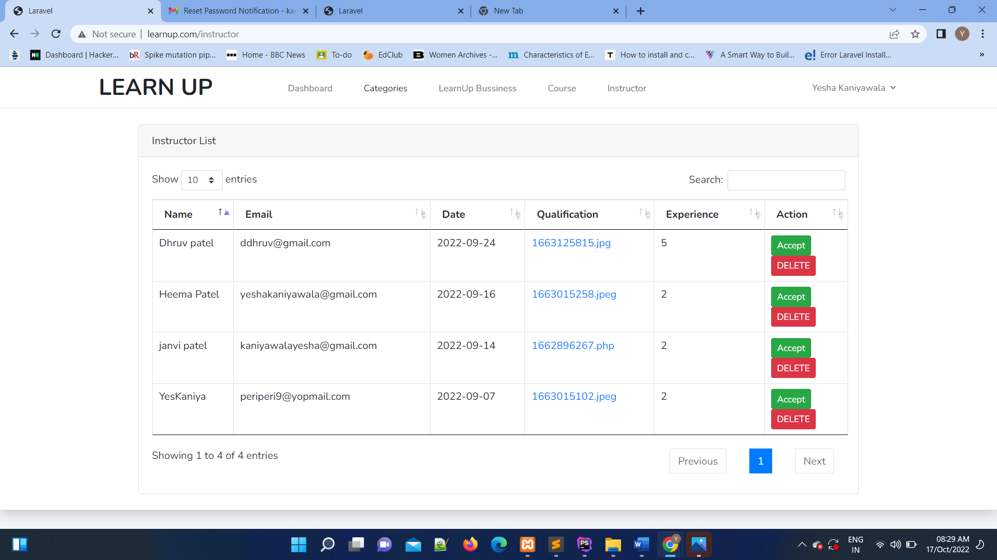

## 5.CODE

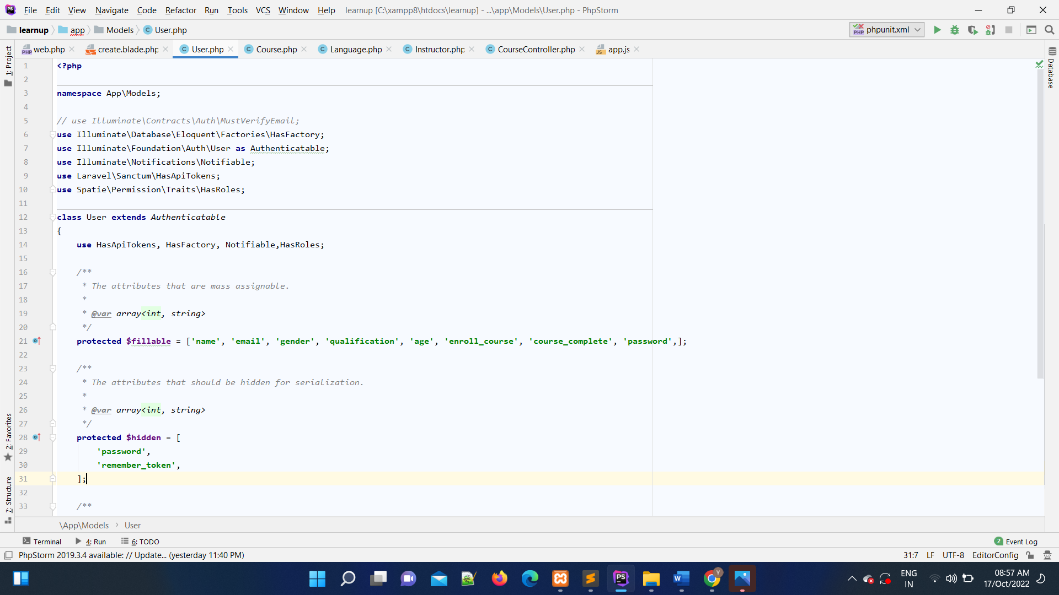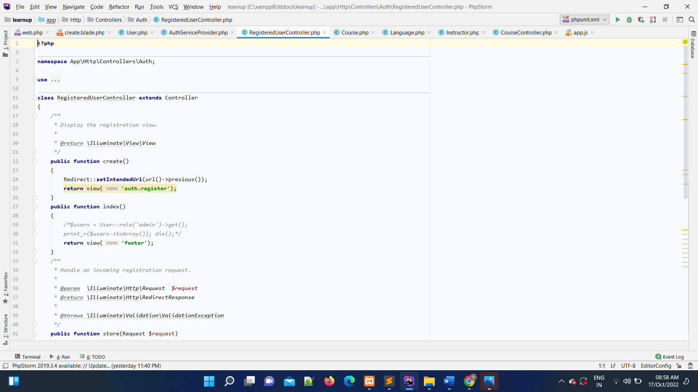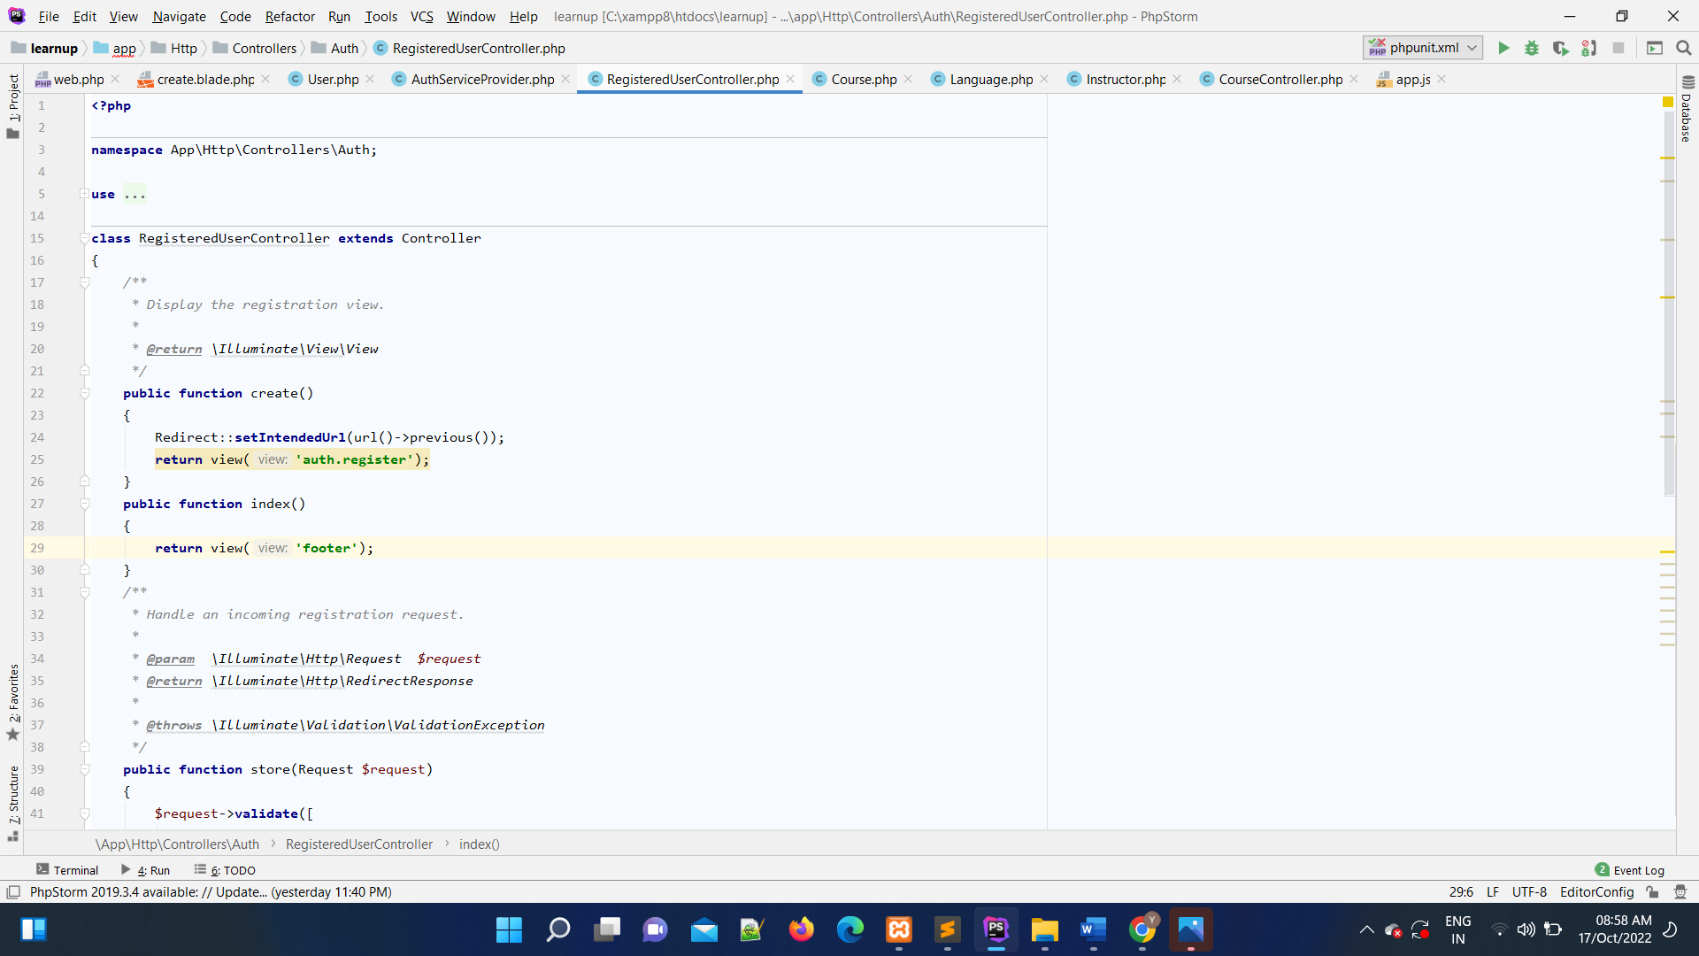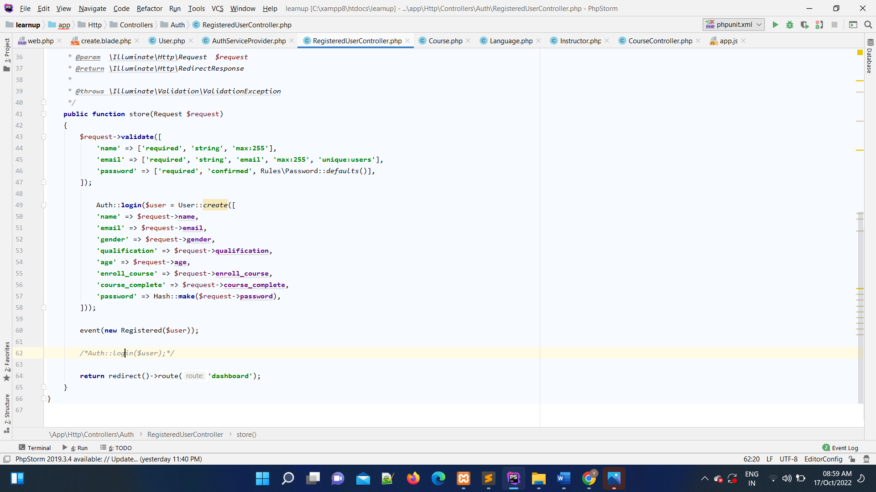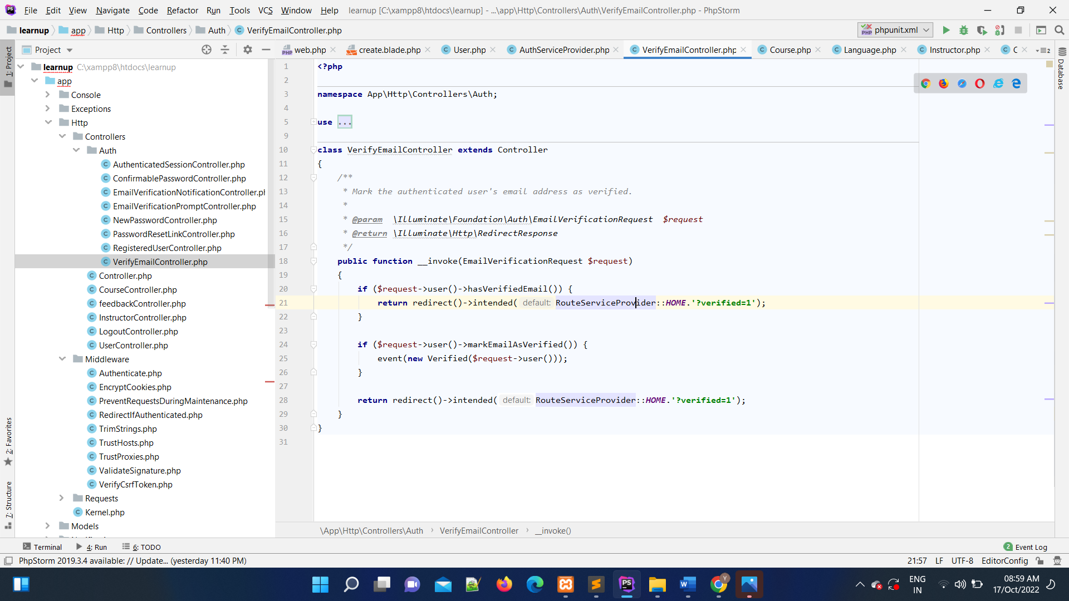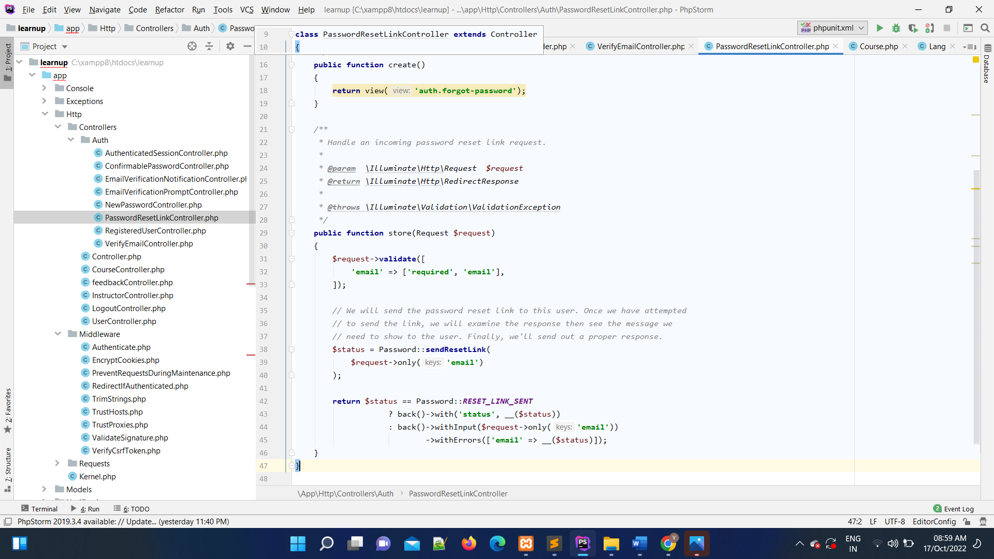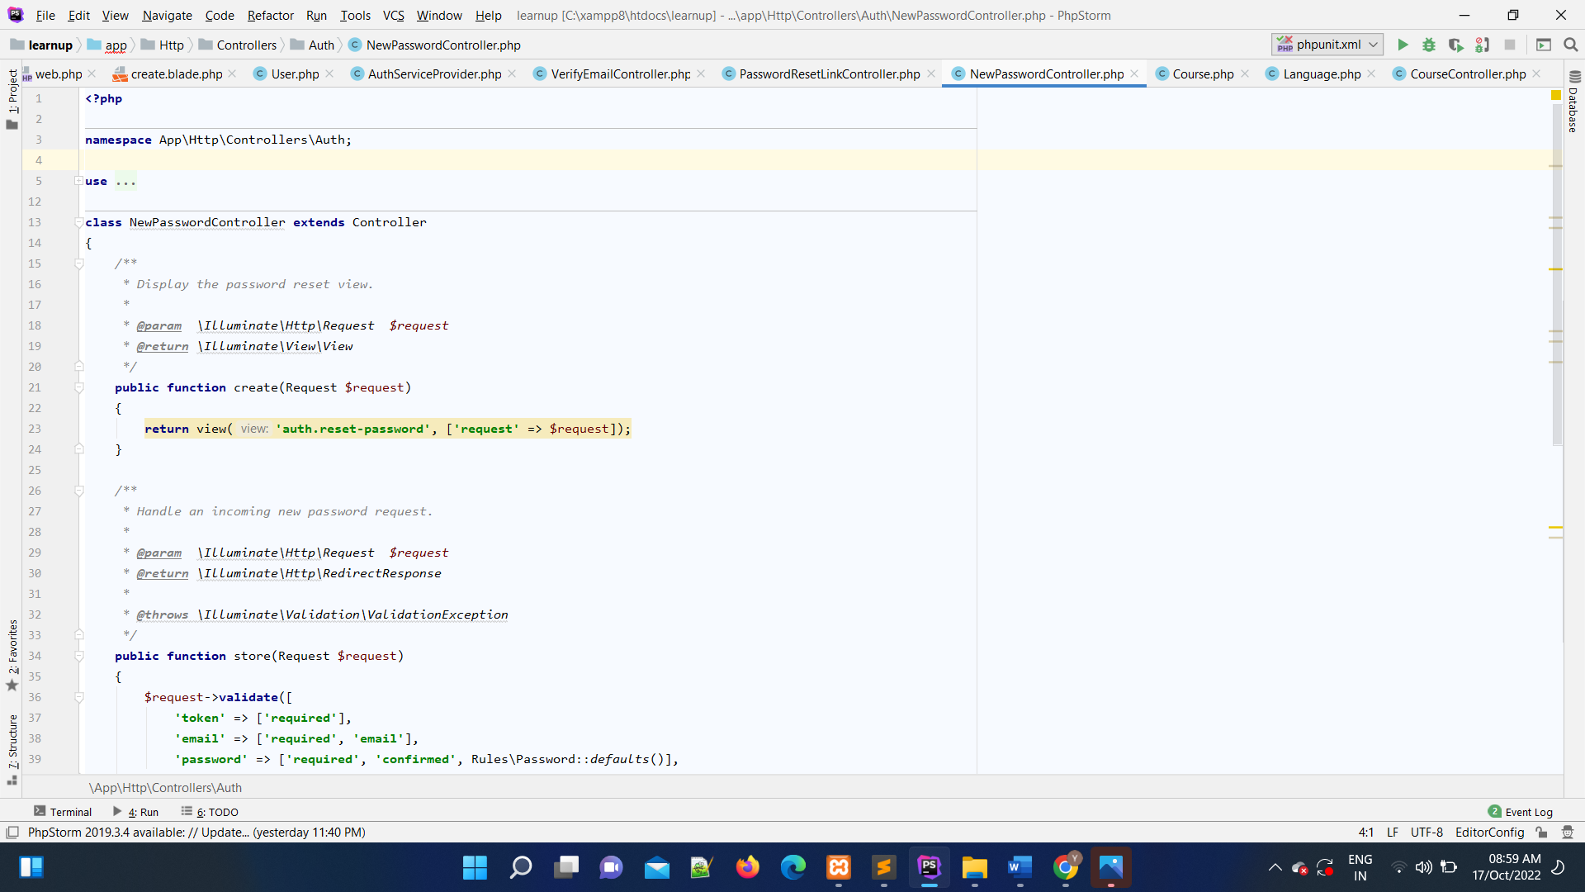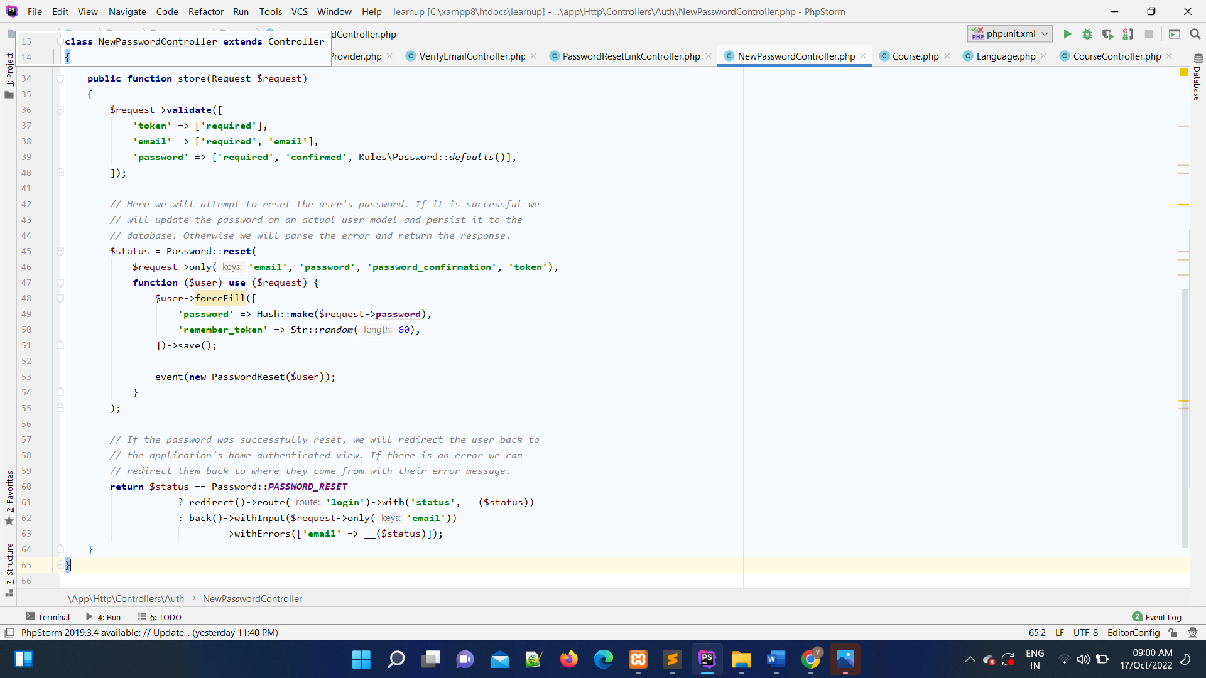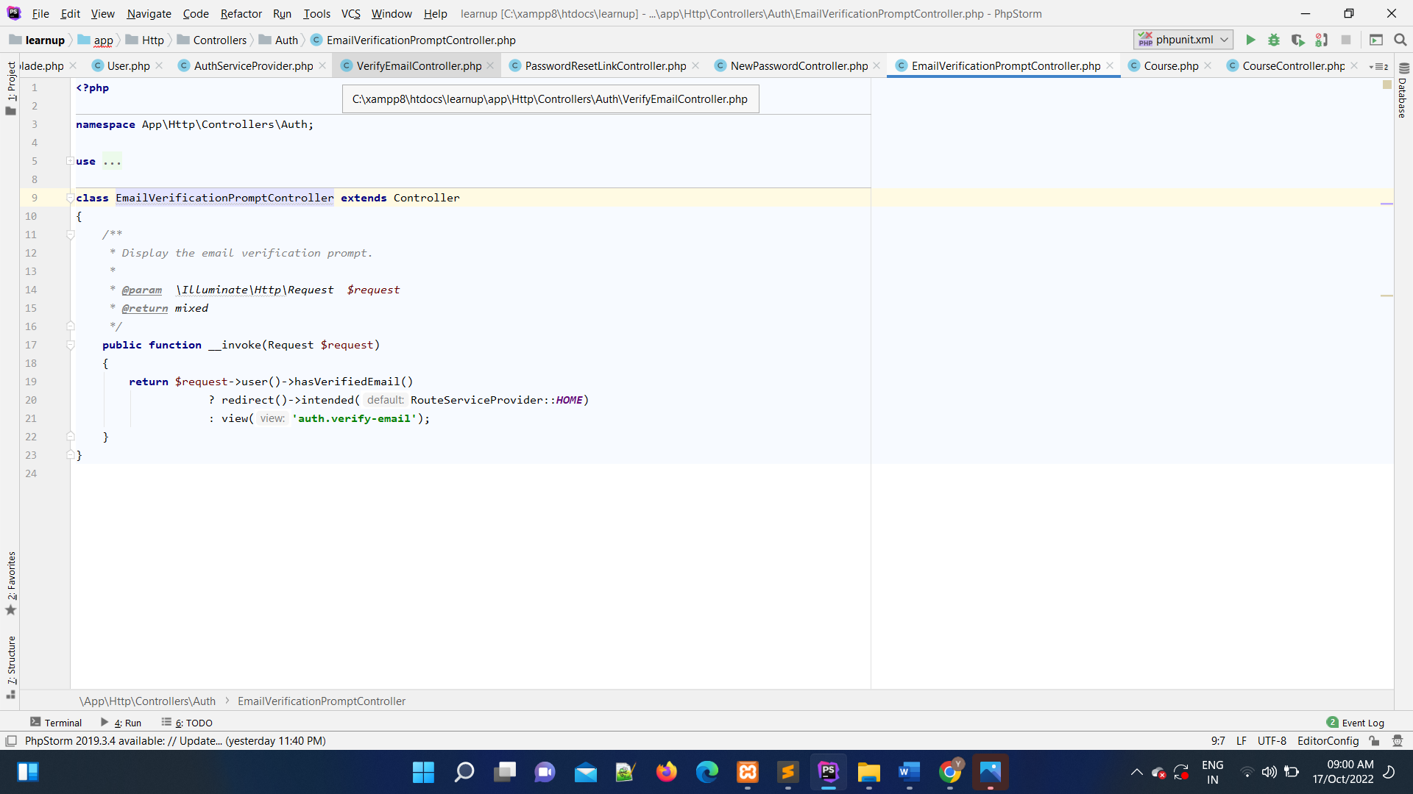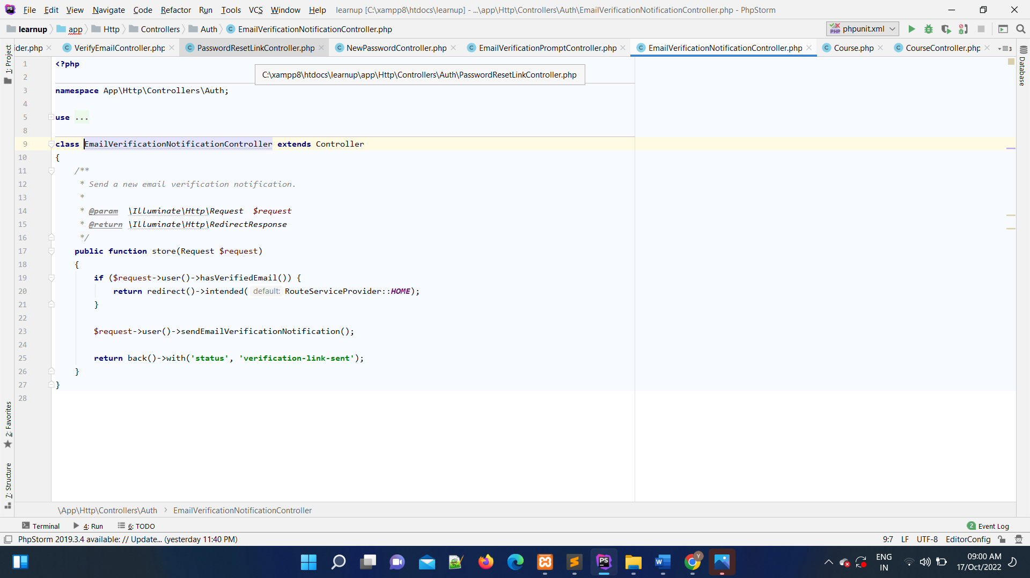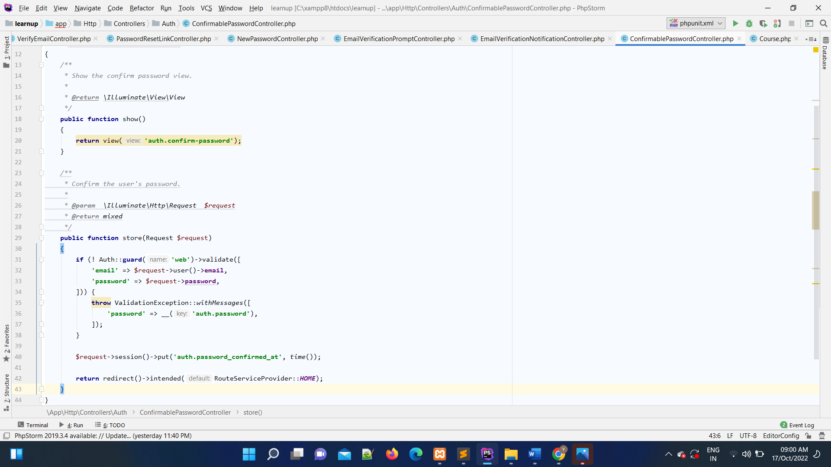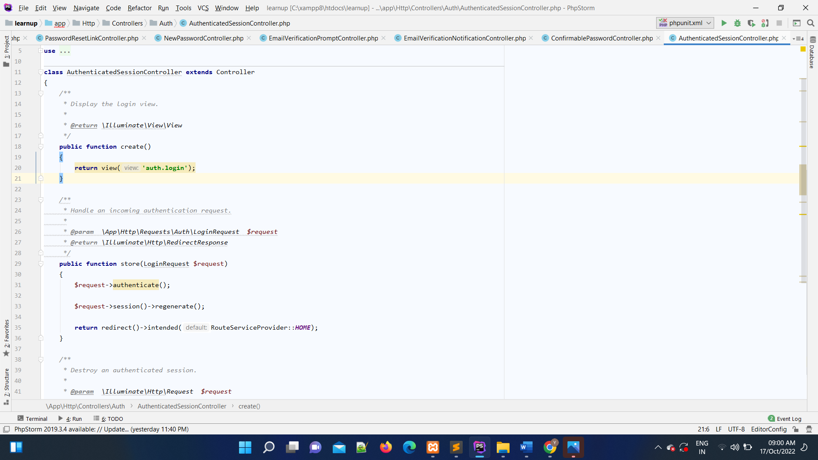

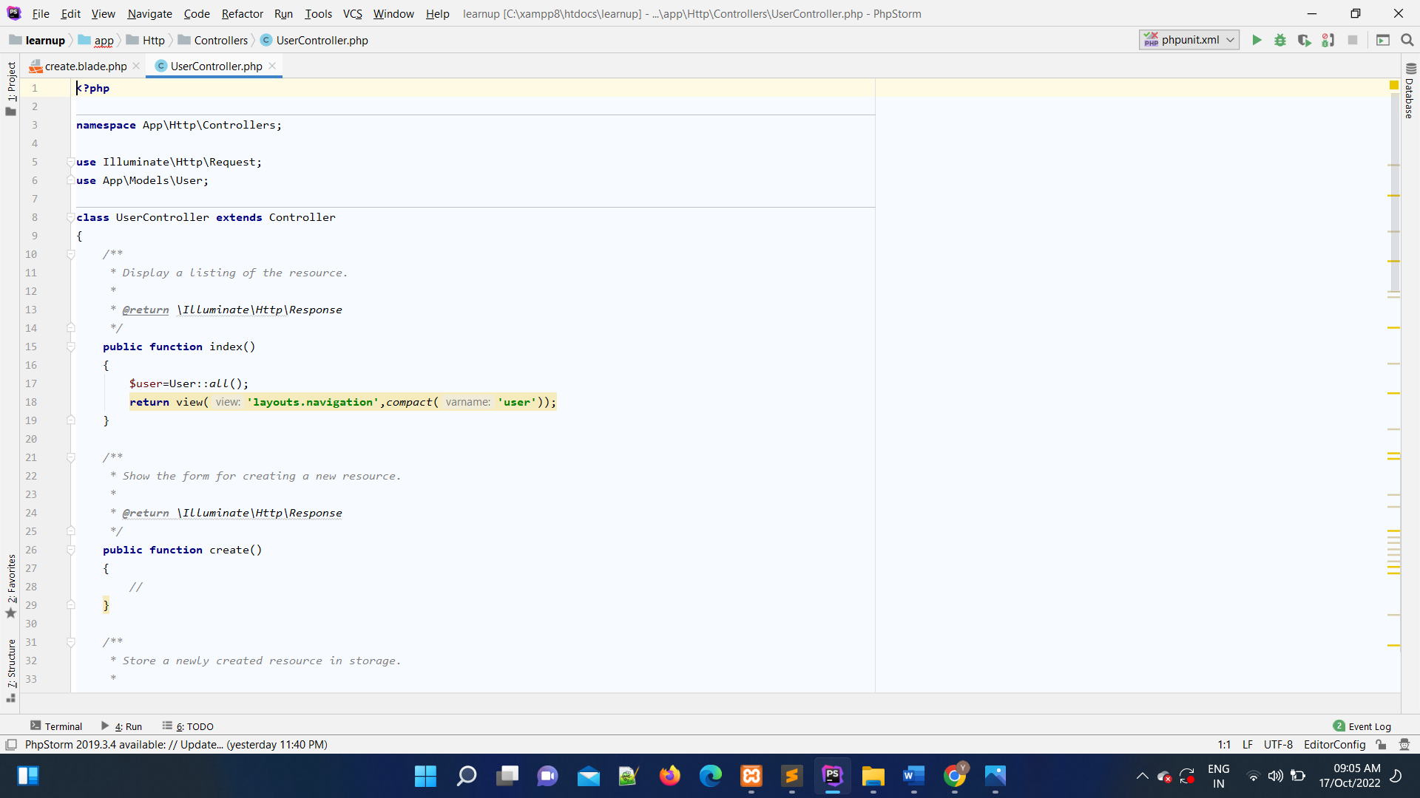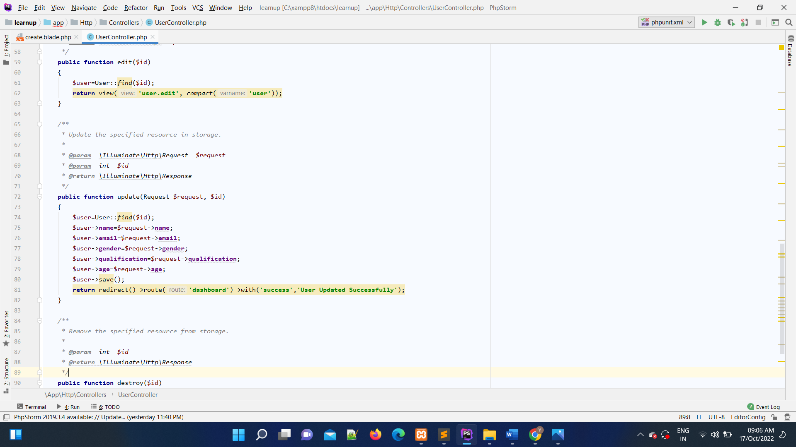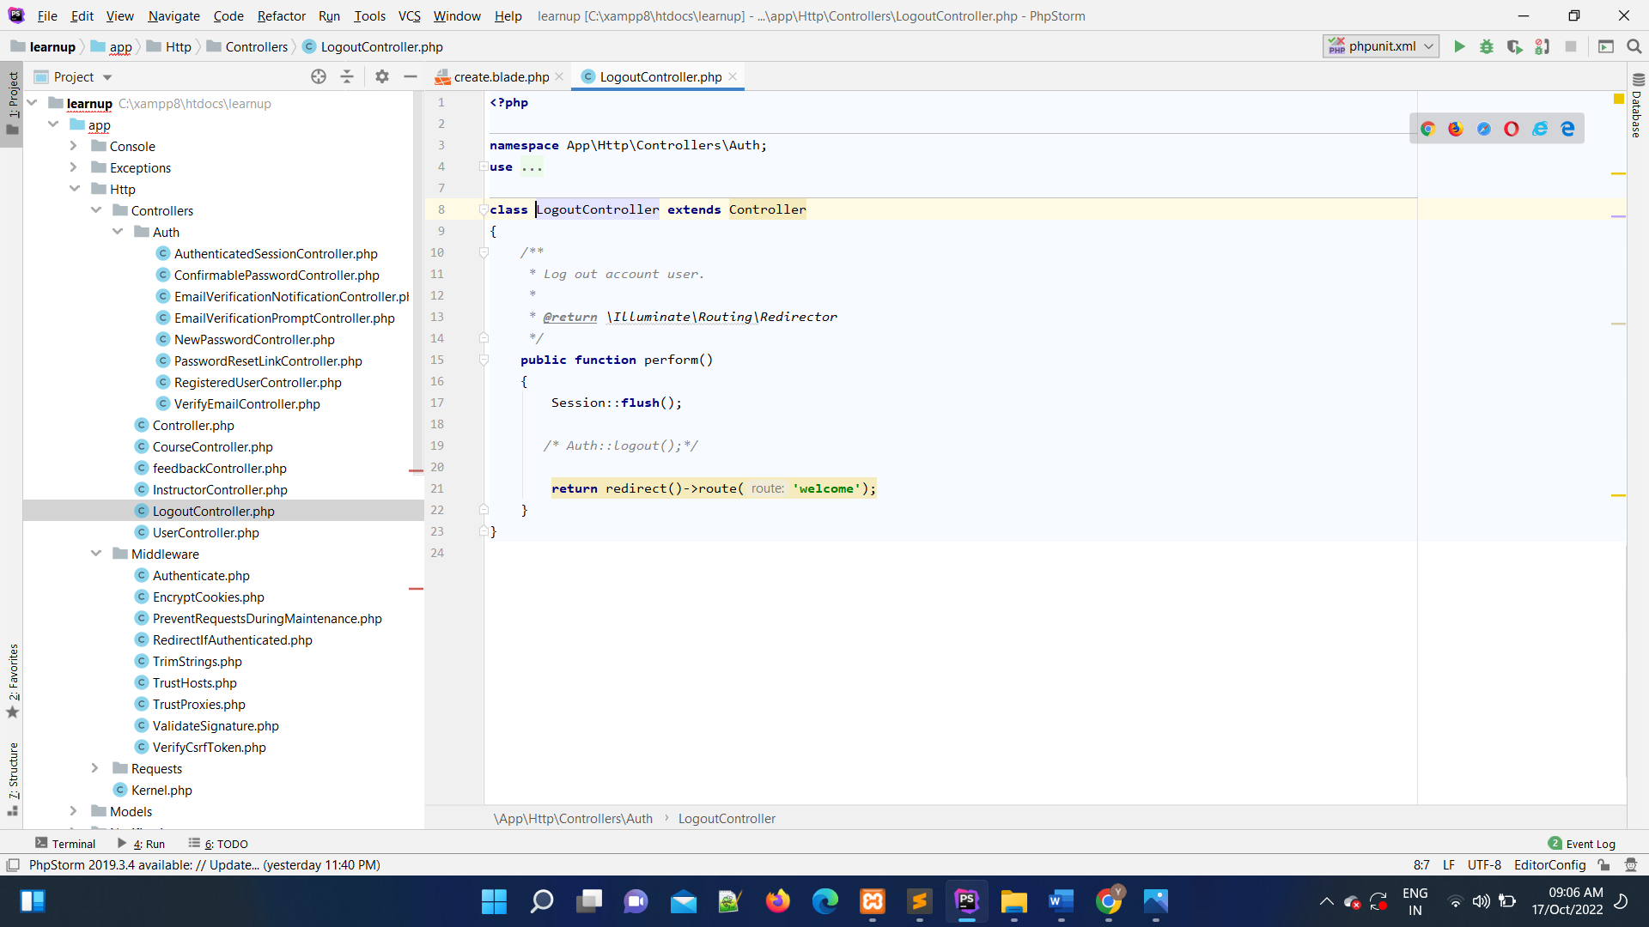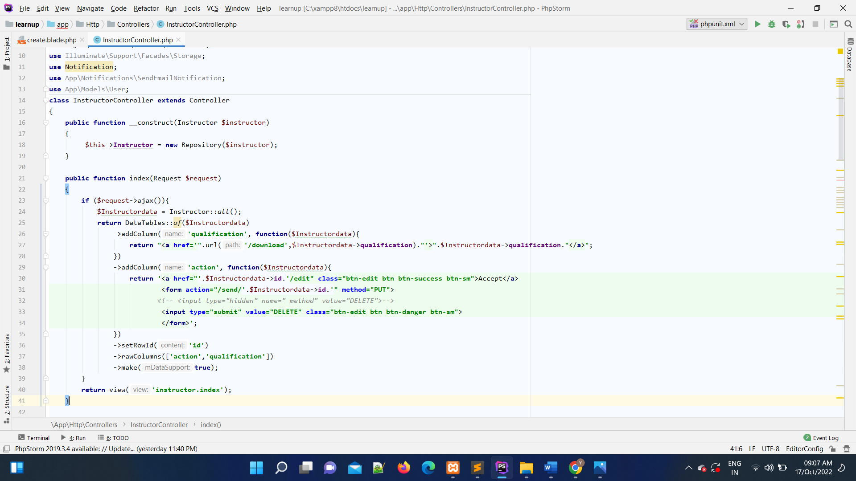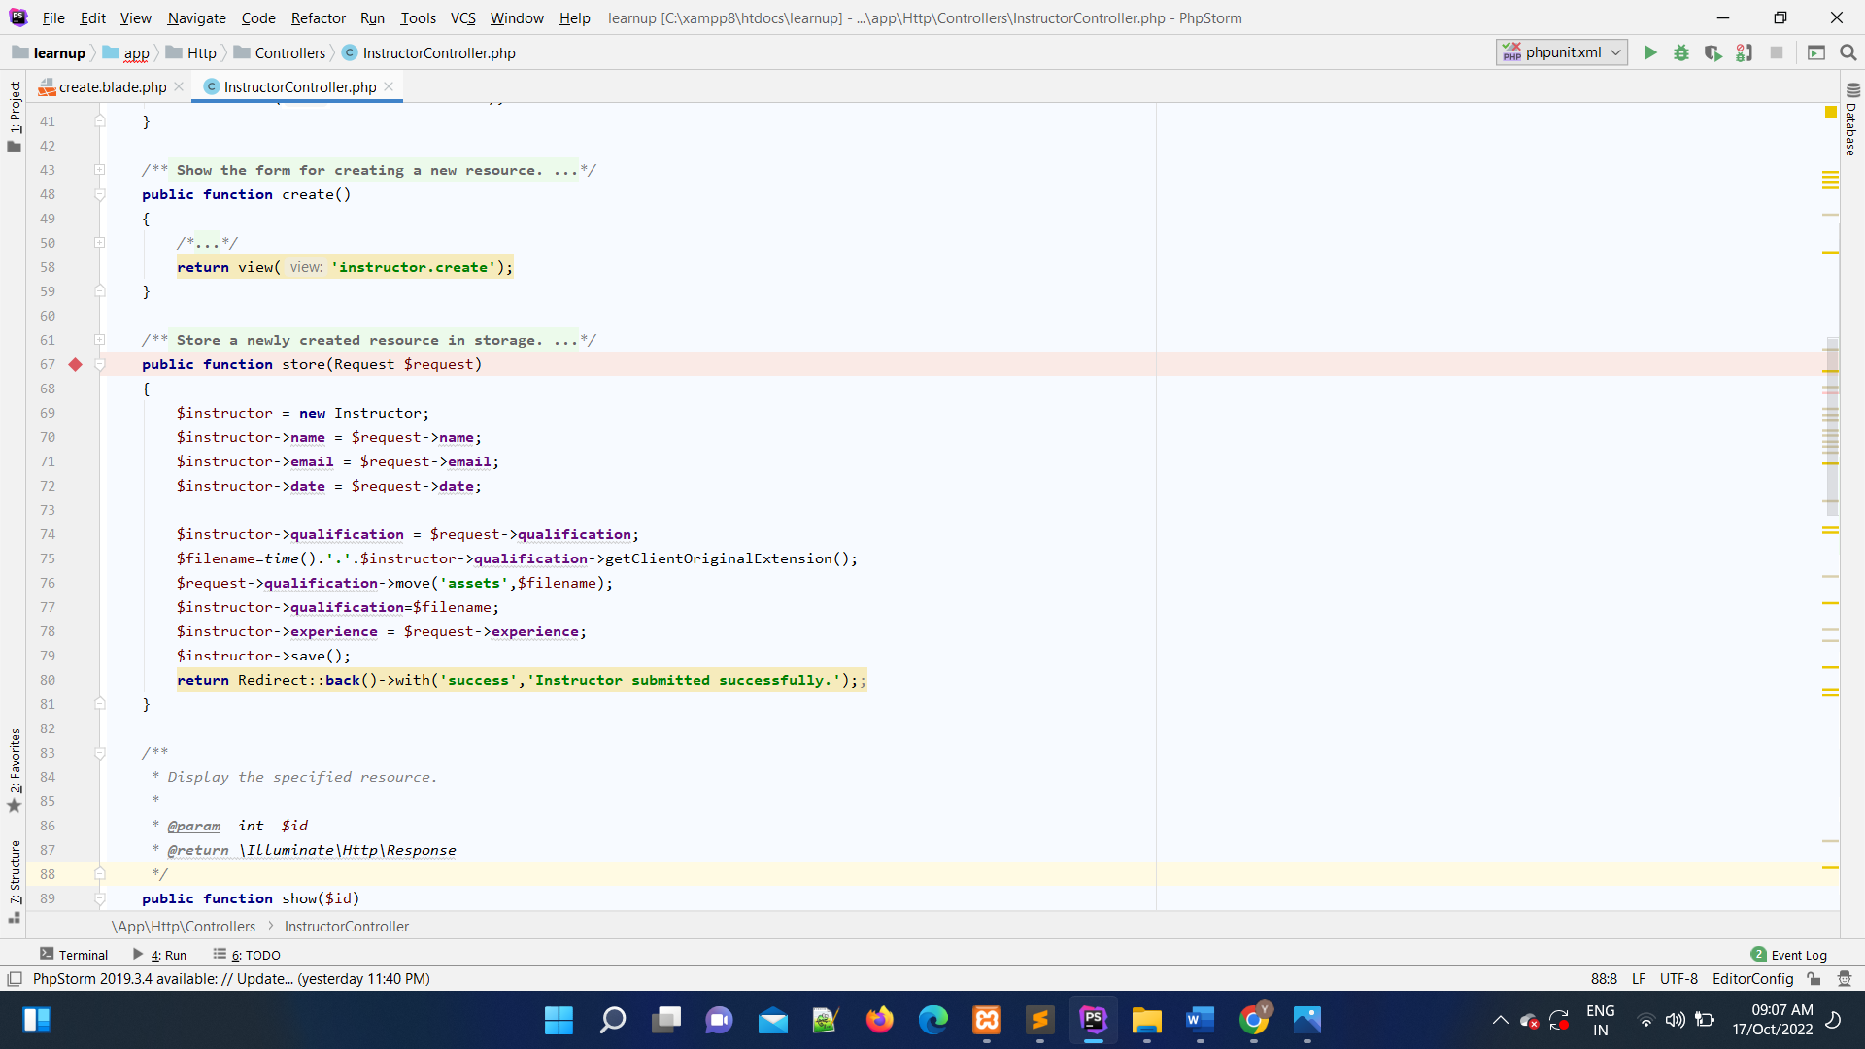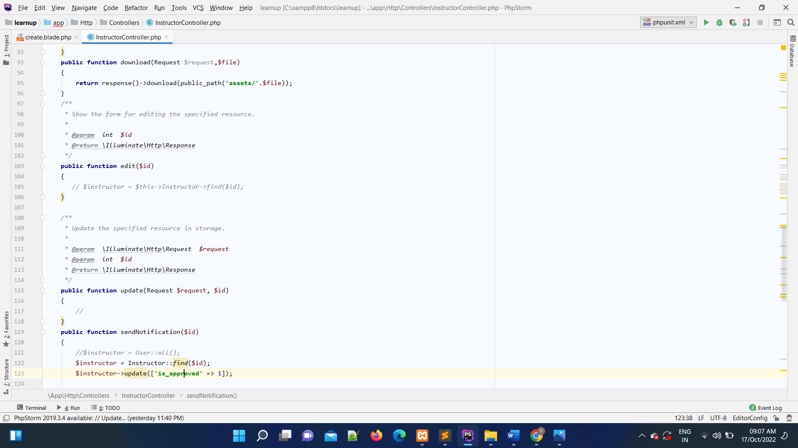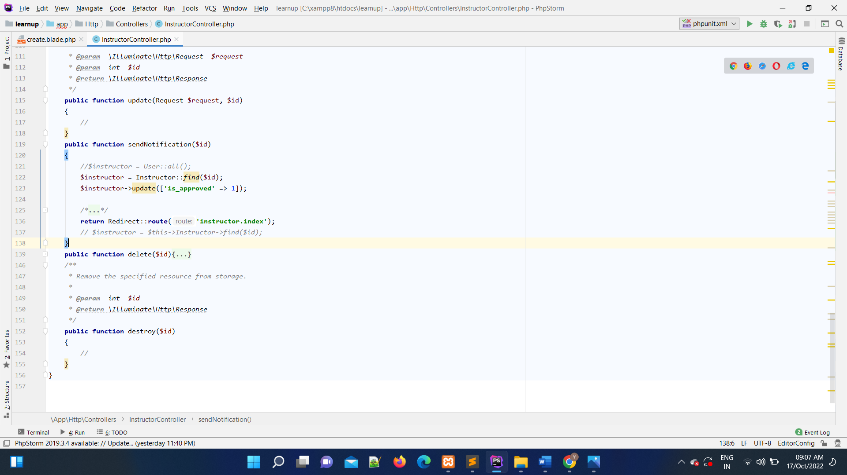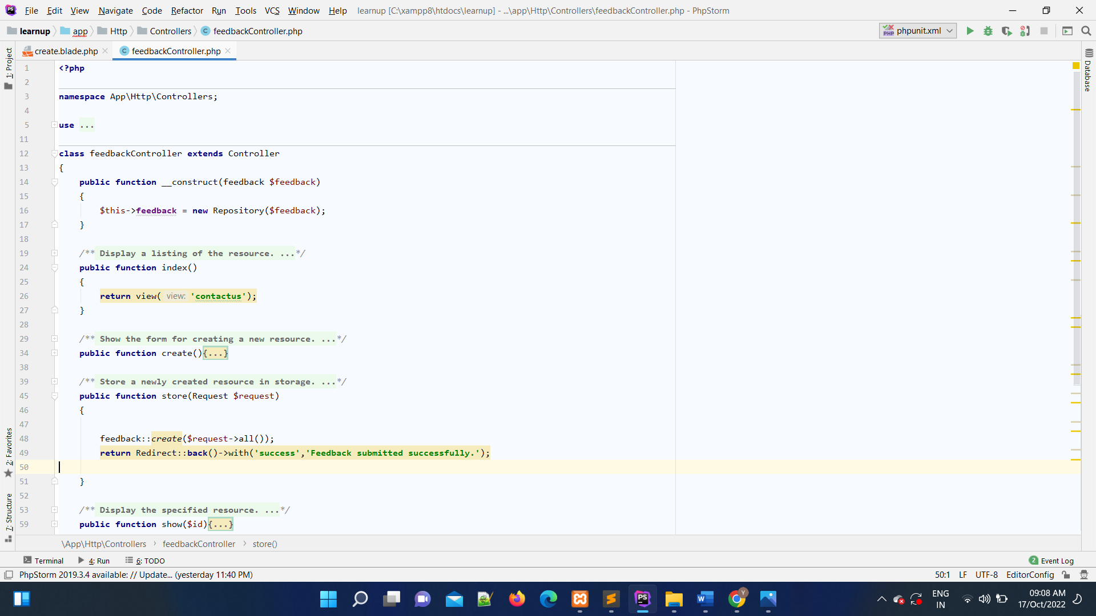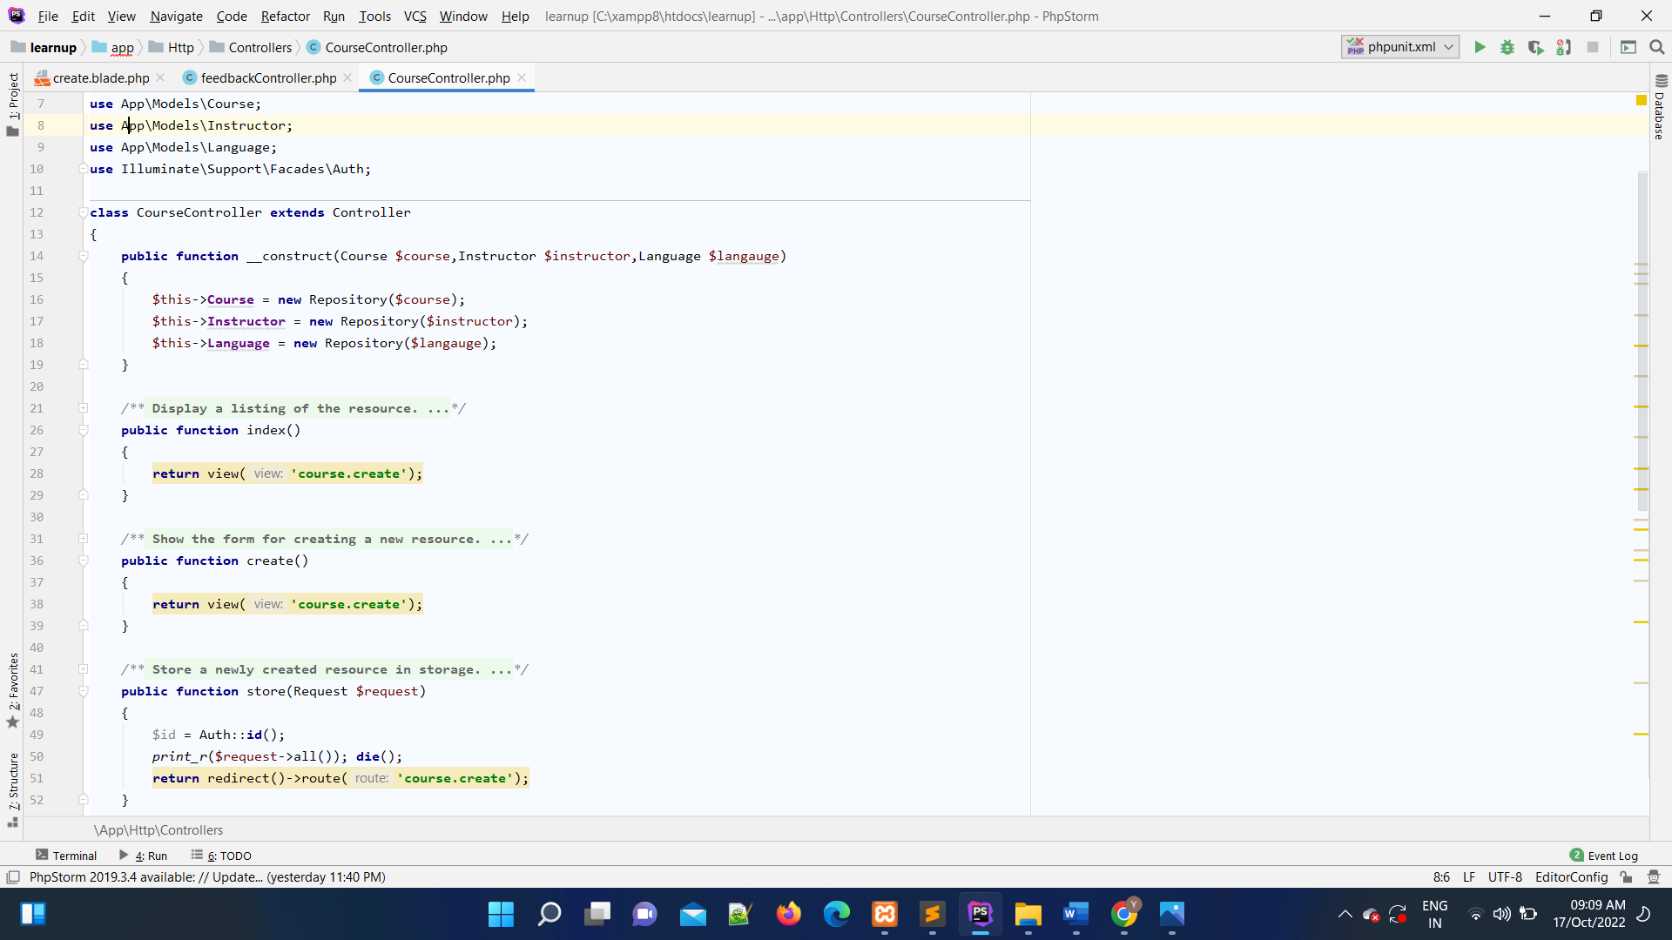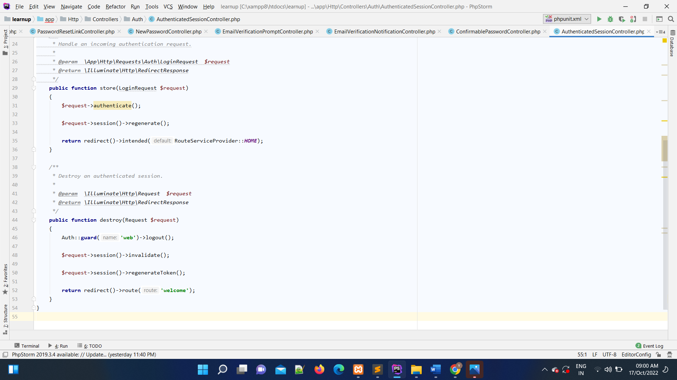

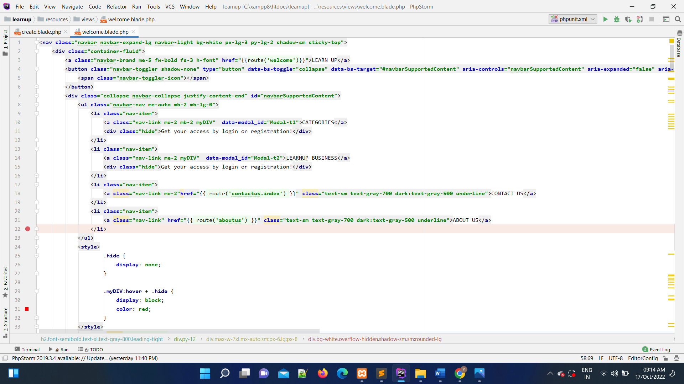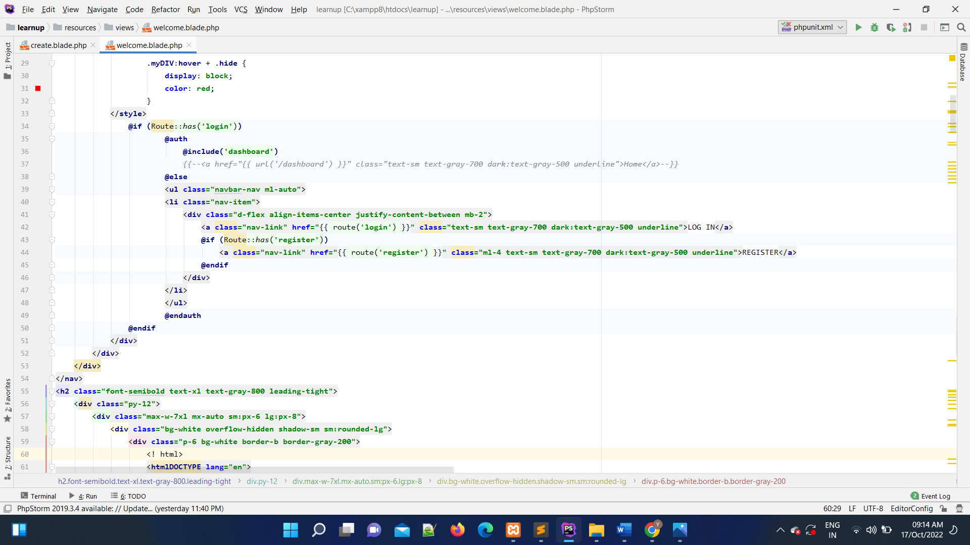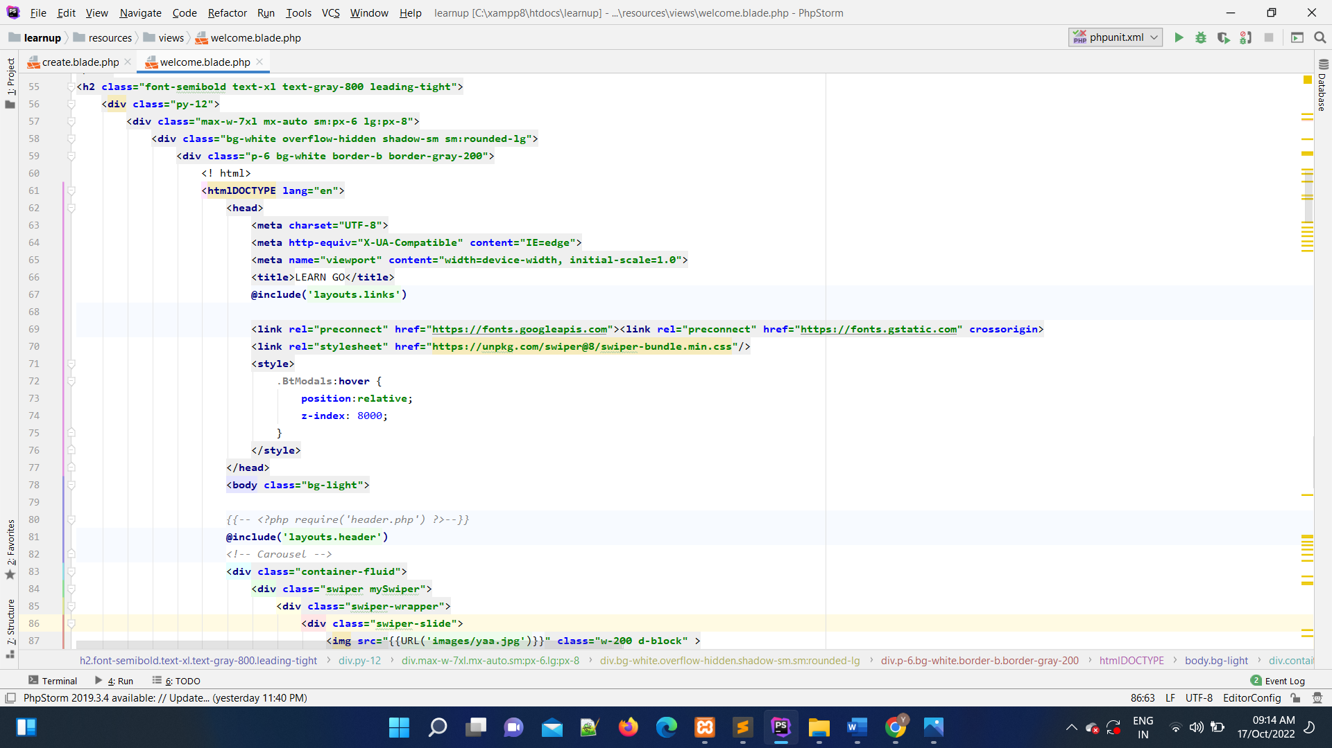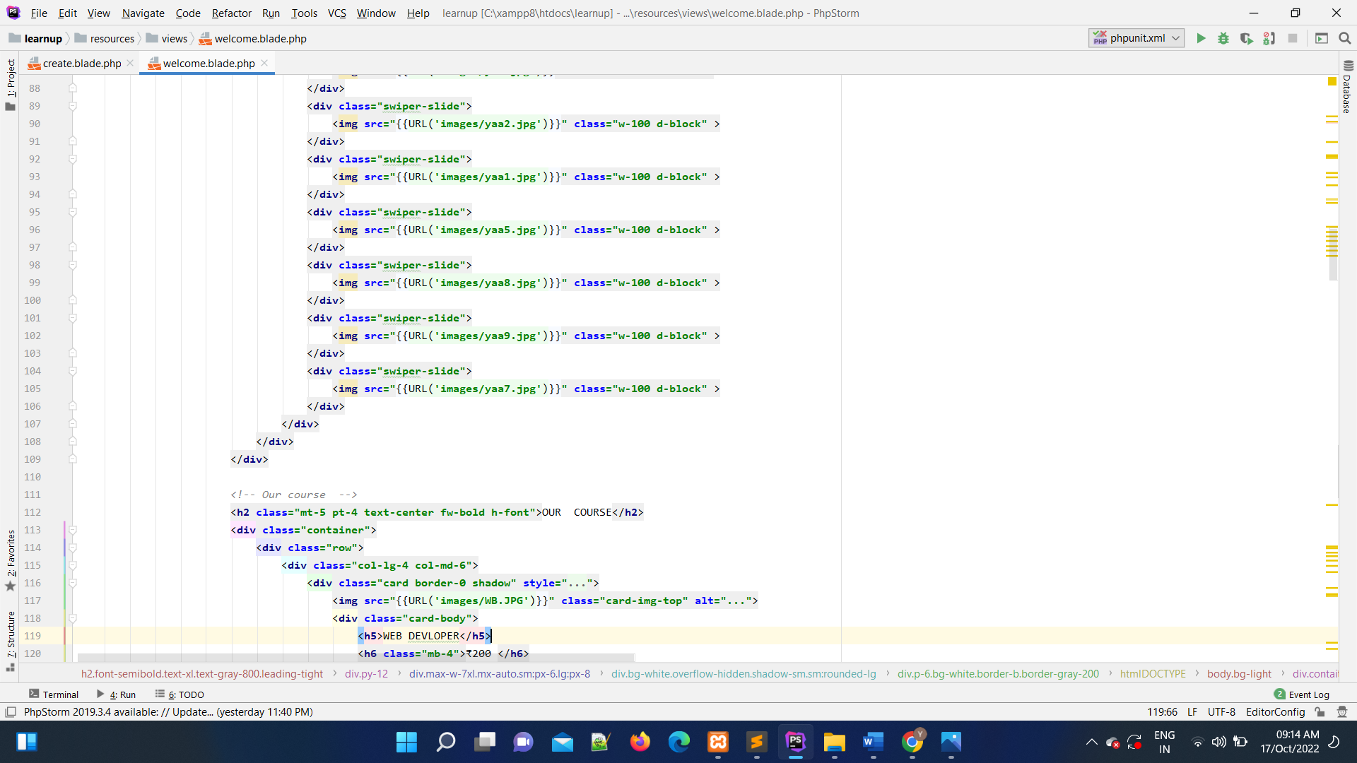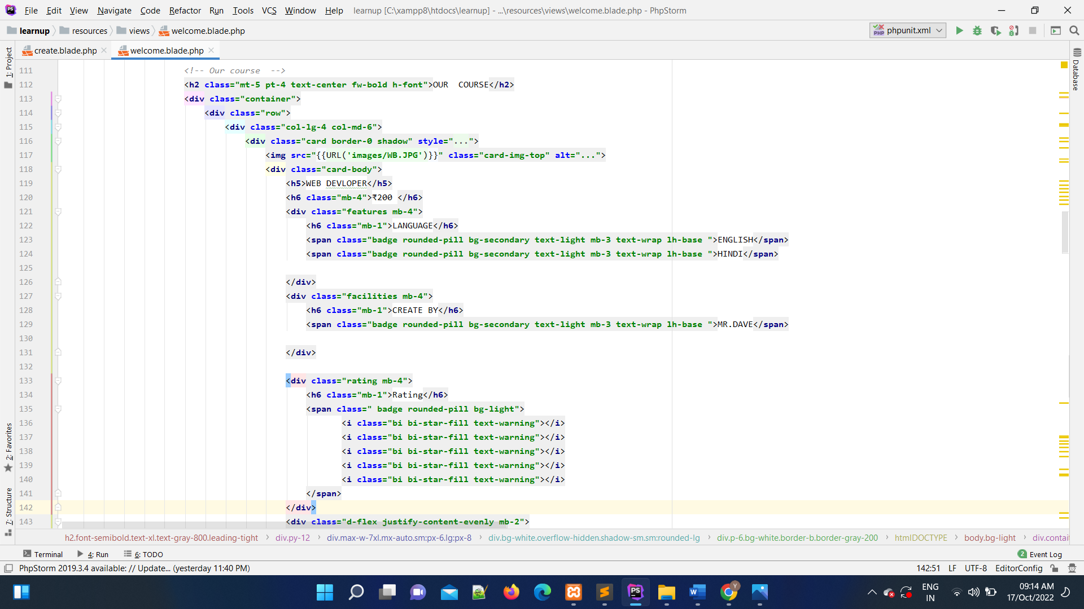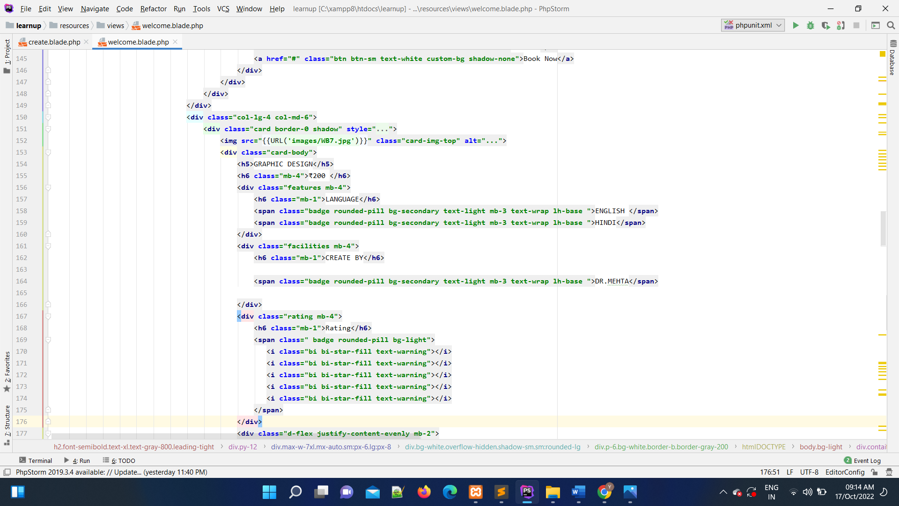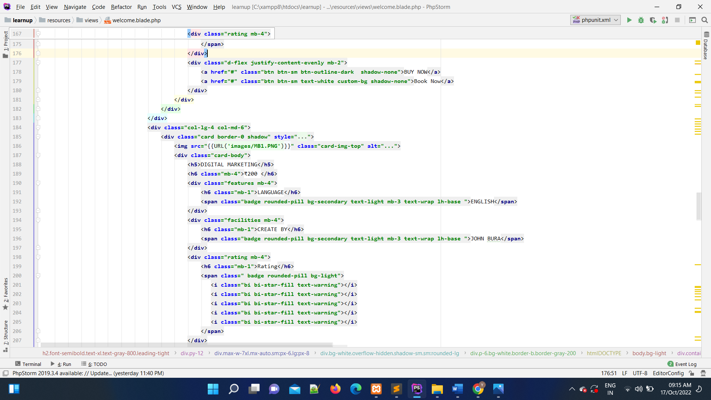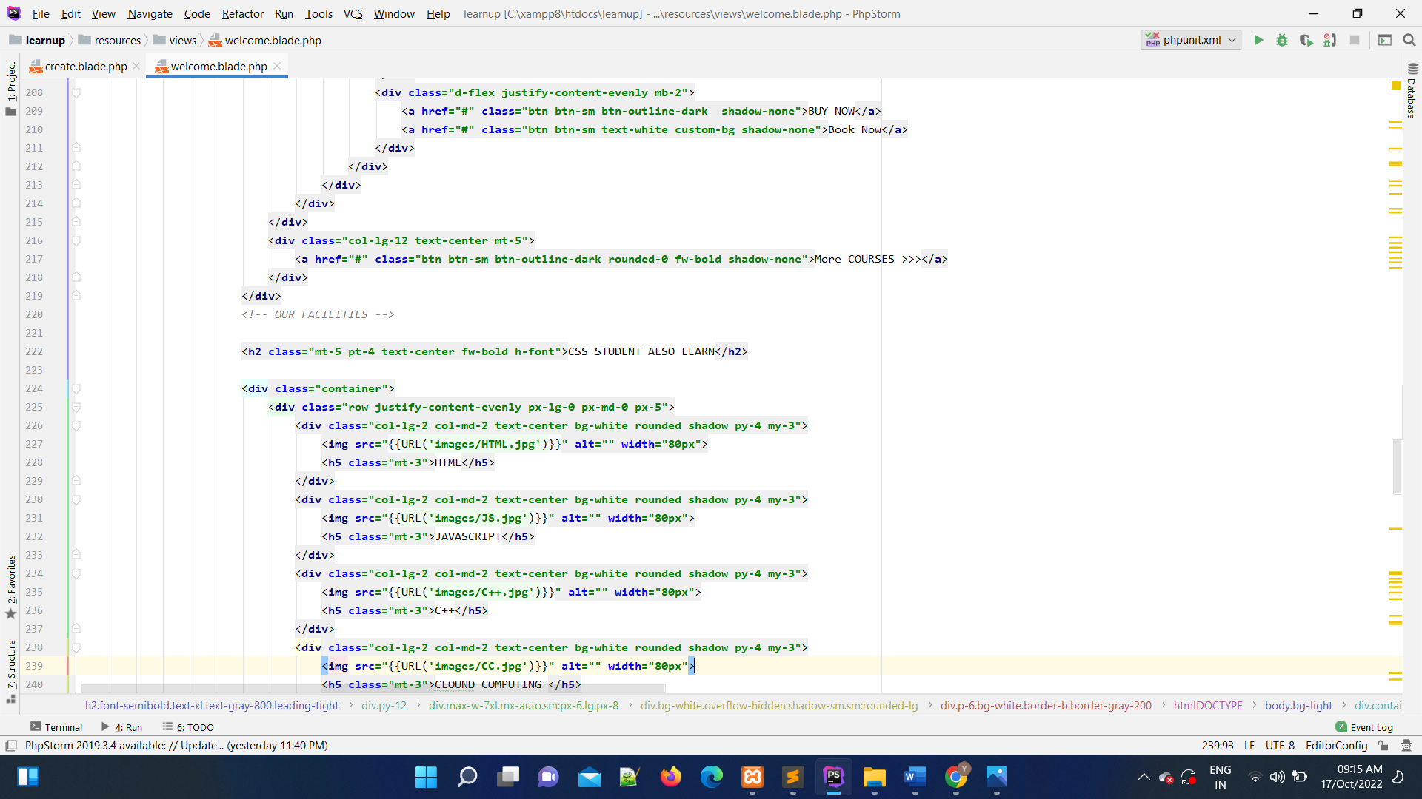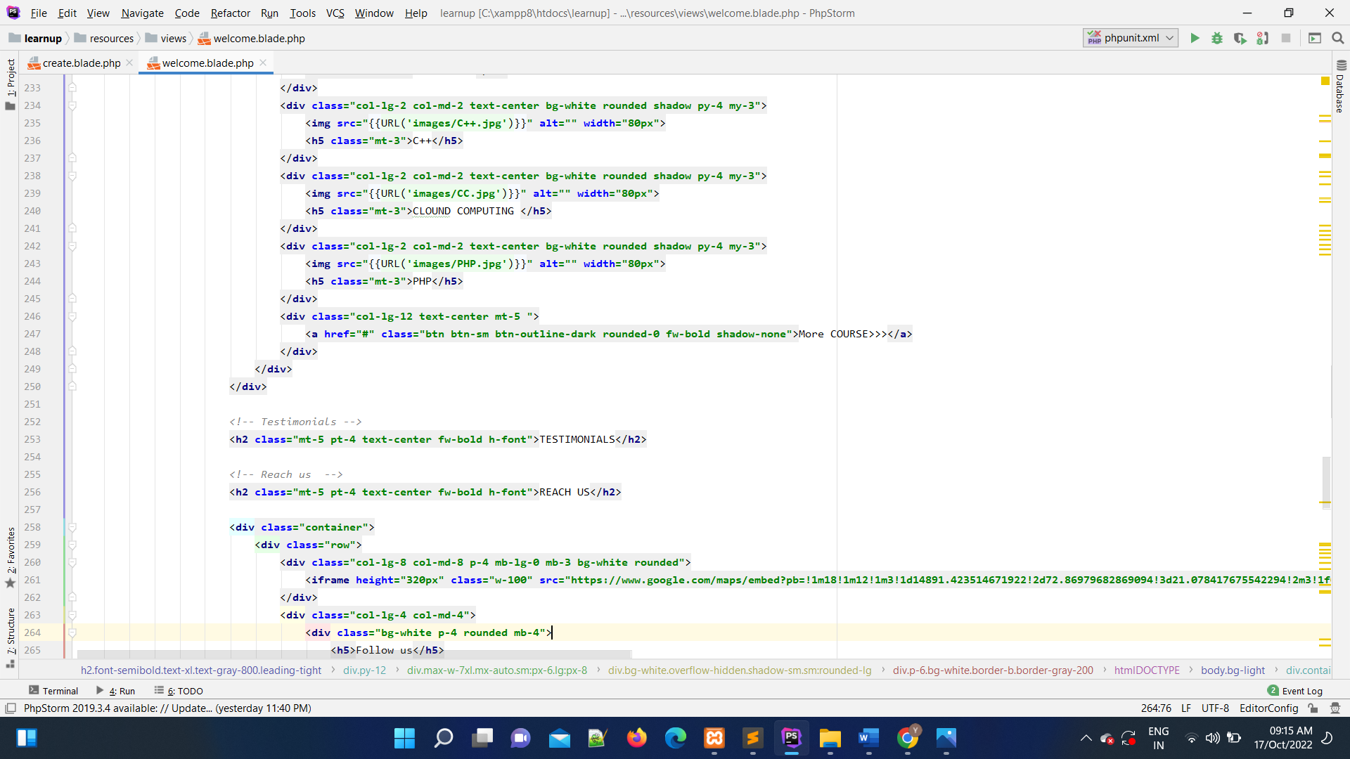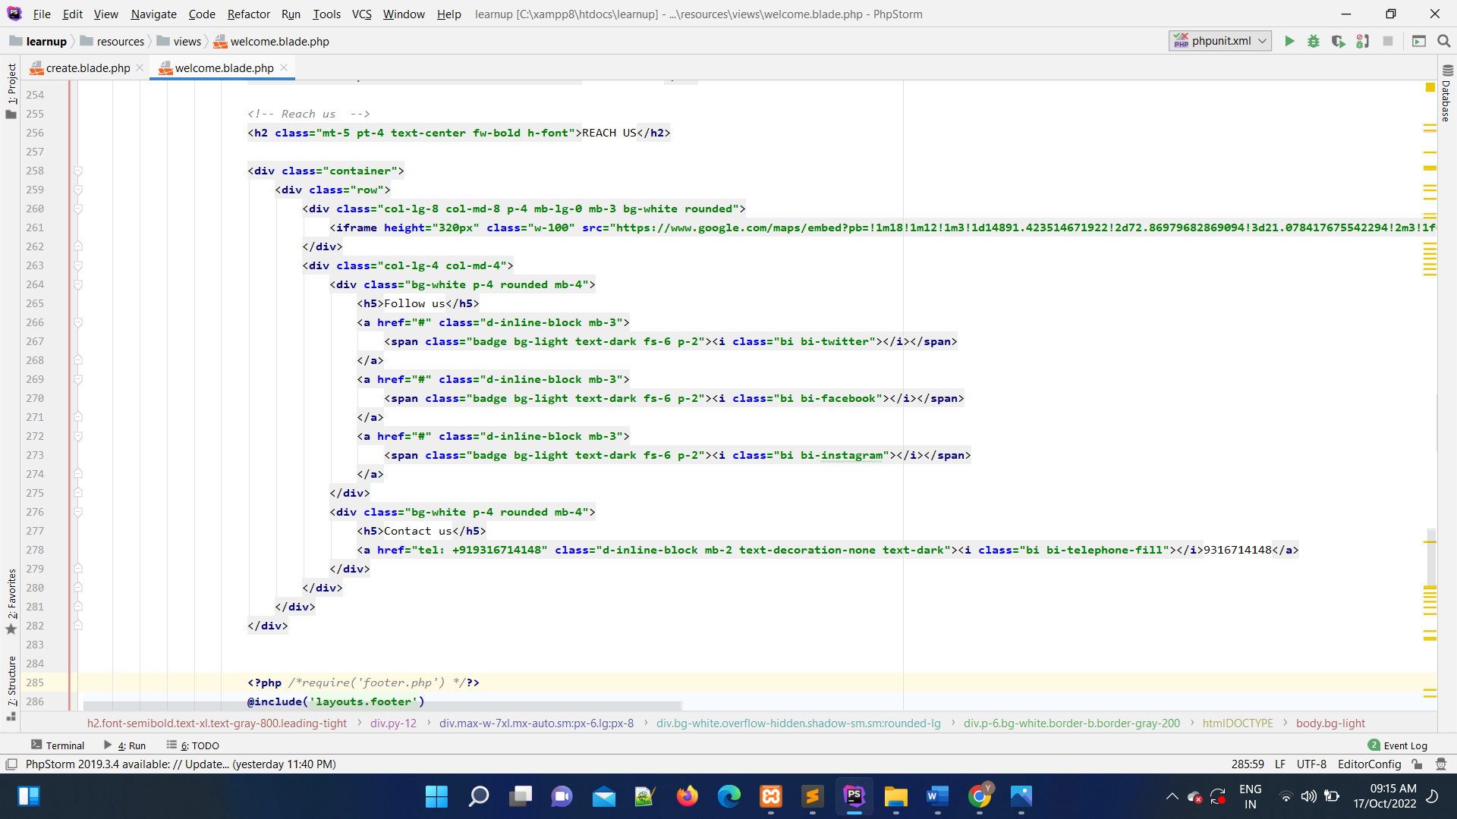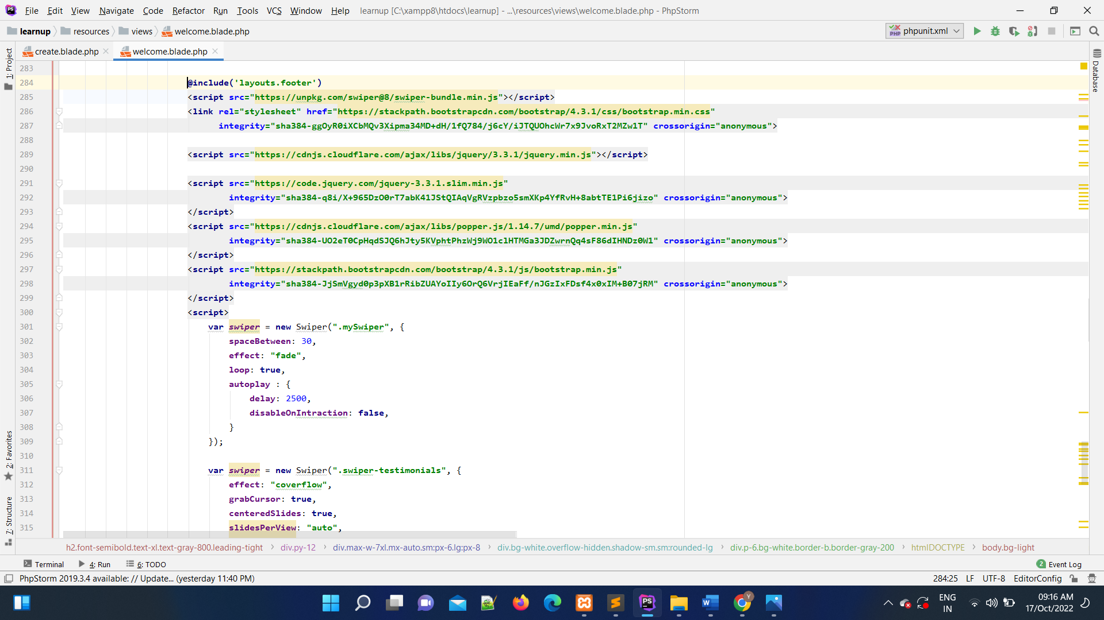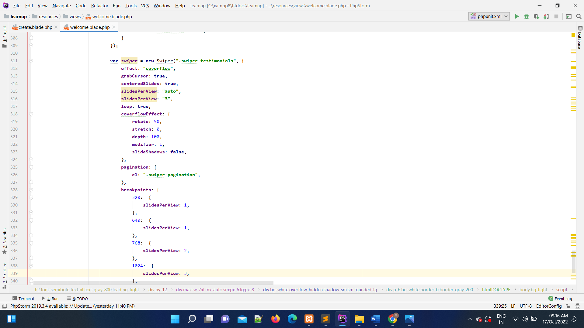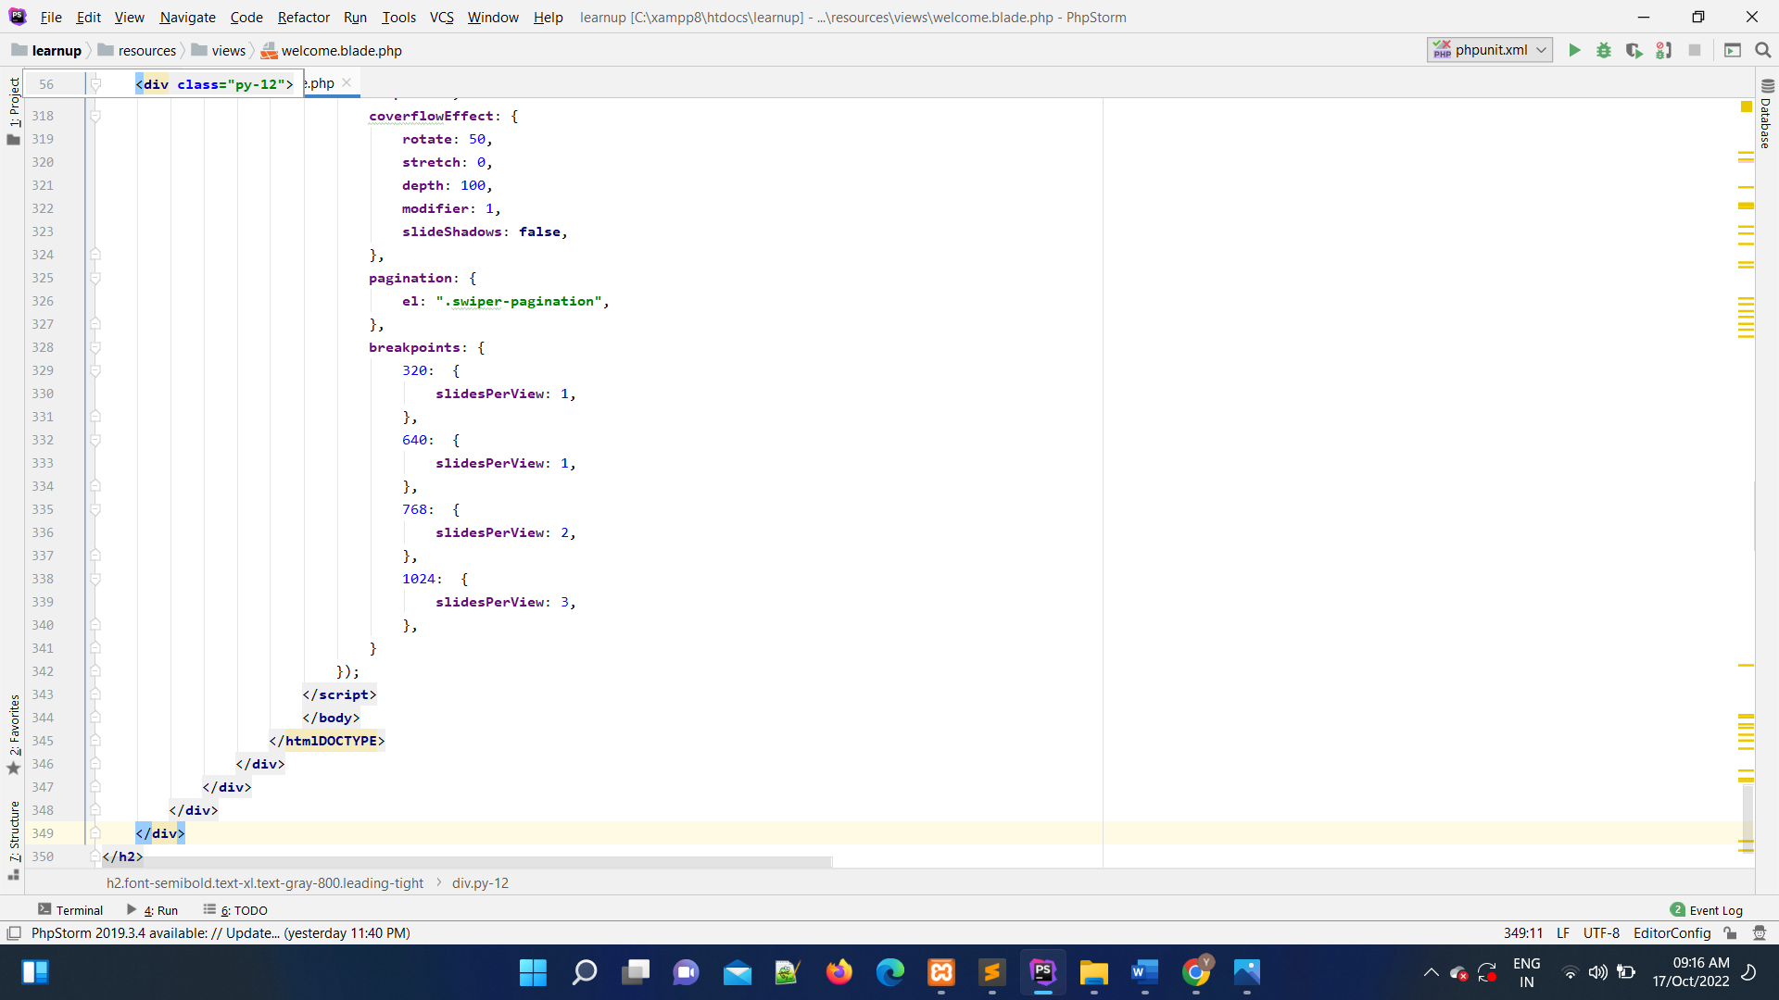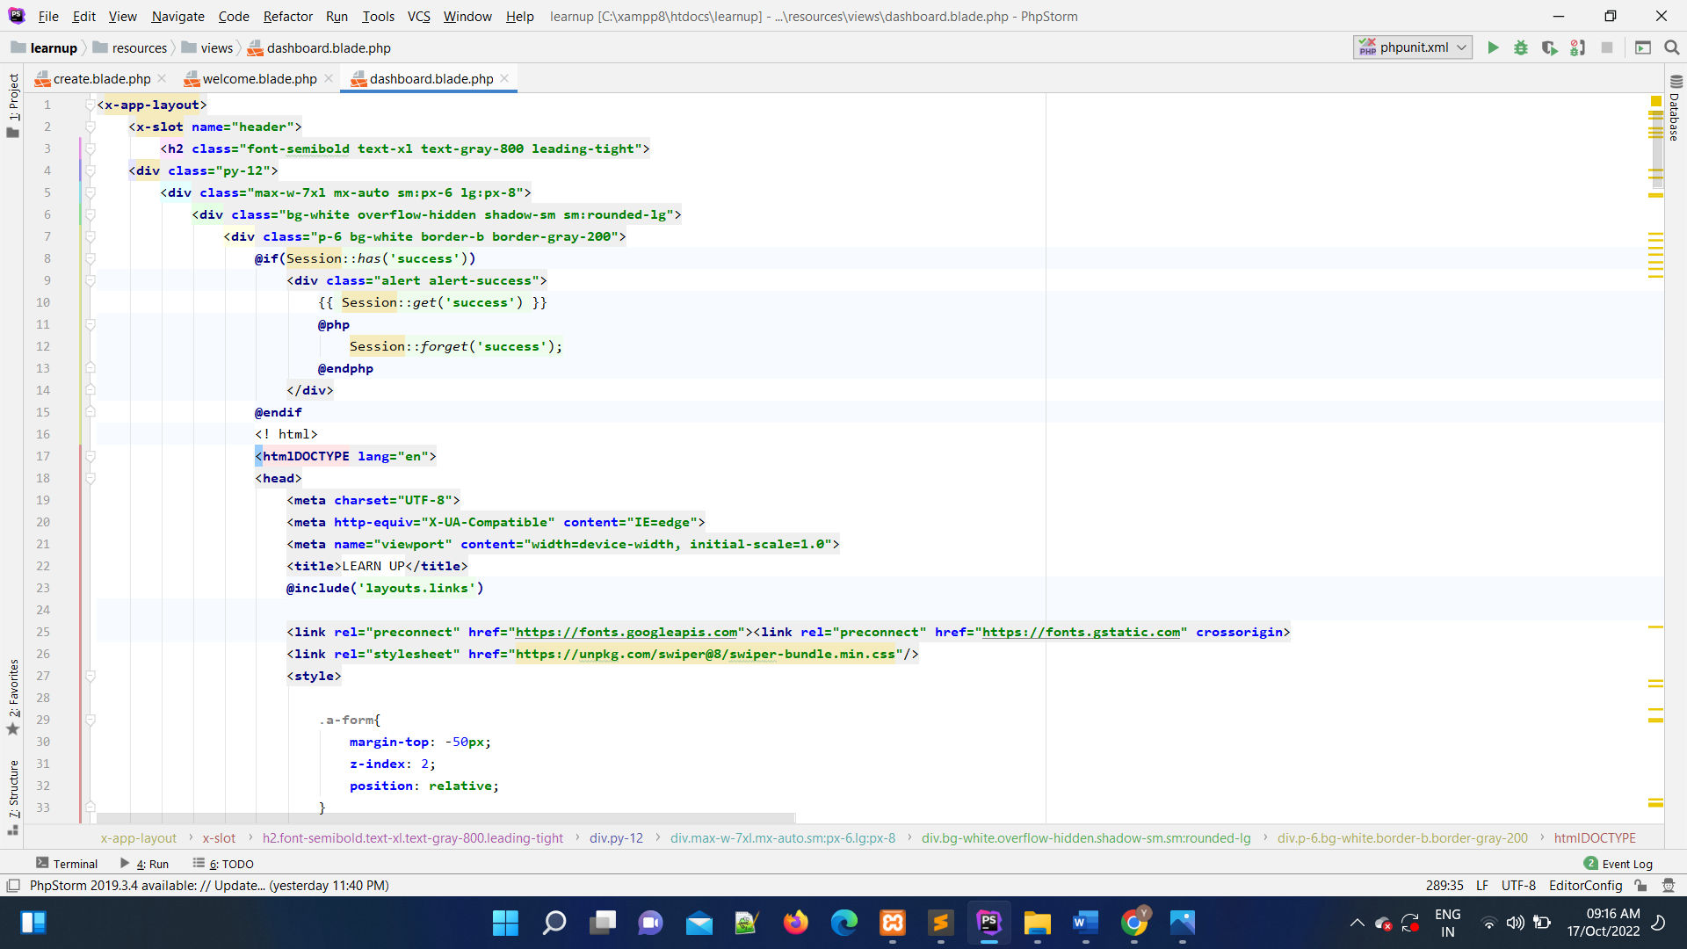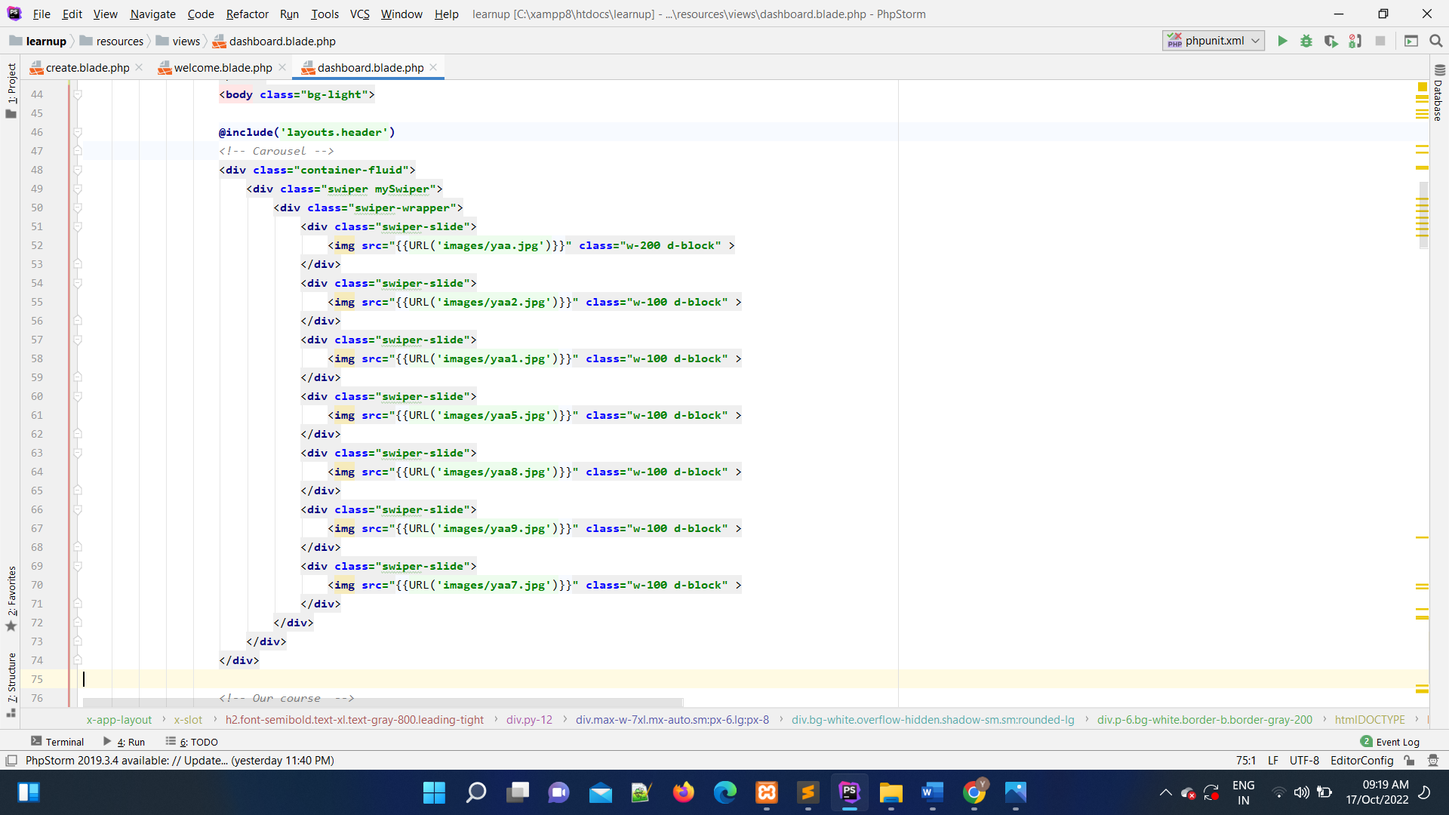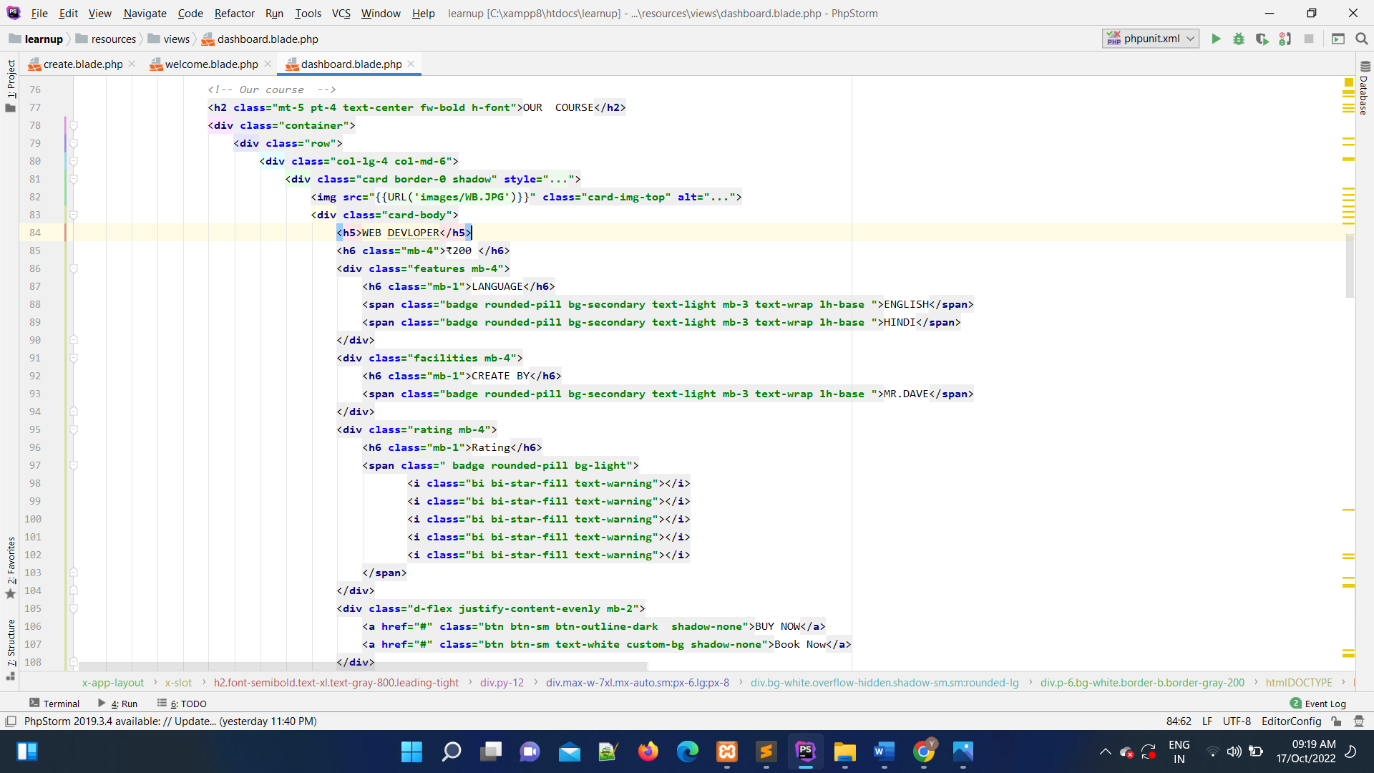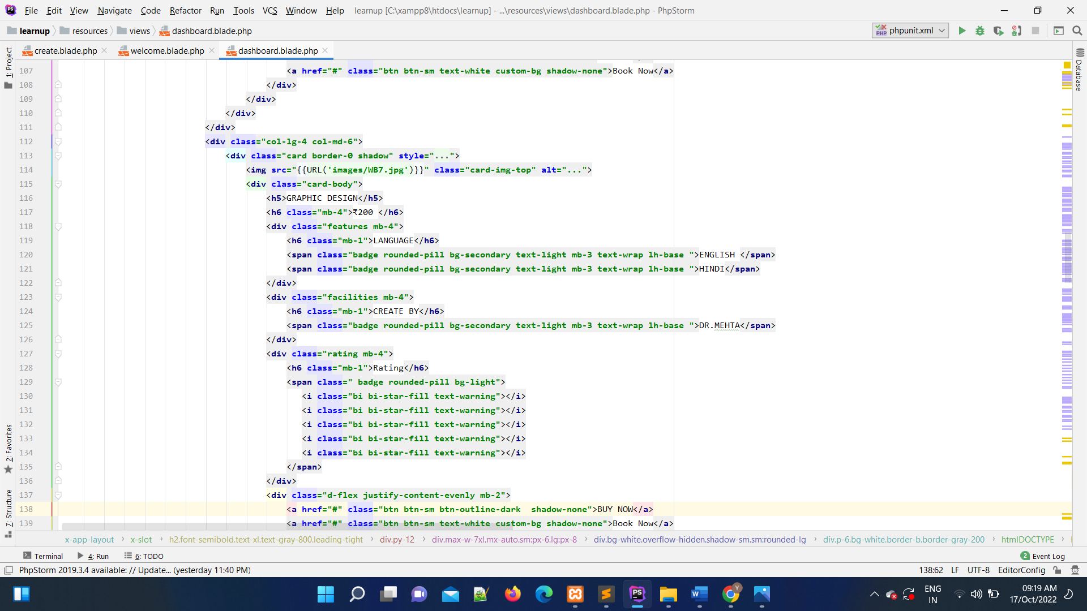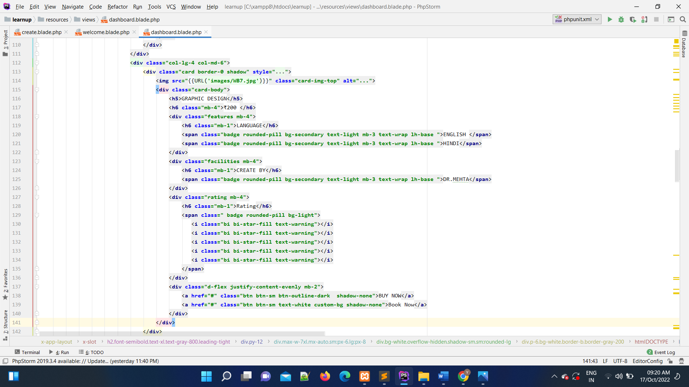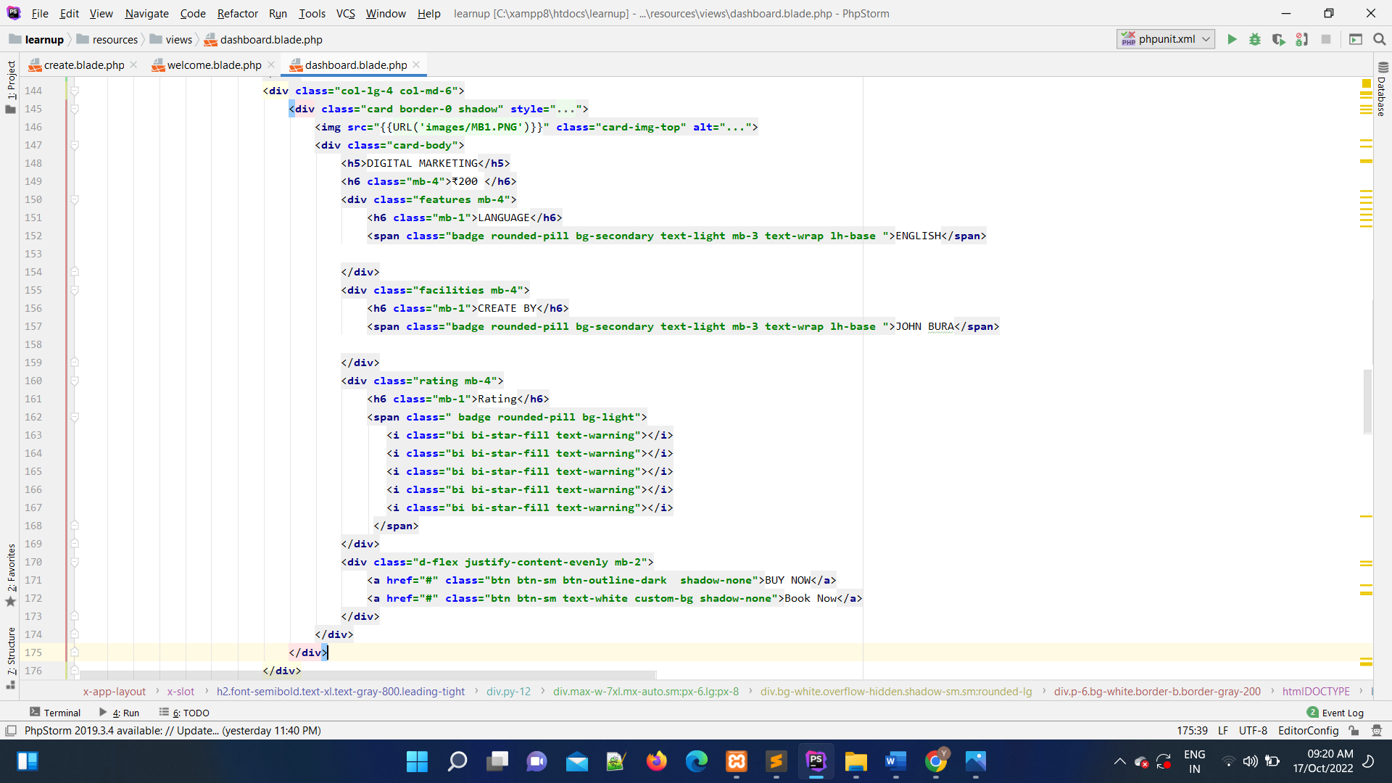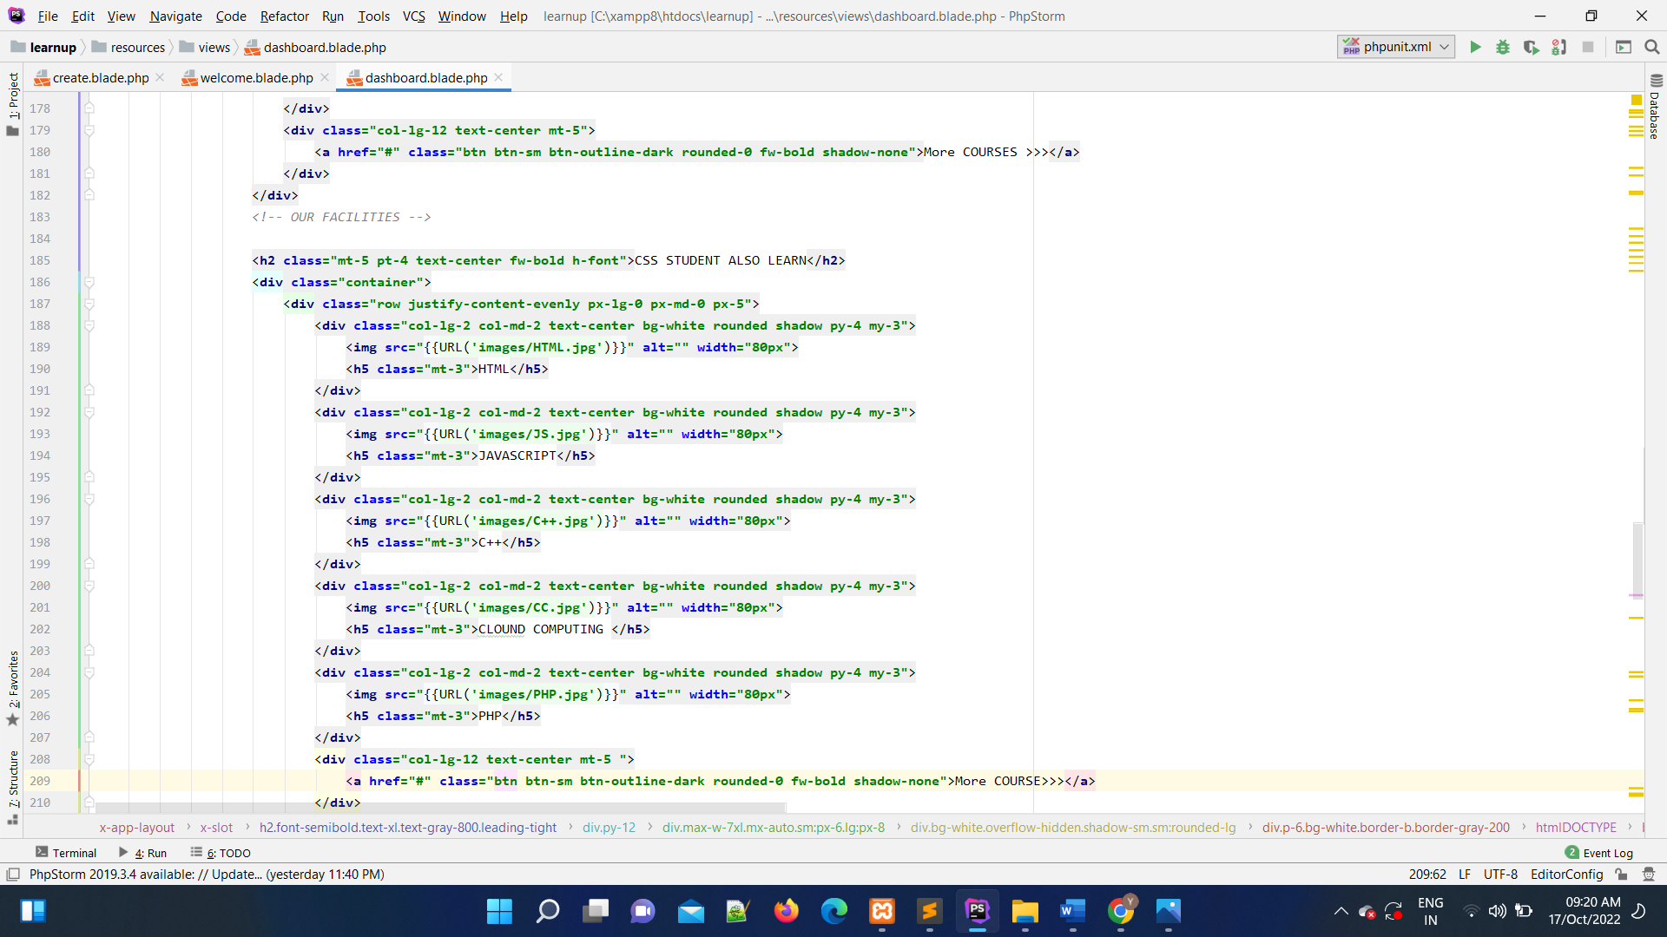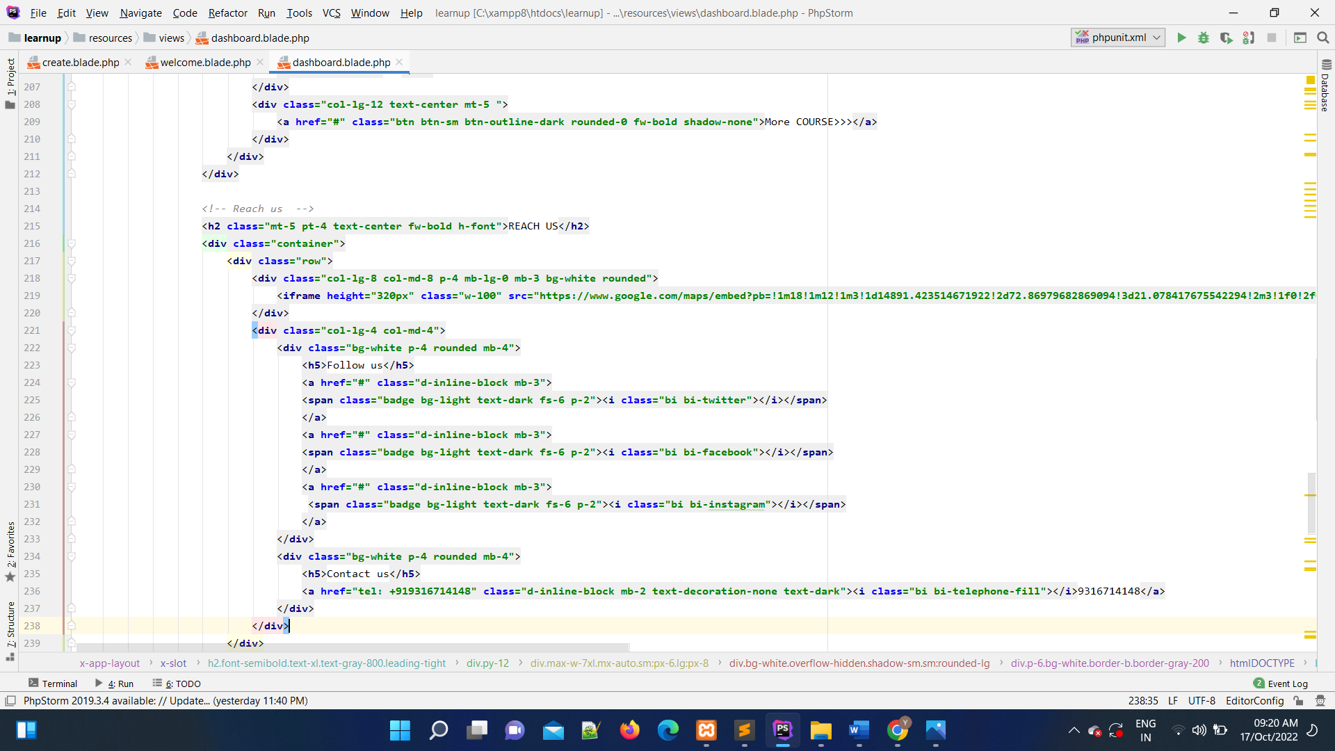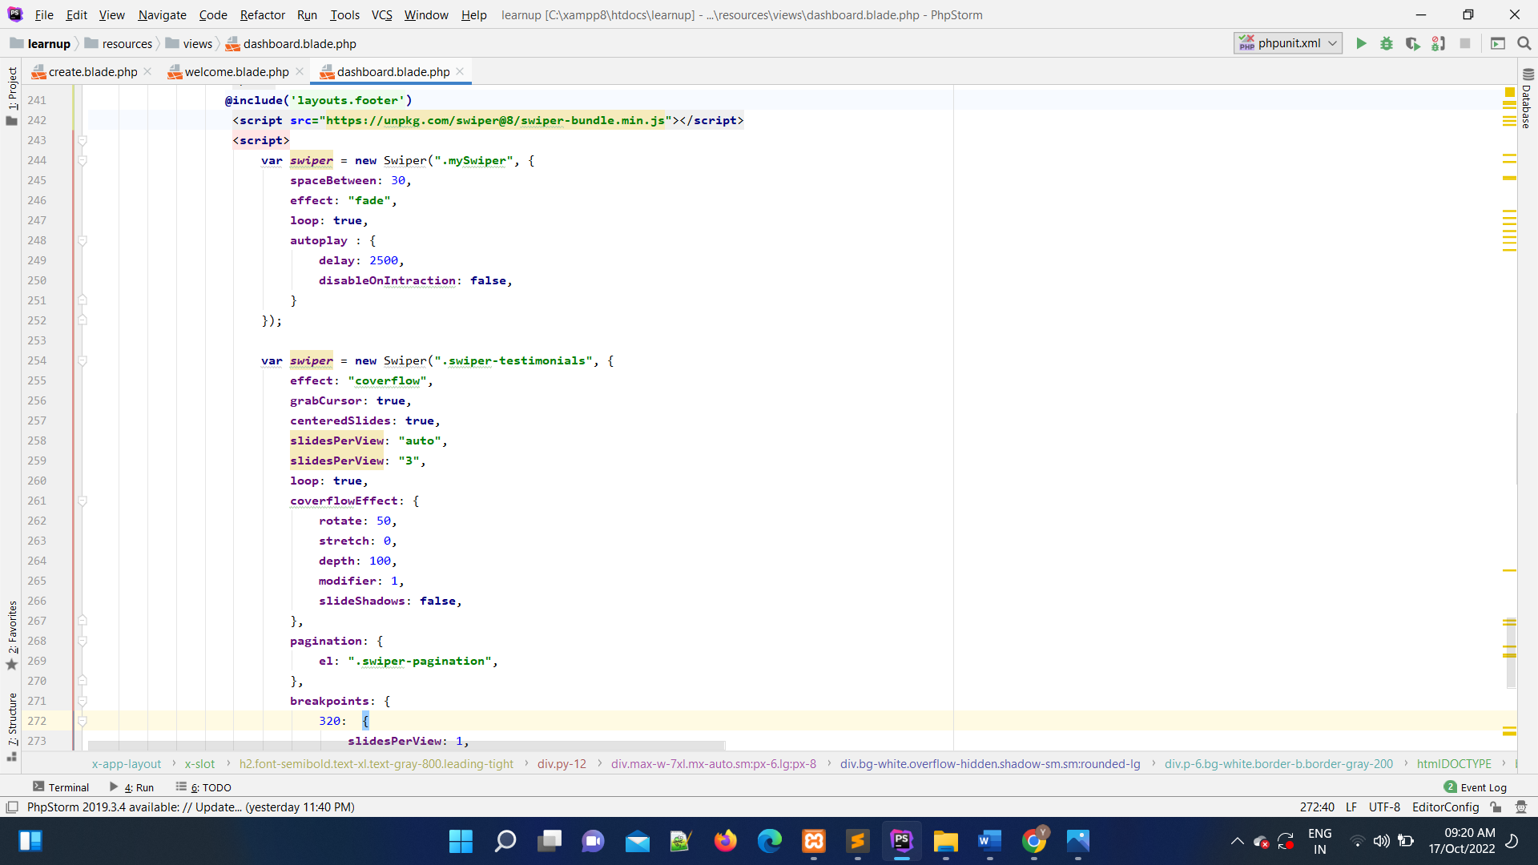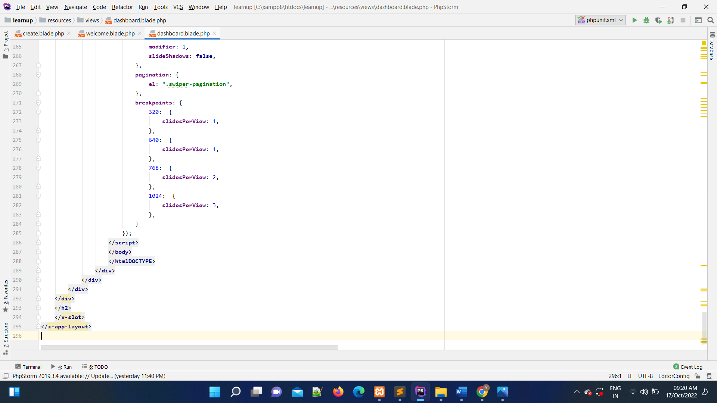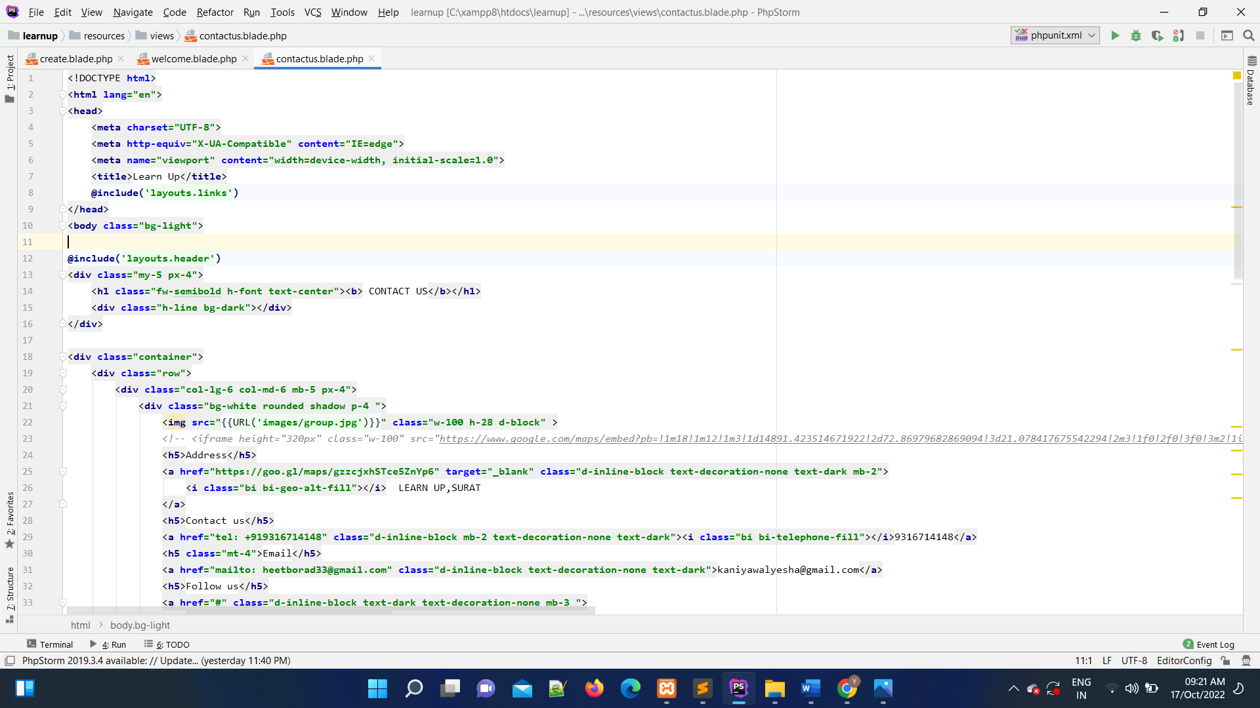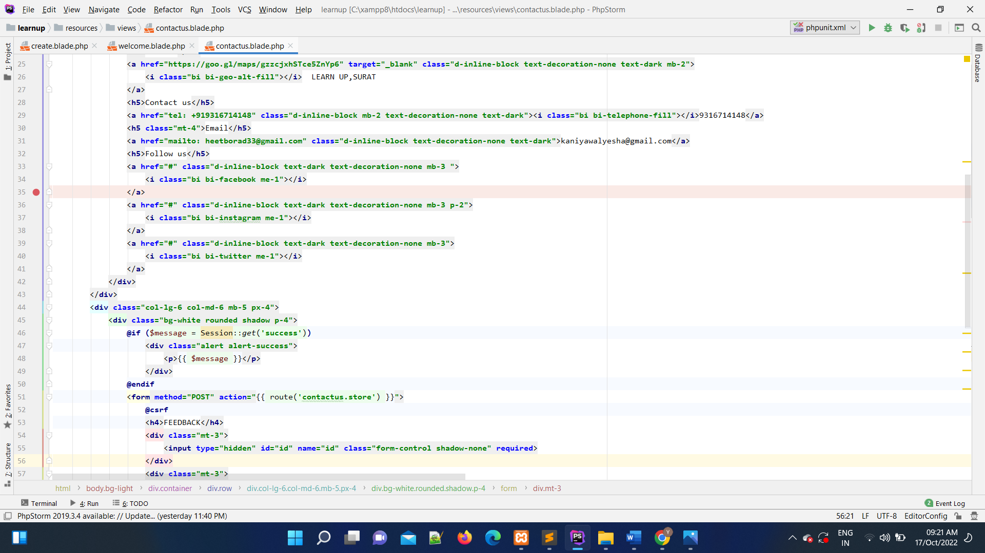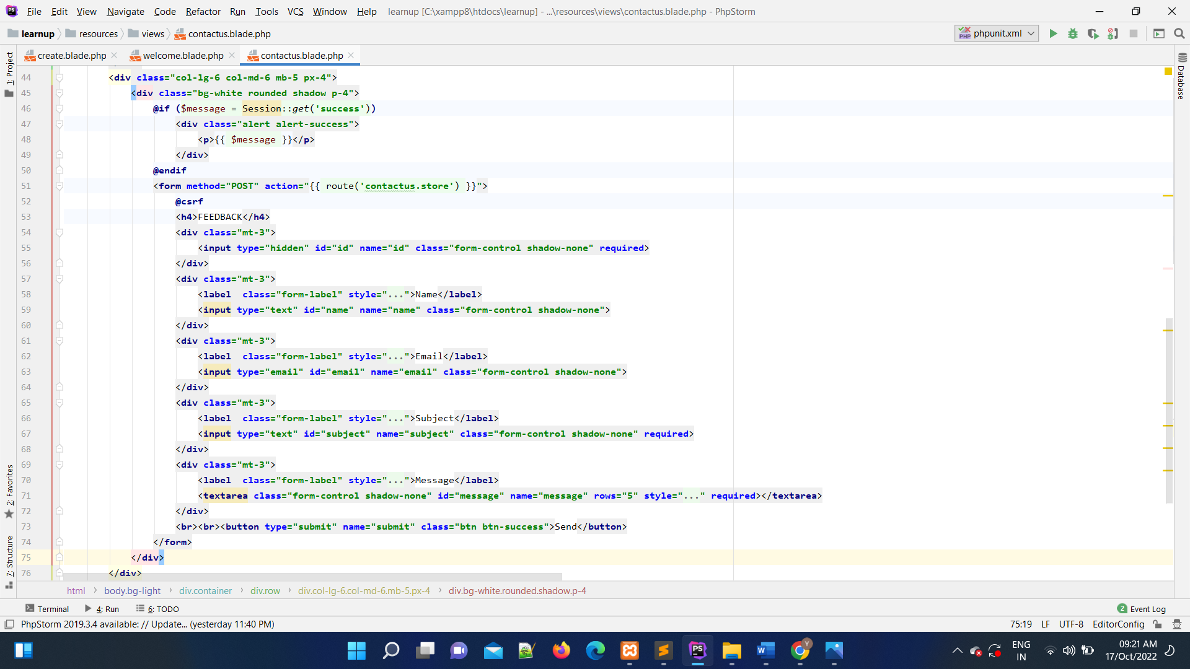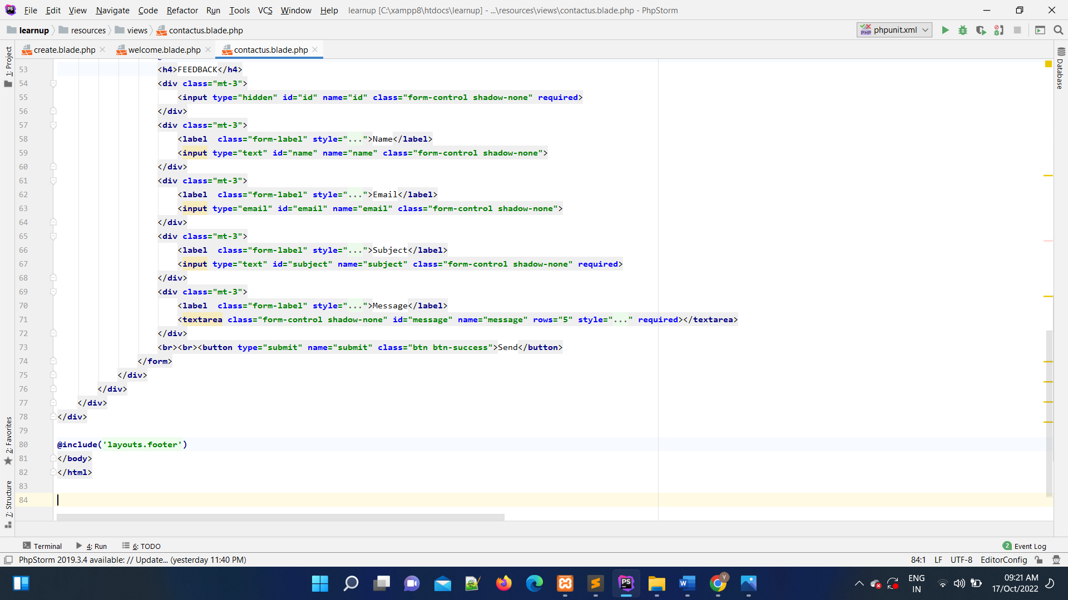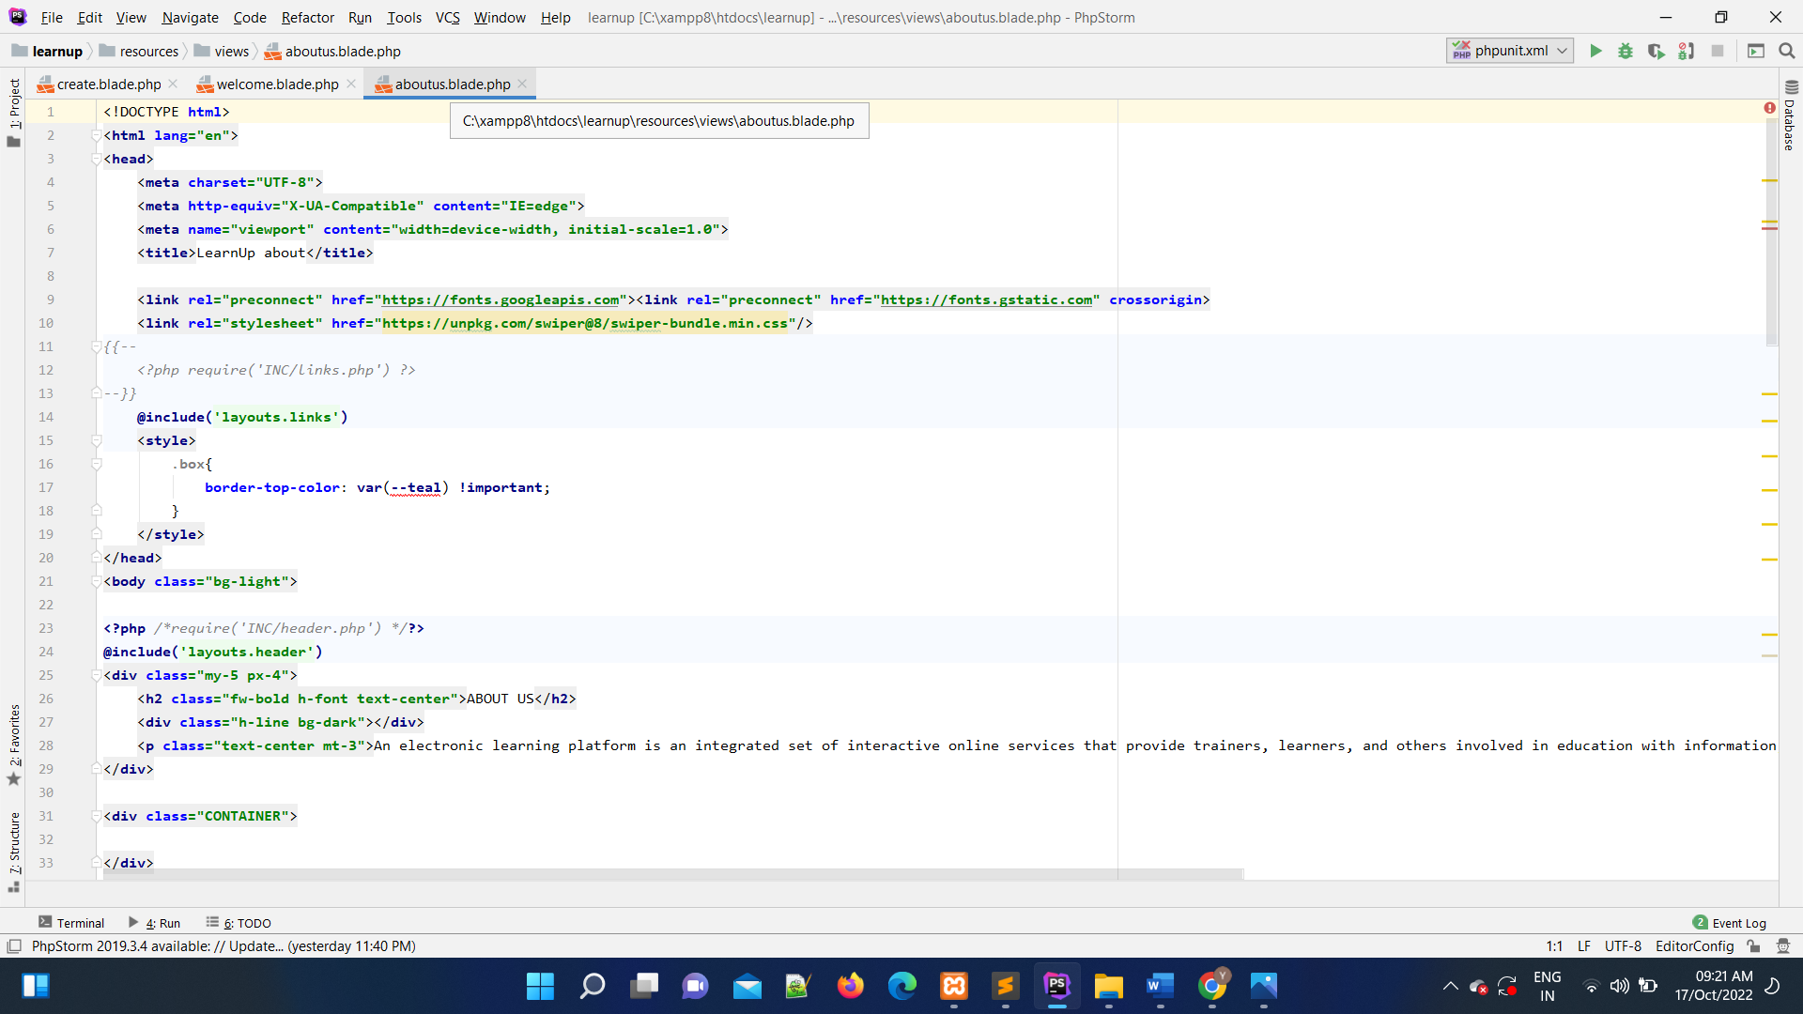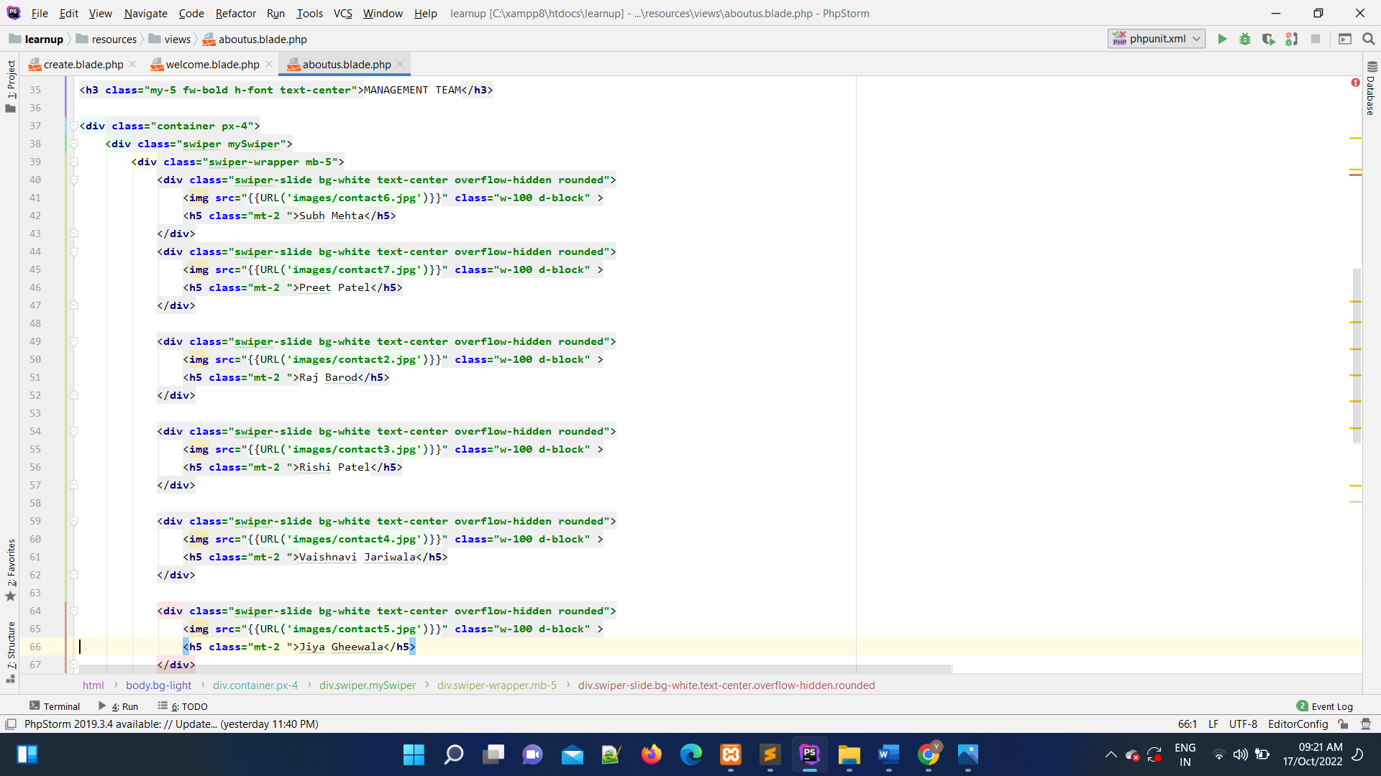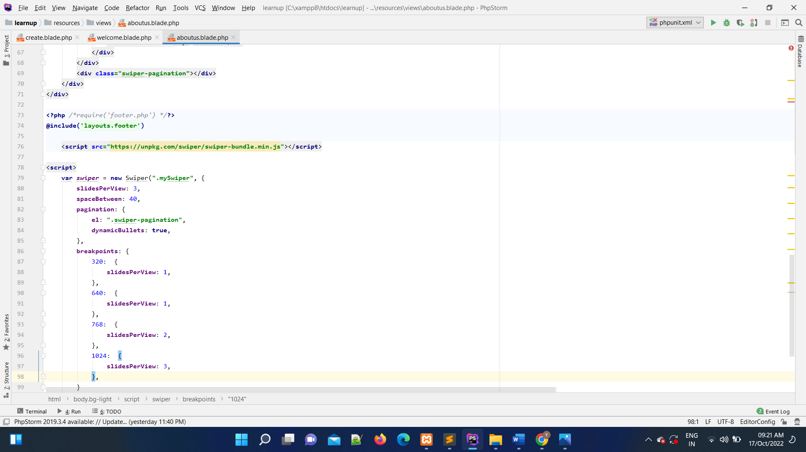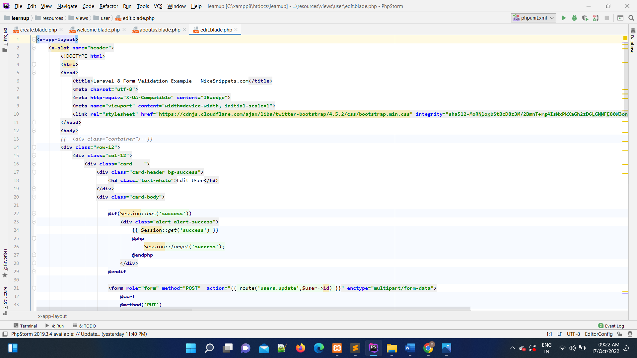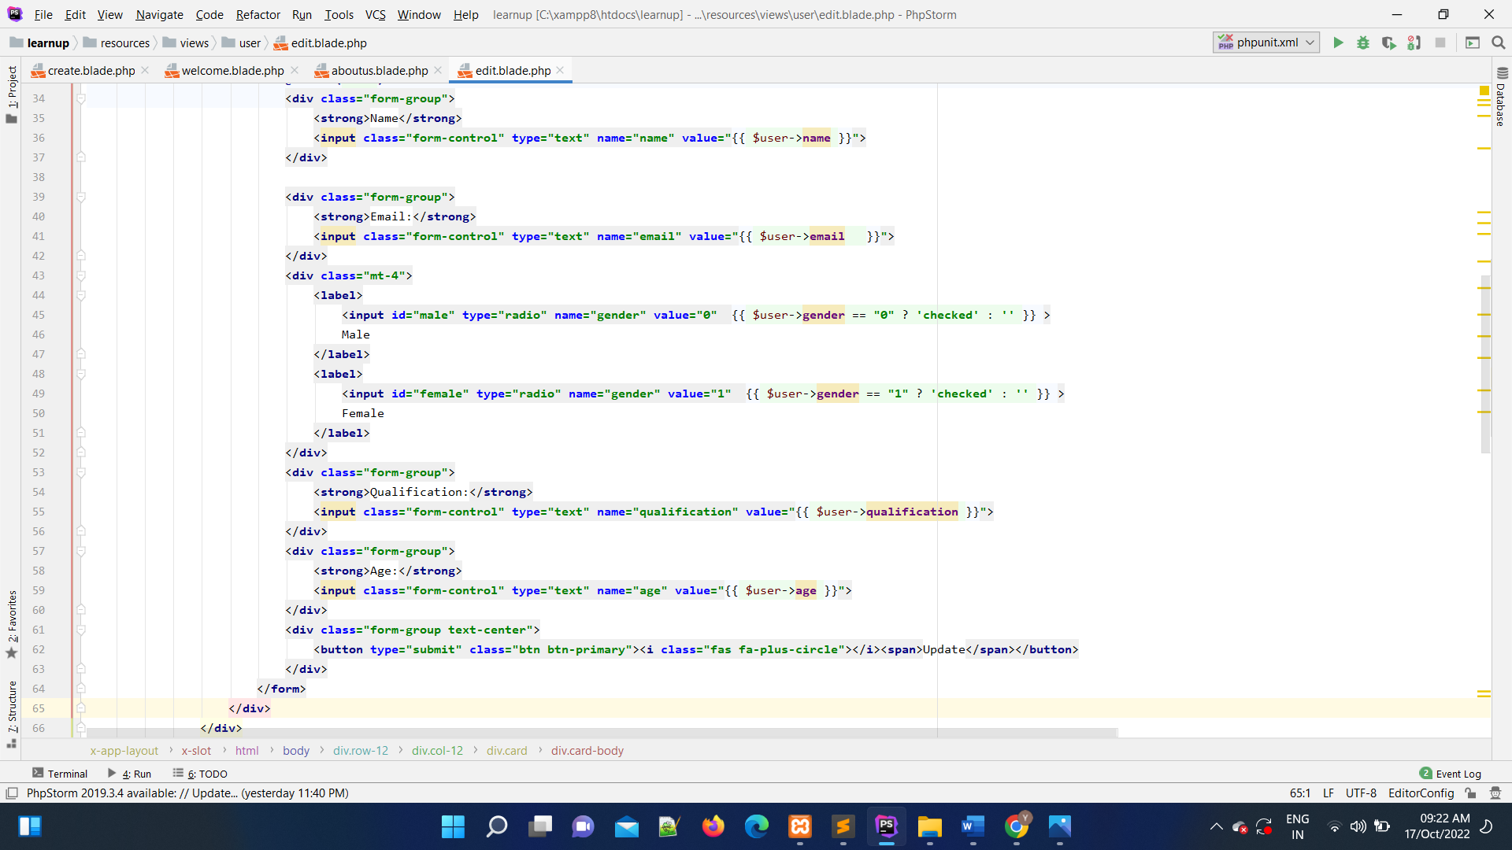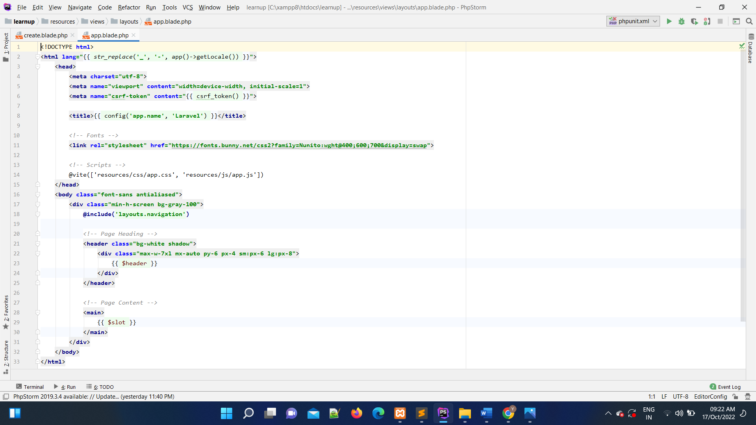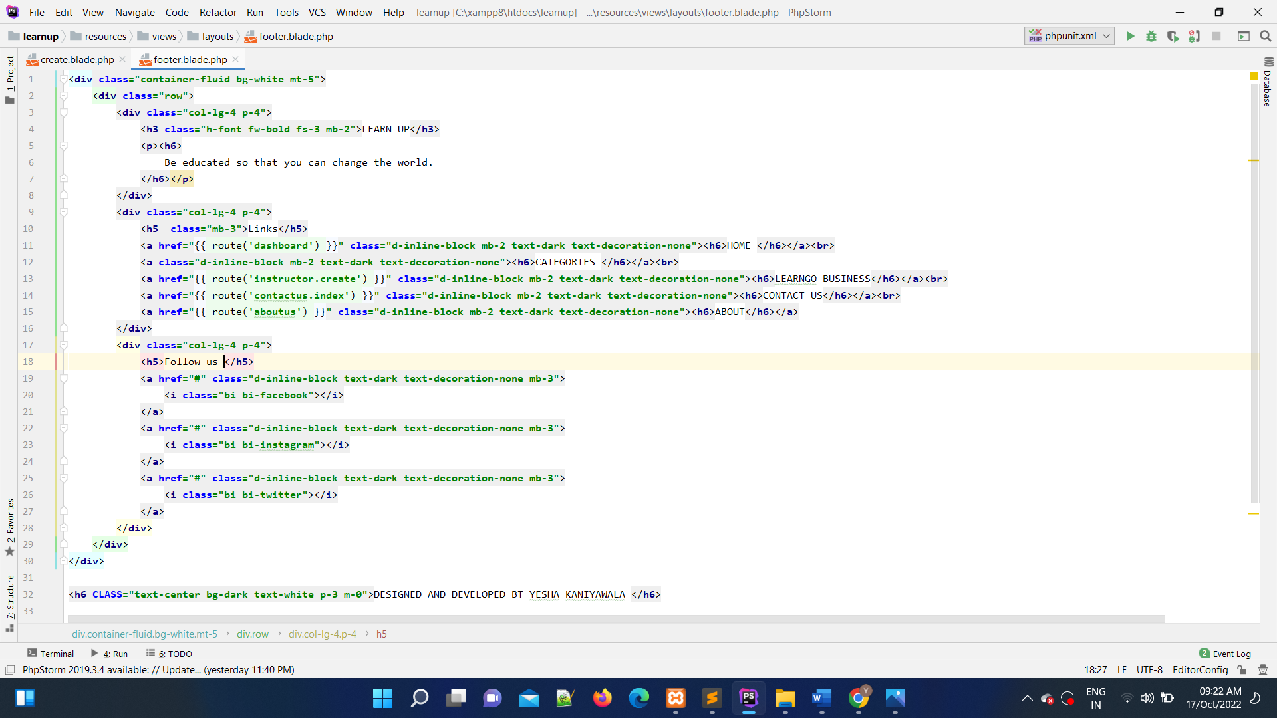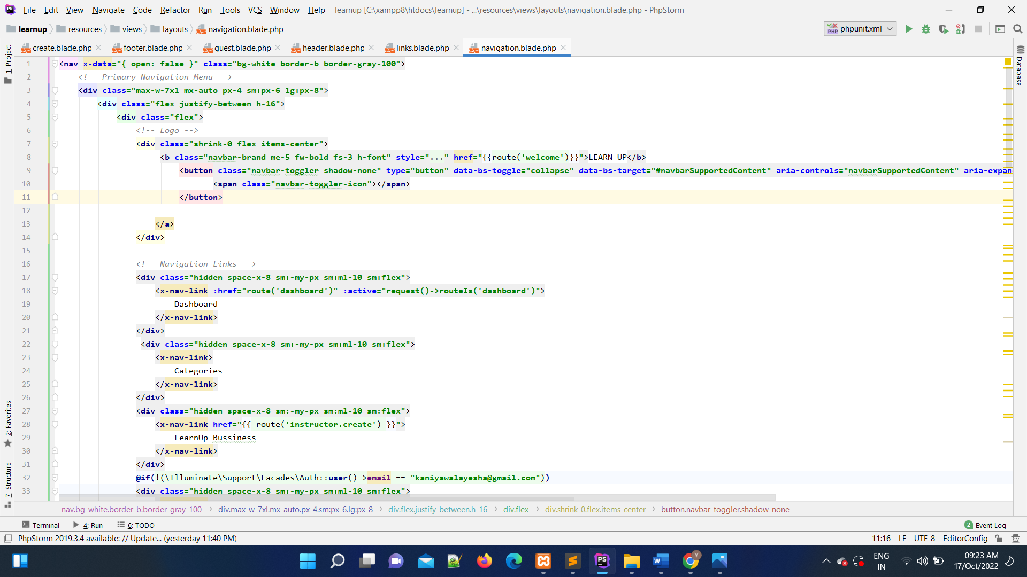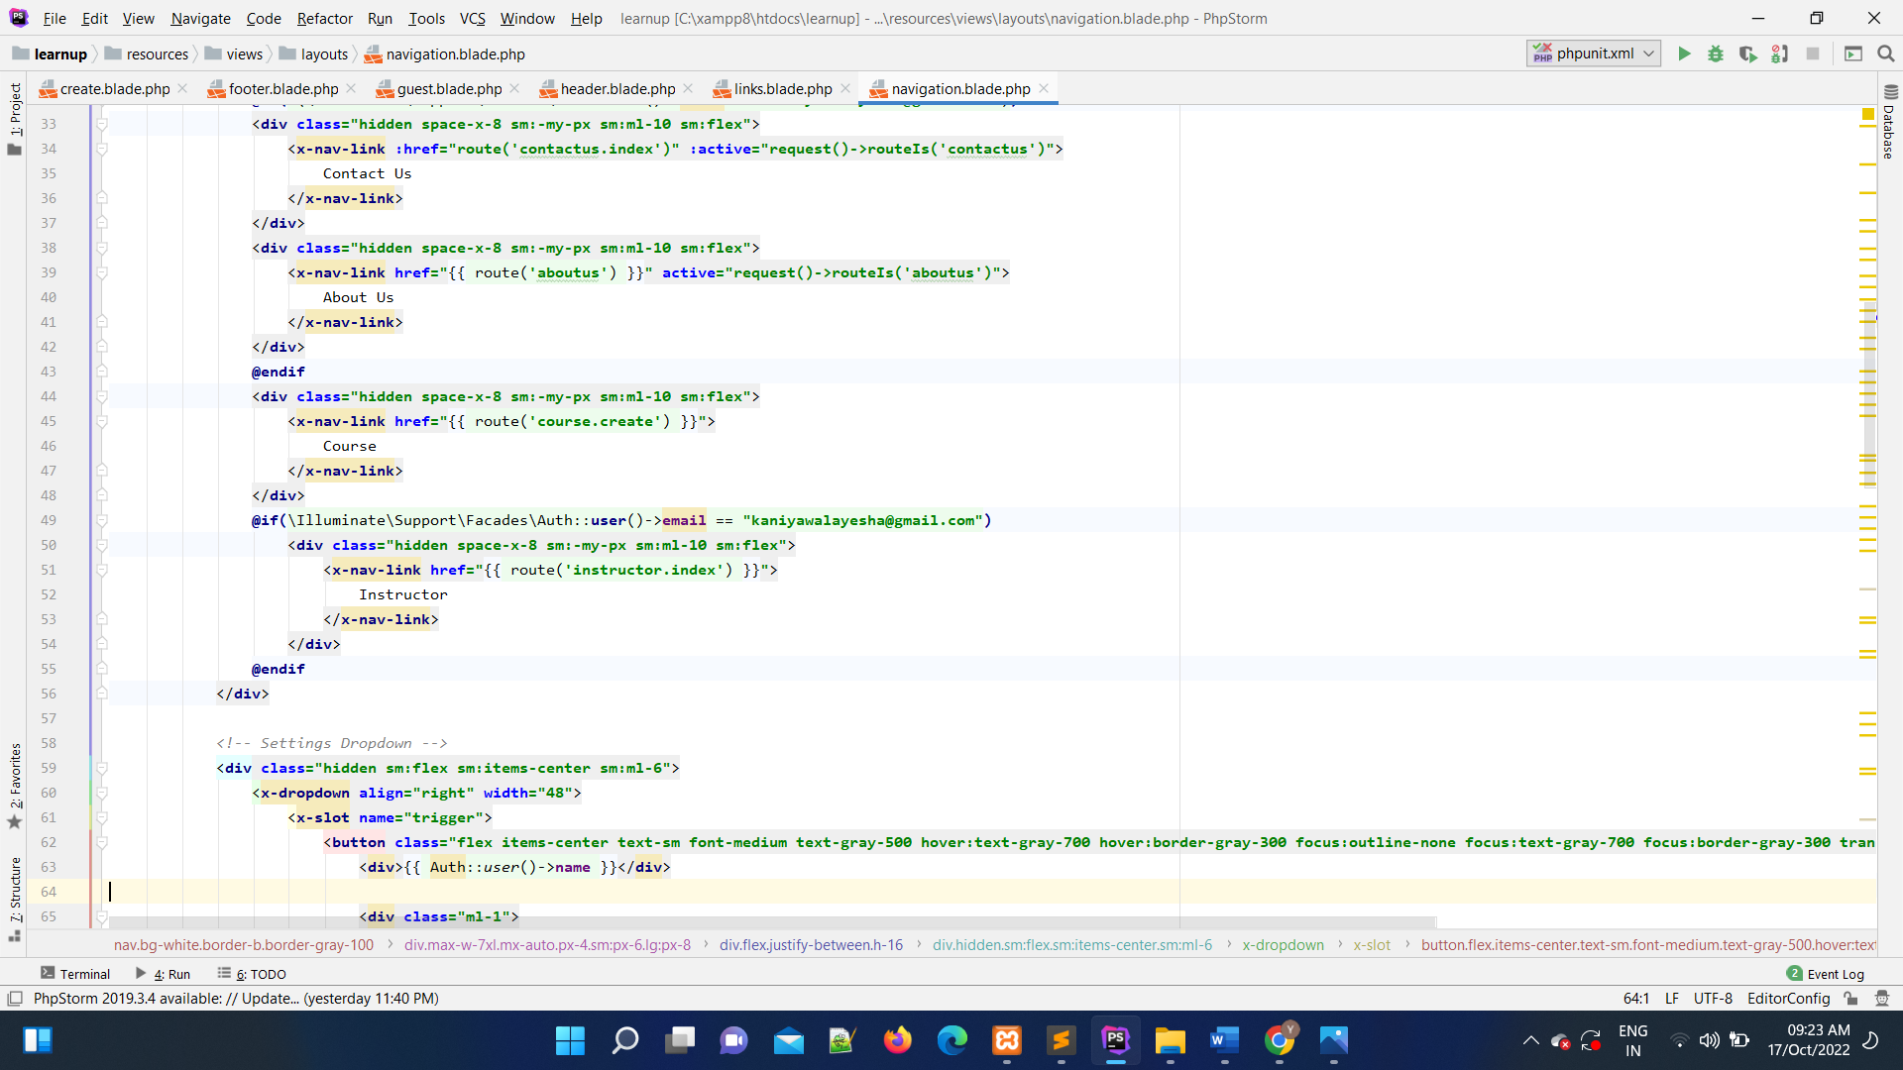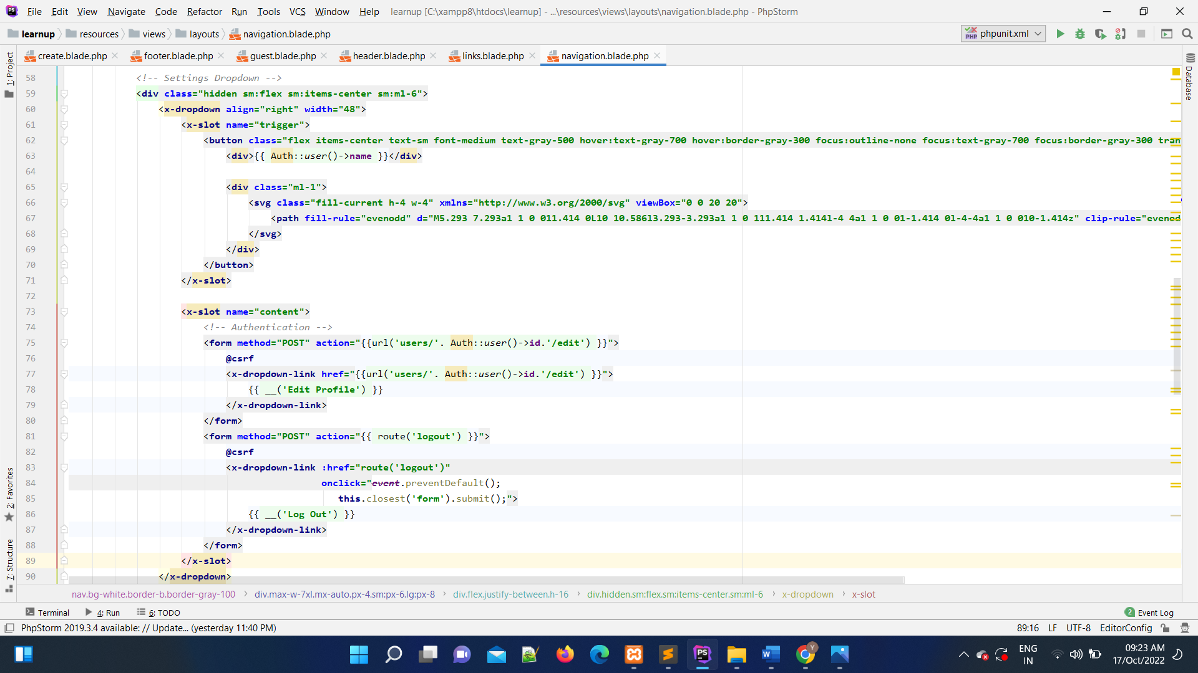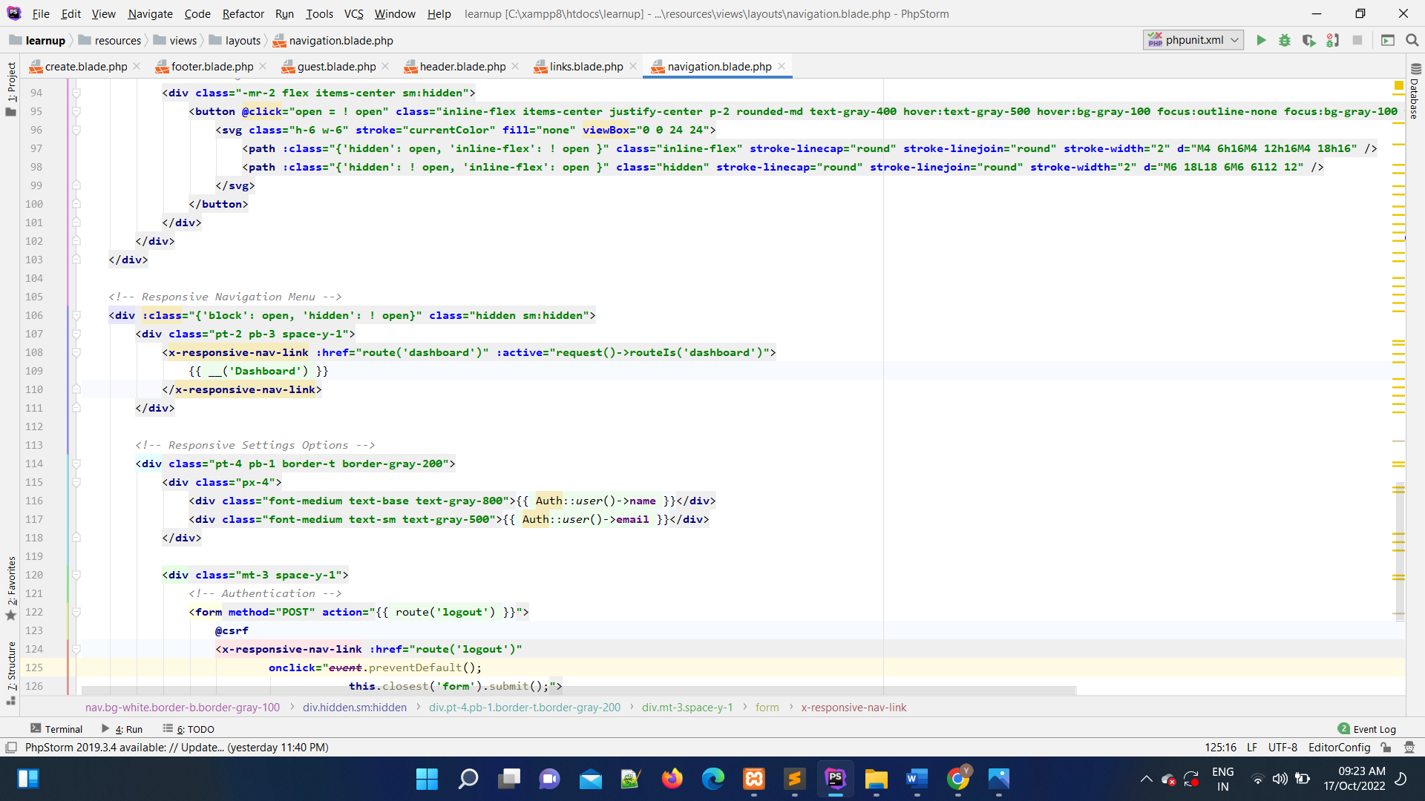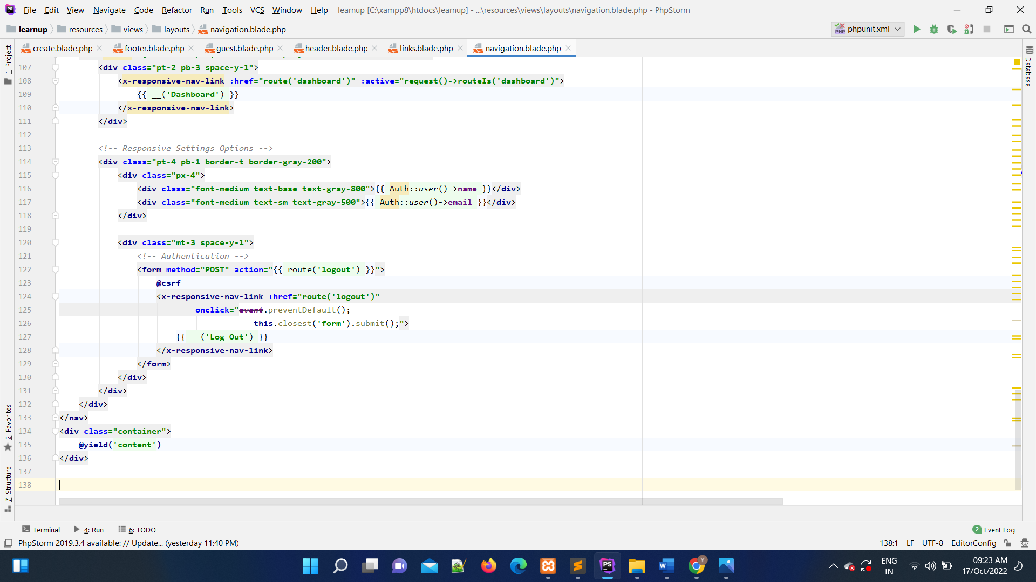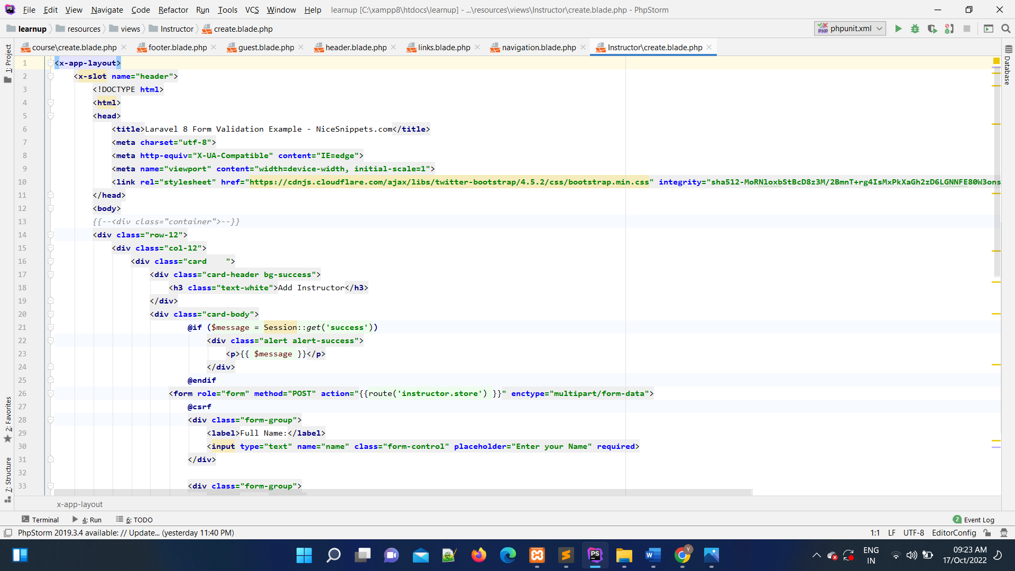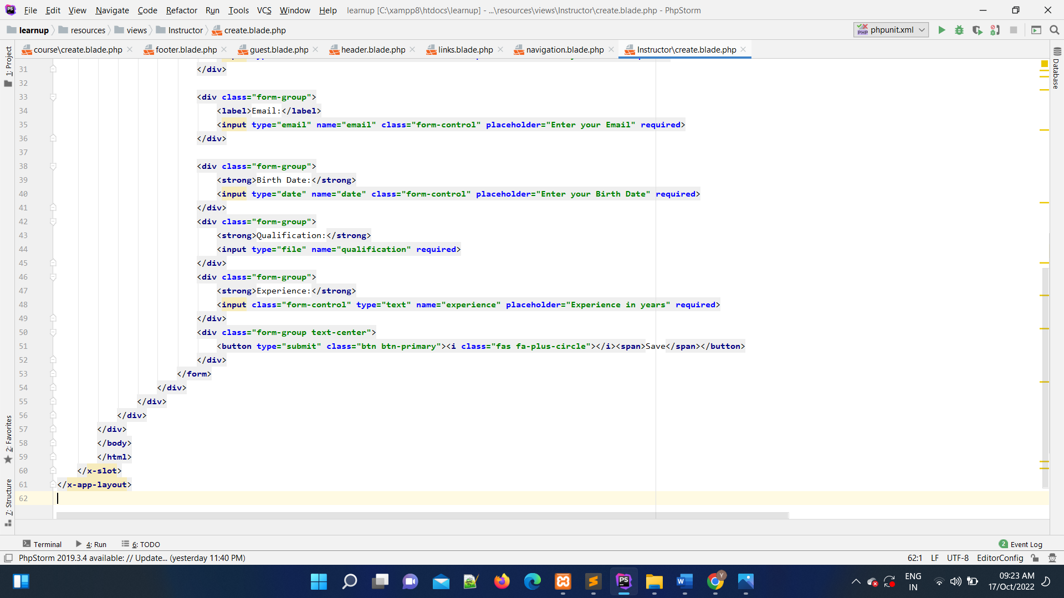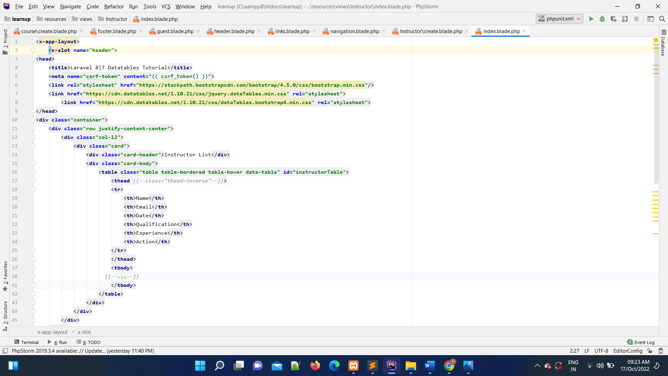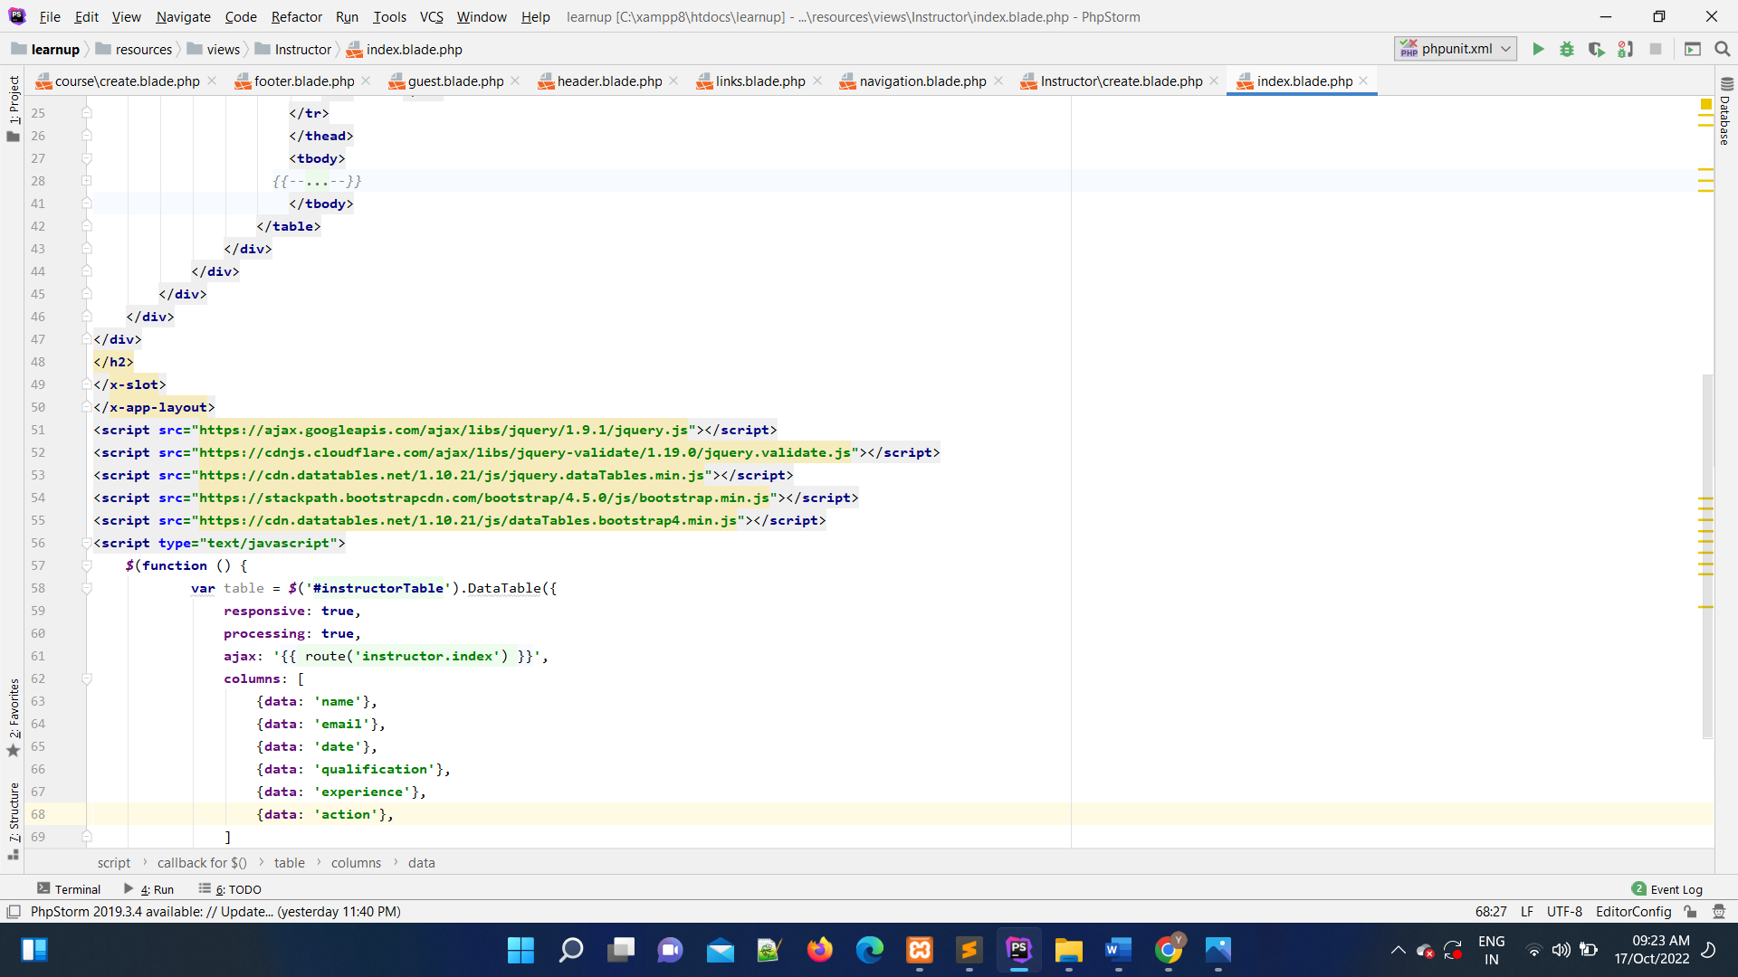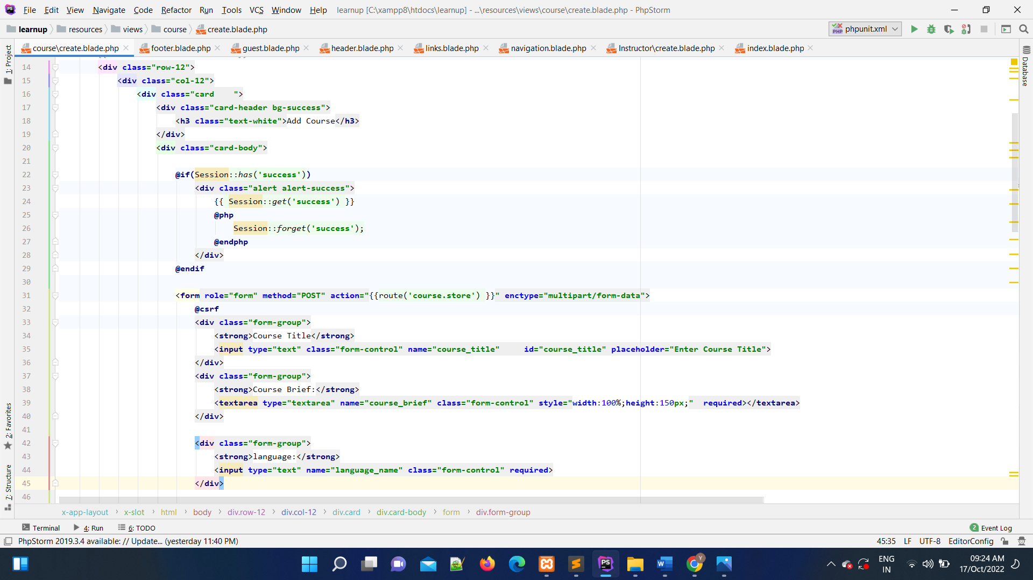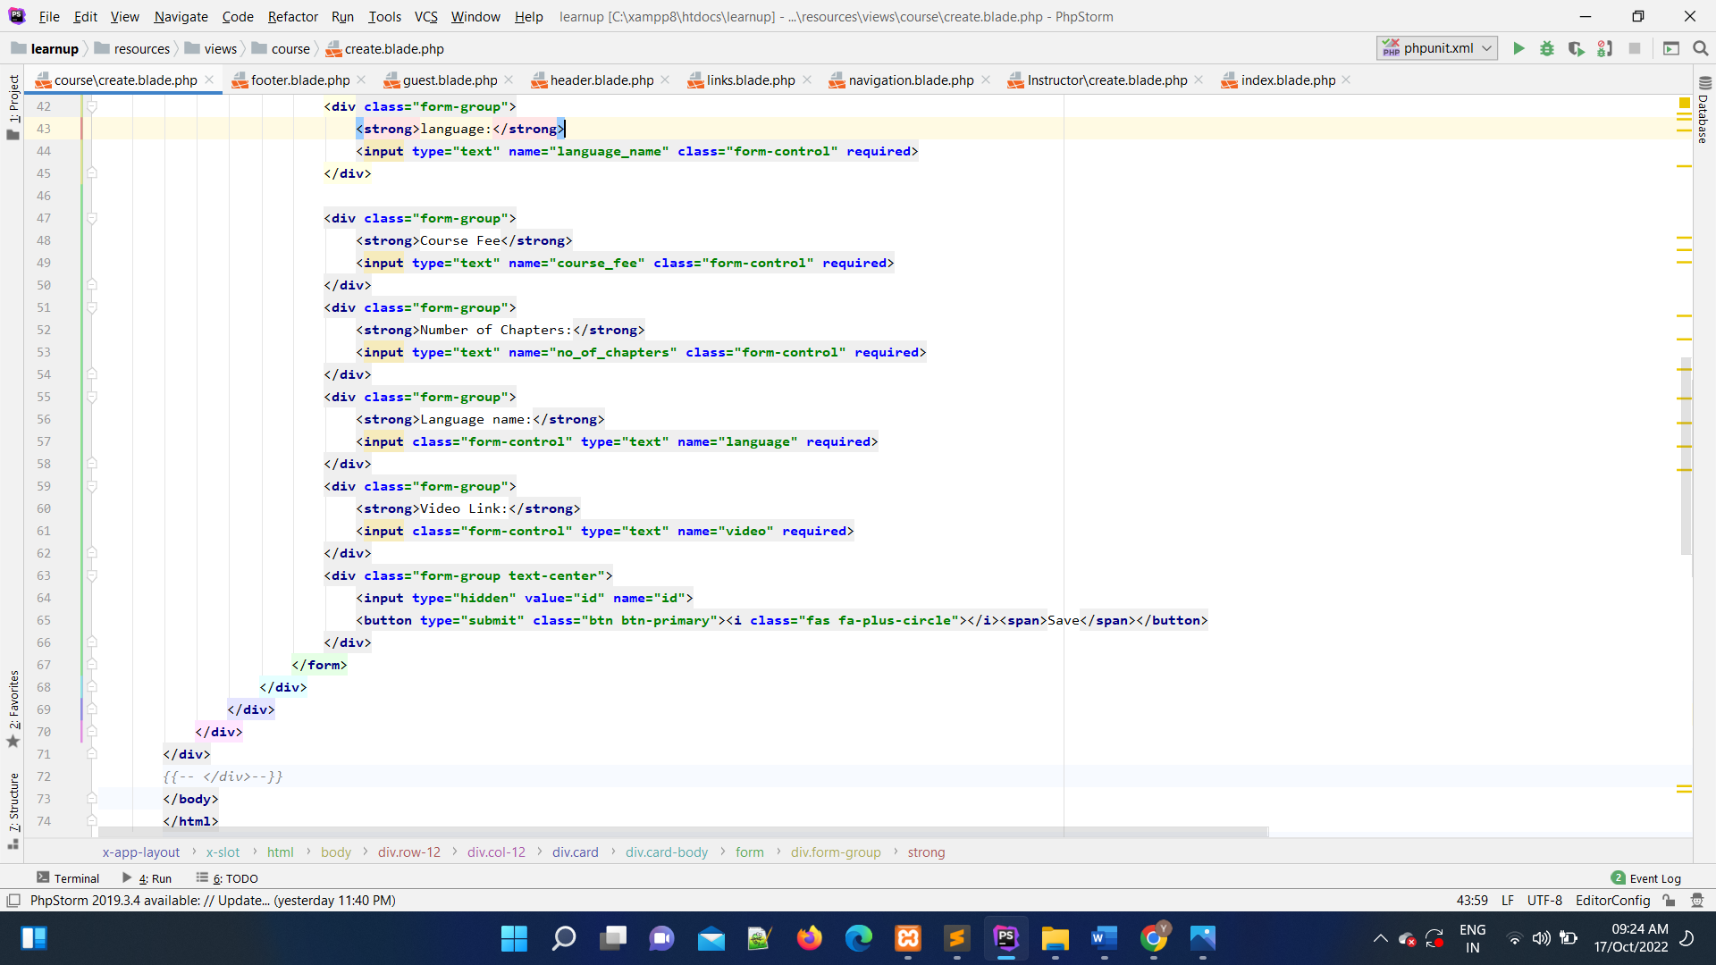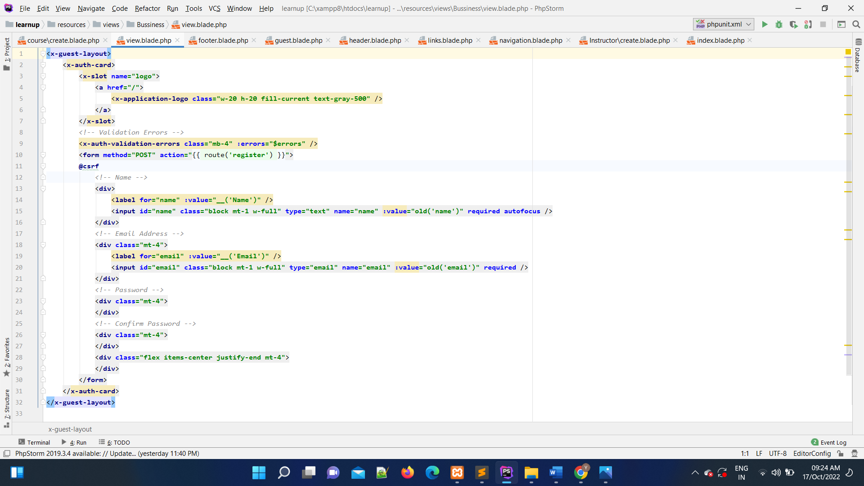

## 6.Testing

* Login Page:

|  |  |  |  |  |  |
| --- | --- | --- | --- | --- | --- |
| **NO.** | **Input** | **Description** | **Expected Output** | **Actual Output** | **Result** |
| **1** | Empty Email | Blank | Error | Error | Login Fail |
| **2** | Empty  /Wrong password | Blank/Wrong | Error | Error | Login Fail |

* 9Upload Resources:

|  |  |  |  |  |  |  |
| --- | --- | --- | --- | --- | --- | --- |
| **NO.** | **Input** | **Description** | **Expected Output** | **Actual Output** | | **Result** |
| **1** | Empty  Name | blank | Error | Error | | Not add |
| **2** | Empty email | Blank | Error | Error | | Not add |
| **3** | Empty Gender | Blank | Error | Error | | Not add |
| **4** | Empty  Age | Blank | Error | Error | | Not add |
| **5** Empty  Qualification | | Blank | Error | Error | Not add | |
| ❖ Add Course: | |  |  |  |  | |
| **NO. Input** | | **Description** | **Expected Output** | **Actual Output** | **Result** | |
| **1** Empty  Title | | blank | Error | Error | Not add | |
| **2** Empty  Course Brief | | Blank | Error | Error | Not add | |
| **3** Confirm  Course fees | | Blank | Error | Error | Not add | |
| 4Confirm  Video | | Blank | Error | Error | Not add | |
| ❖ Add Course: | |  |  |  |  | |
| **NO. Input** | | **Description** | **Expected Output** | **Actual Output** | **Result** | |
| 1. Empty Name | | blank | Error | Error | Not add | |
| **2** Empty email | | Blank | Error | Error | Not add | |
| 1. Confirm   qualification | | Blank | Error | Error | Not add | |
| 4Confirm  experience | | Blank | Error | Error | Not add | |

**7.0 NEW TOOLS/ TECHNOLOGIES LEARNED/ USED:**

* Phpstrom:- It is the main development environment in which we willCode.
* Some CSS for page design

* Template field for passing value .
* Phpmyadmin using sql for database.

**8.0 SYSTEM LIMITATION/CONSTRAINTS:**

* This application can be work when internet and Wi-Fi connection would be Available.
* Confirm status about application can be done when internet and Wi-Fi connection would be available.

## 9. Future Enhancement & Opportunities

* More efficient design and user experience.
* Apply More efficient constraints .
* Add feature in course page which instructor resources show for user.
* Add payment method.

**10. BIBLIOGRAPHY & REFERENCES:**

**Books**

* Laravel Documentation

### **Website**

* [www.google.com](http://www.google.com/)
* [www.stackoverflow.com](http://www.stackoverflow.com/)
* [www.aspsnippets.com](http://www.aspsnippets.com/)
* [www.youtube.com](http://www.youtube.com/)